A COMPREHENSIVE TRAINING ON HPE’S AI

SOLUTION OFFERINGS: BUILD, DEPLOY AND ACCELERATE

HPE Official Curriculum

CloudThat

12/7/2023

Learner’s Lab Guide

**Welcome!!!**

**Course: -** A Comprehensive Training on HPE’s AI Offerings - Build, Deploy and Accelerate

**Prerequisite:**

1. Open AWS console at <https://465222204141.signin.aws.amazon.com/console> and sign in with the provided userame and password (Collect password from trainer)

**You are done with prerequisites.**

**Chapter-1**

**Create your Lab Environment**

**Create a EC2 Instance from Amazon Machine Image (AMI)**

1. In AWS Console select Instances

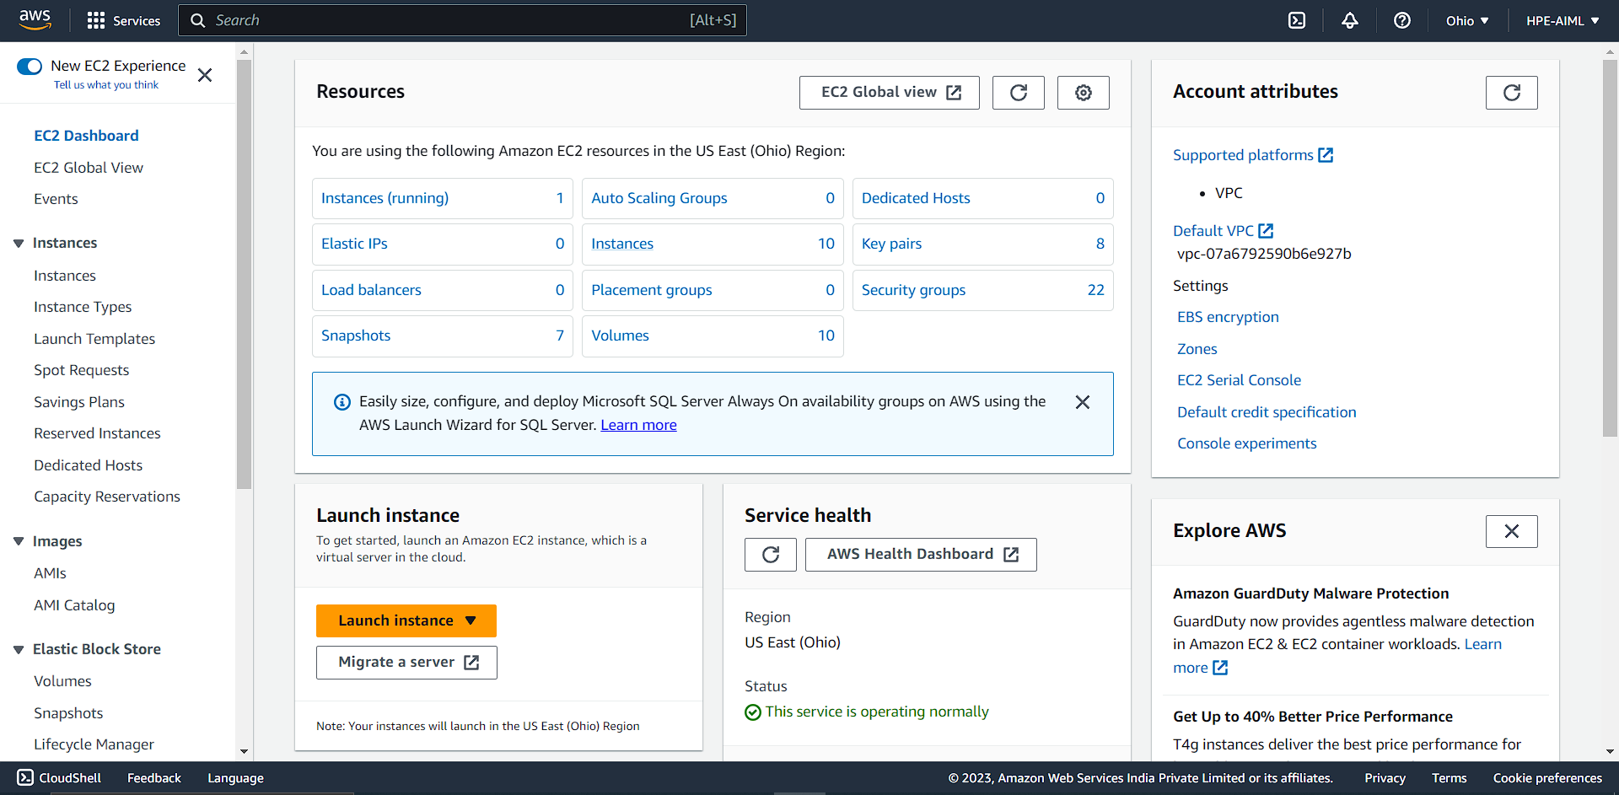

1. You can see the list of instances and their status. Select “Launch Instance” button

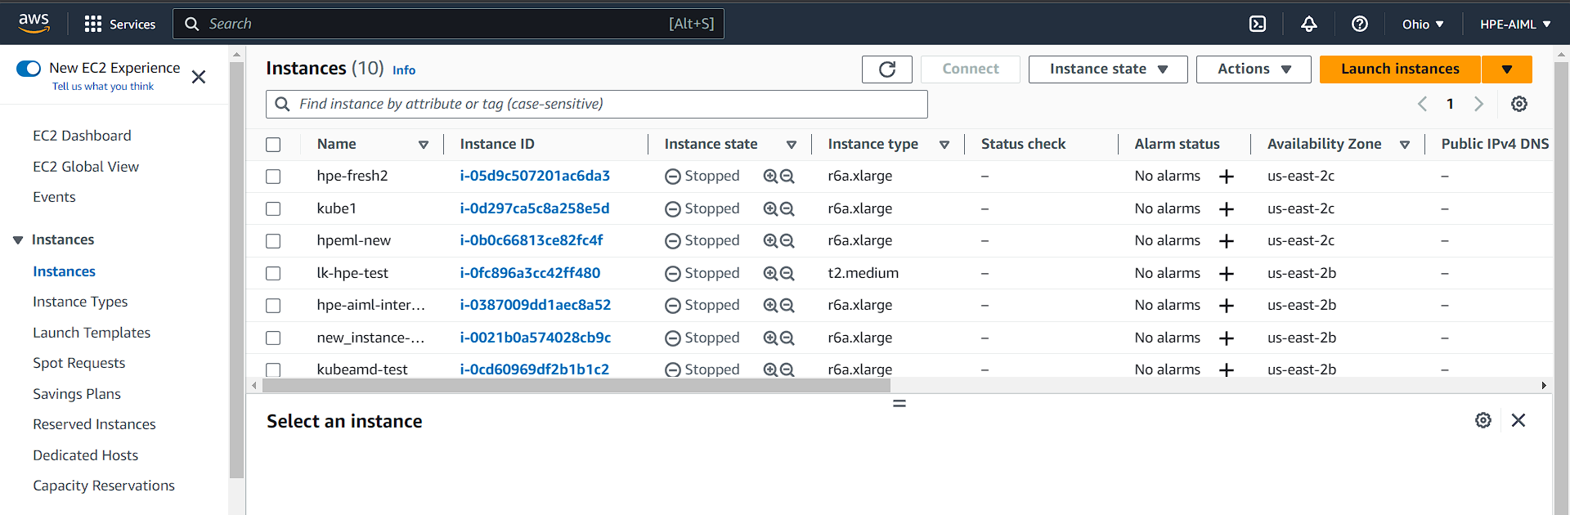

1. It will take you to Launch an Instance page. Here you must provide following info

* Name and Tags: <yourfirstname>hpe

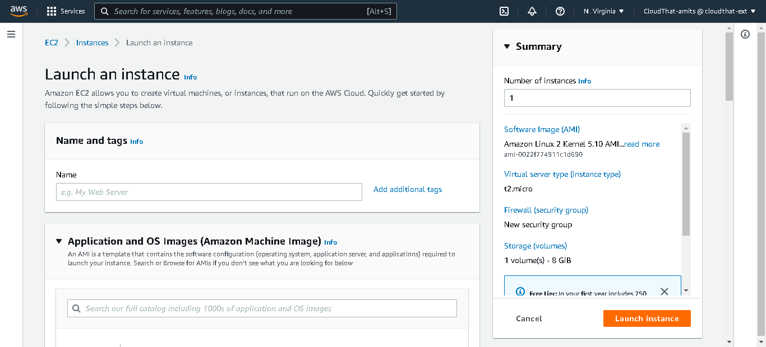

* Application and OS images : Select My AMI option below search bar, as shown below

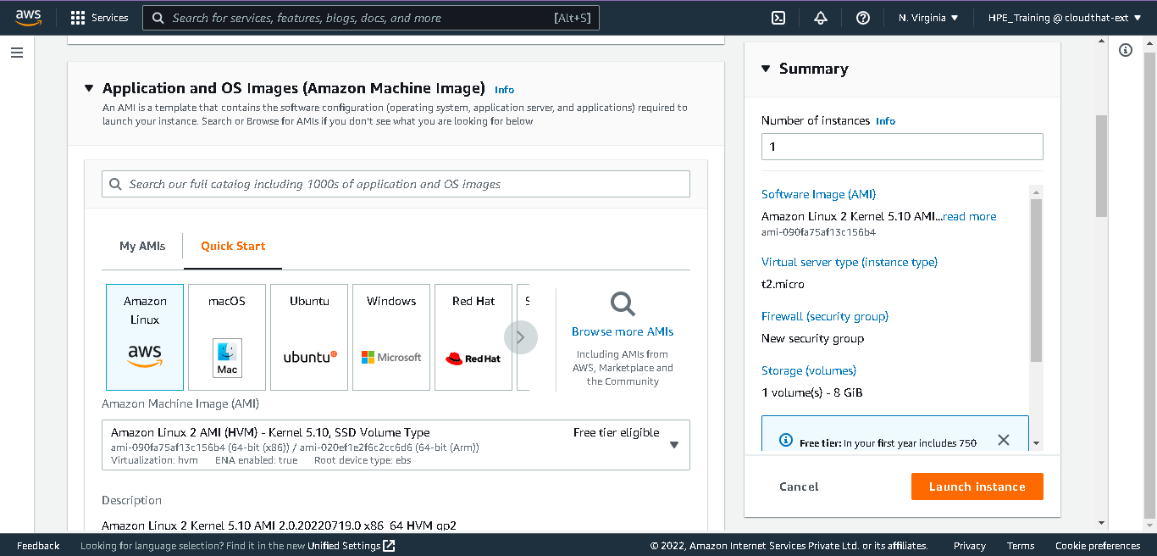

It will change AMI as below, select the AMI mentioned by the Instructor

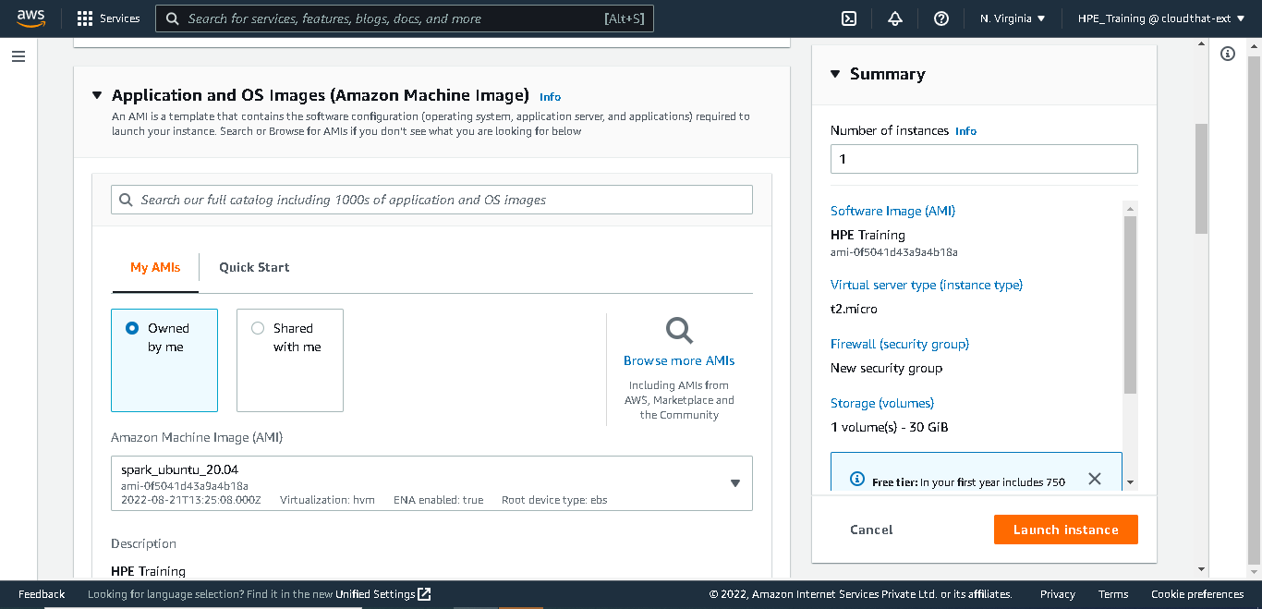

* Then scroll down to Instance type: select r6a.xlarge from dropdown

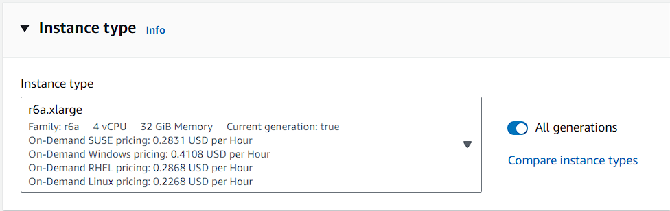

* Key Pair (login)
  + Either select from list – if you already created keypair

Click on down arrow in keypair search bar

Select your keypair

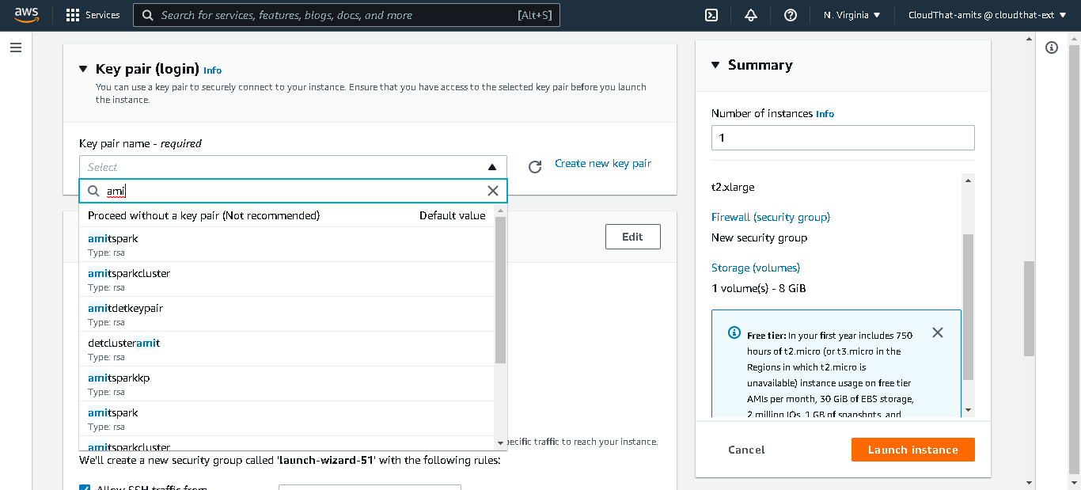

* Else you can create key pair and use it

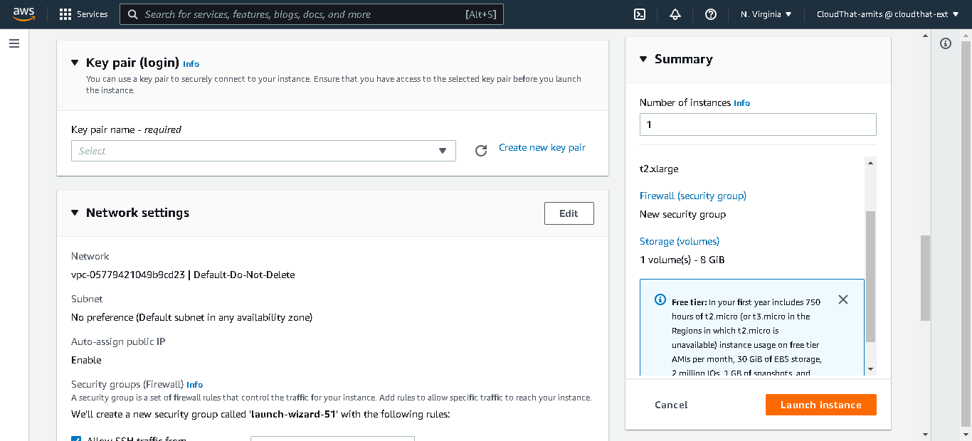

Click on create new key pair with name <yourfirstname>hpe and click on create KeyPair tab. It will download one file <yourfirstname>hpe.pem.

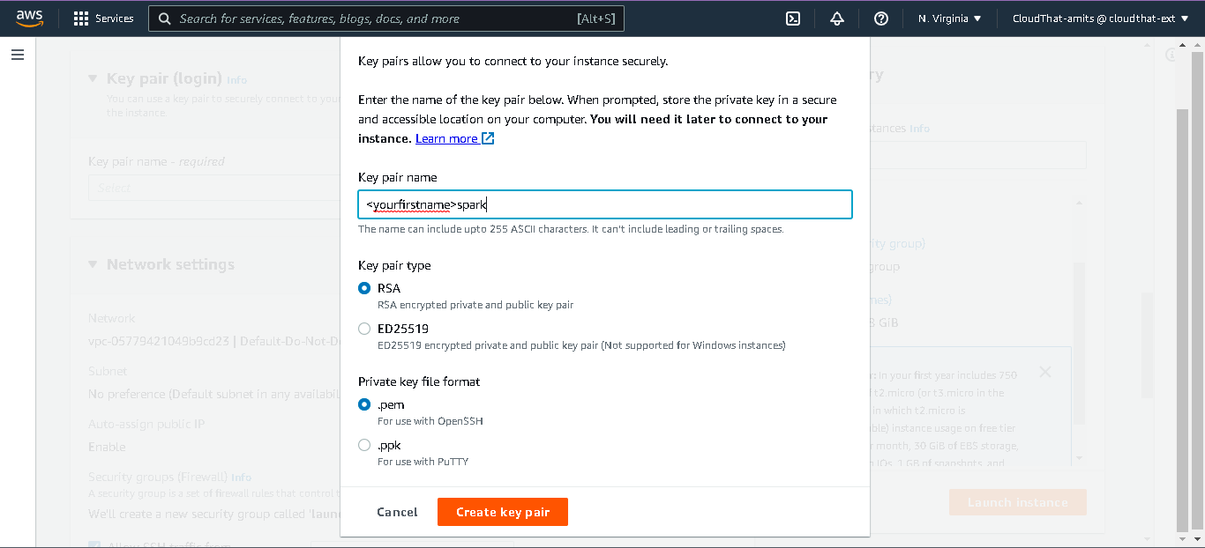

After creation of new key pair its name appear in KeyPairName Textbox.

* Network Setting
  + Click on Edit Tab

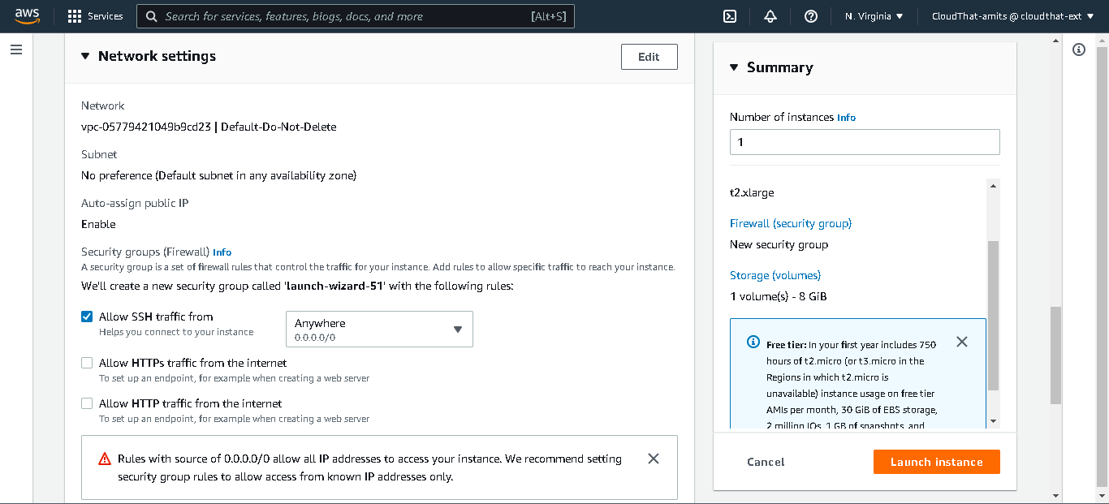

* + It will open edit configuration page in same dialogue. Then click on radio button in front of *Select Existing group security group* and thenclick on down-arrow from *Common Security Group* textbox. Select “Launch-wizard-3”

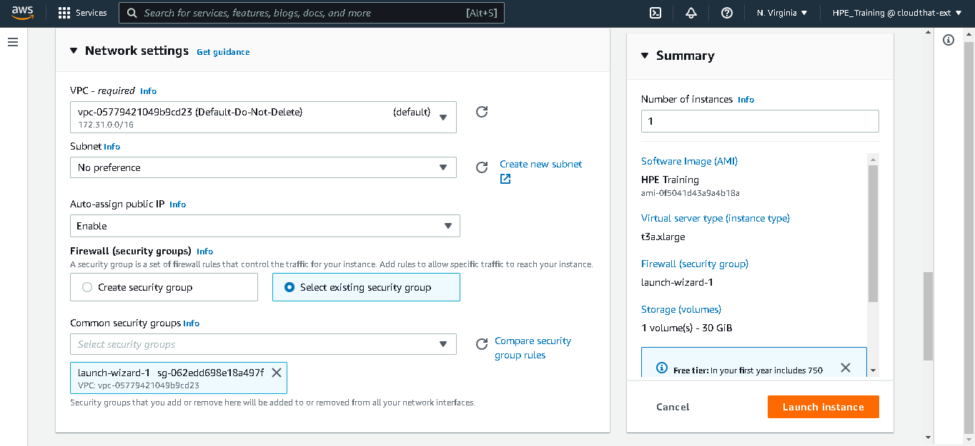

* Configure Storage:- Check the values are 50 and gp3, if not then edit it.

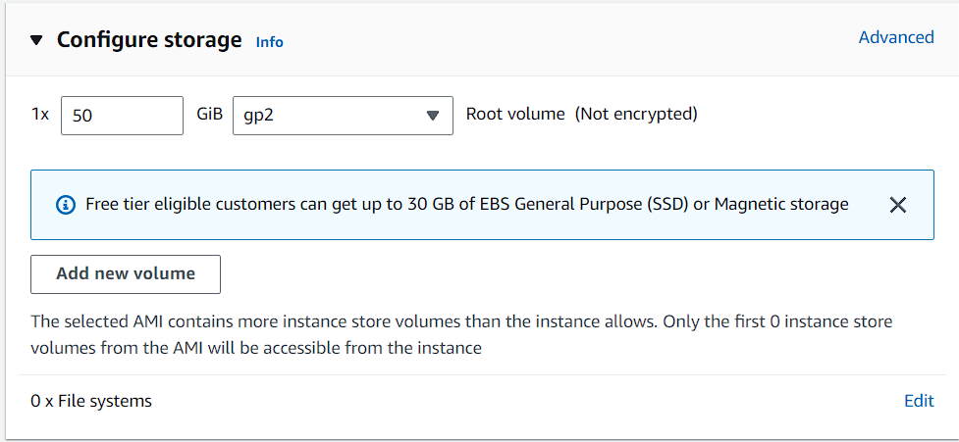

Click on Launch Instance

* Click on View all Instance tab

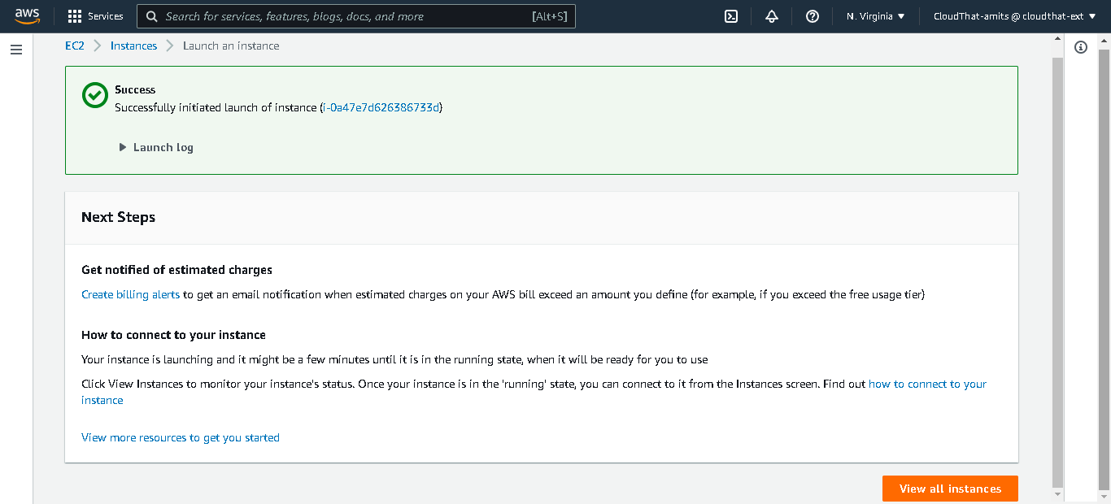

Step 7: It will redirect to Instances Page. Scroll down to locate your Instance. Under Instance check you can see state running but EC2 instance is not initialized and pass status check. You can see that under status check, So wait for 2-3min to initialize EC2 instance. Once Done Click on Instance id at right hand side of Instance Name.

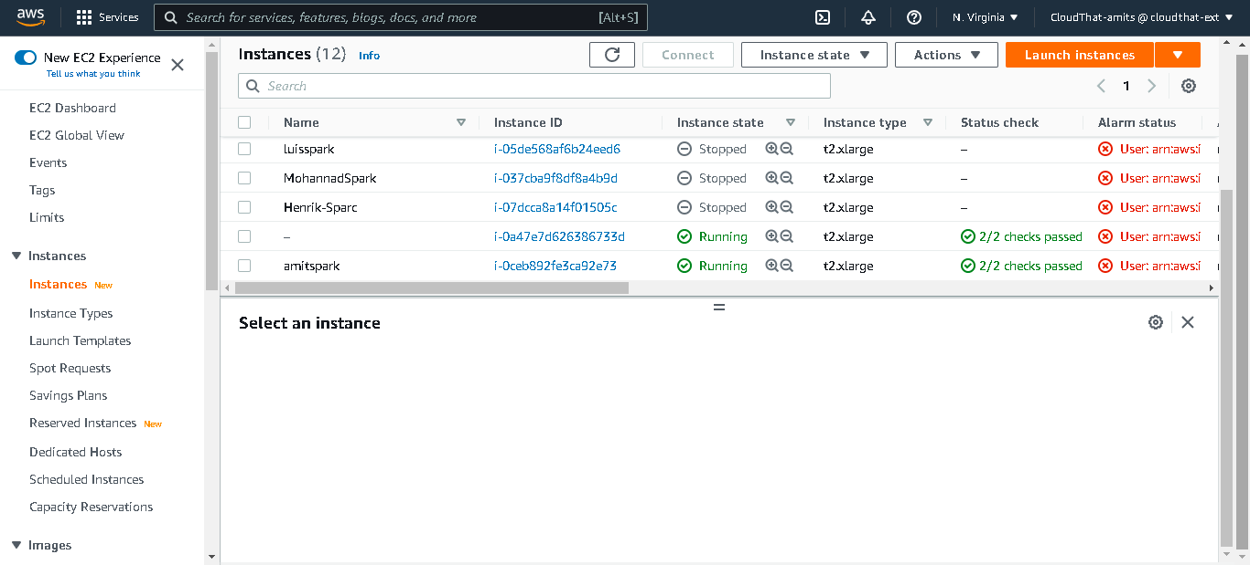



Step 8: Note Down Public and Private address. Use copy icon from page to copy address

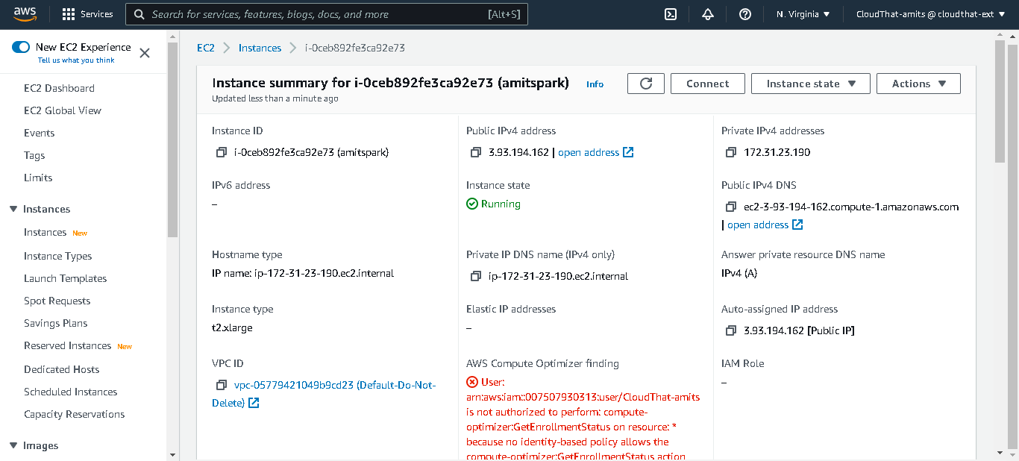

**you are done with Creating EC2 Instance.**

**Chapter-2**

**Connect to EC2 instance**

1. **With EC2 instance connect**

Step 1: Login to aws management console with credentials share over mail

Step 2: In Search bar type EC2, click on EC2 – it will open EC2 Dashboard

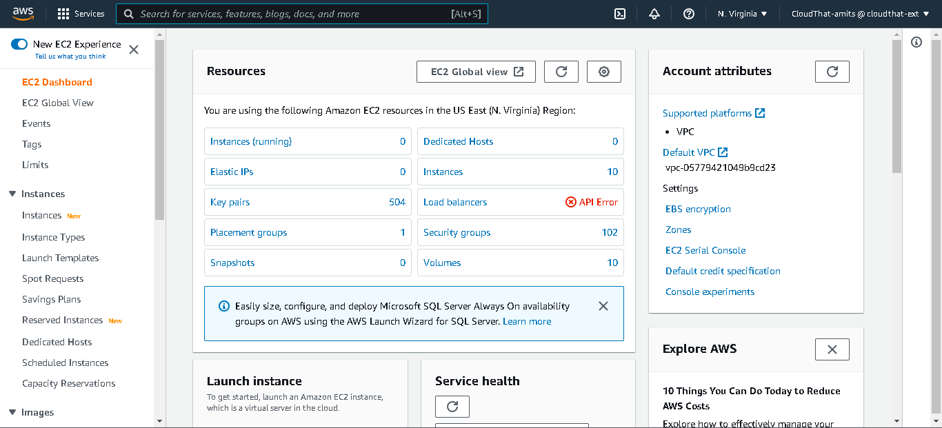

Step 3: Click on Instances – It will take you to Instances Dashboard



Step 4: Locate EC2 instance (if any filter is there kindly clear filter before search ). Type your EC2 instance name in search. Click on Instance Id [highlighted in blue] in-front of your EC2 instance name.

Step 5: Click on Connect tab



Step 6: It will take you to Connect to instance page. Then Click Connect [Default username is ubuntu, do not change it]

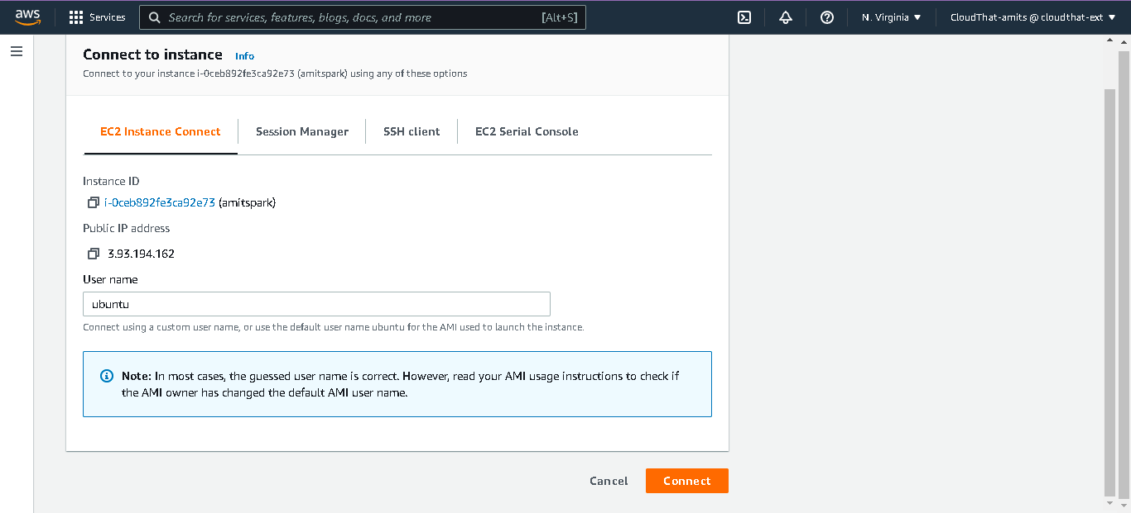

Step 7: After successful connect you will be getting Command Line Interface like below

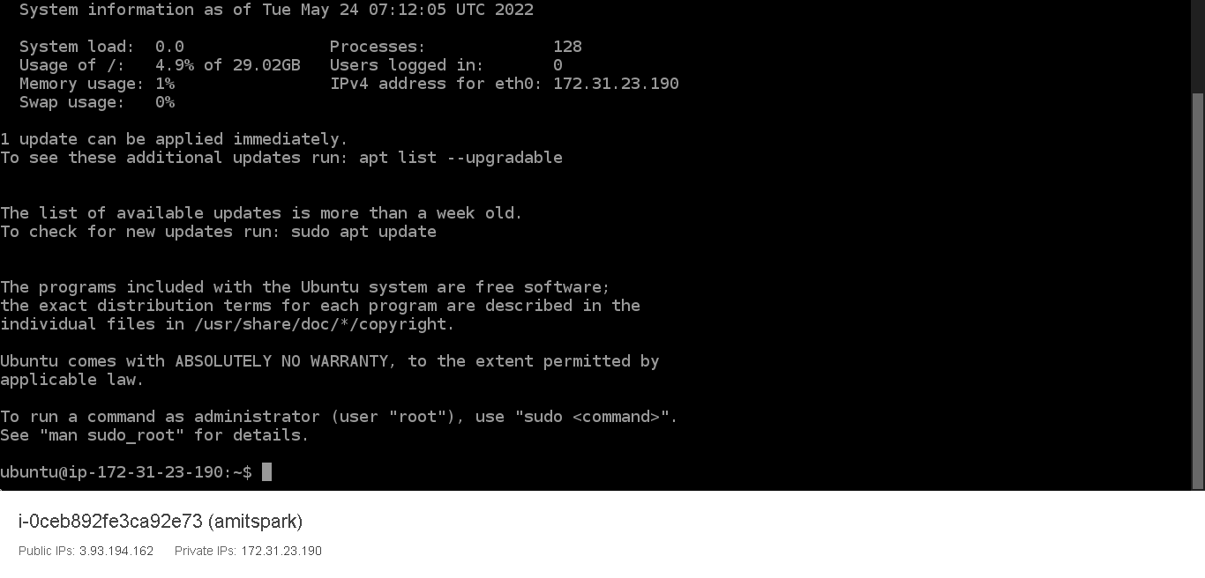

1. **With putty**

Step 1: Install PuTTY on your local computer

Download and install PuTTY from the [PuTTY download page](http://www.chiark.greenend.org.uk/~sgtatham/putty/). If you already have an older version of PuTTY installed, we recommend that you download the latest version. Be sure to install the entire suite.

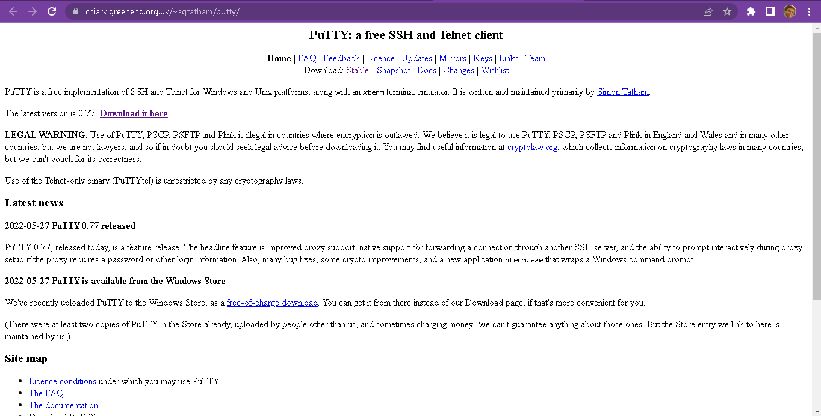

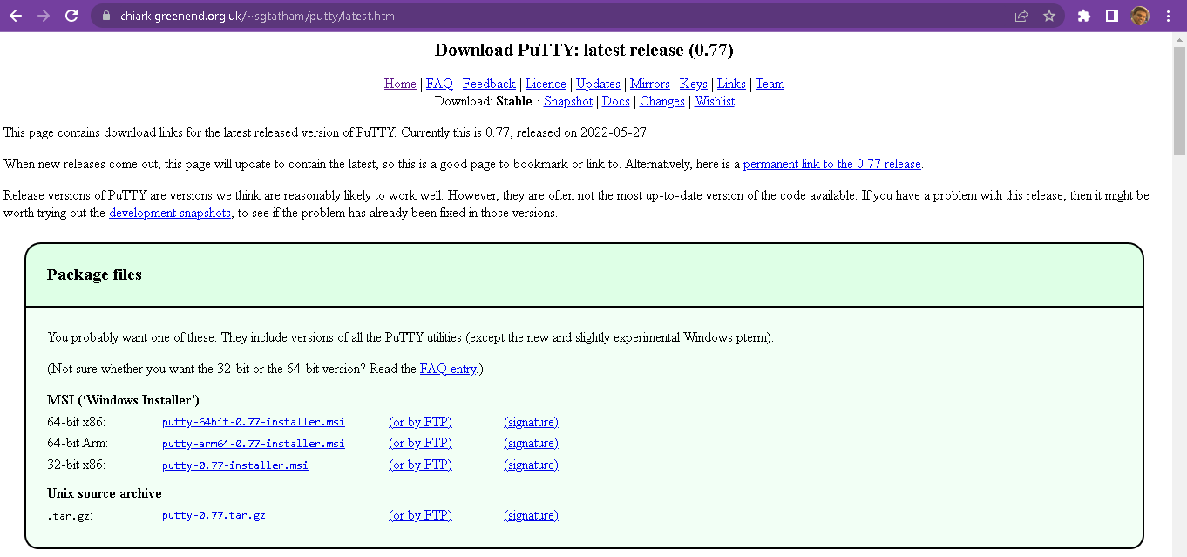

It will download .msi file. Once download complete. Execute file – [go with all default option]

Step2: Convert .pem file ito .ppk

Open Puttygen - [type Puttygen in search on taskbar and open]

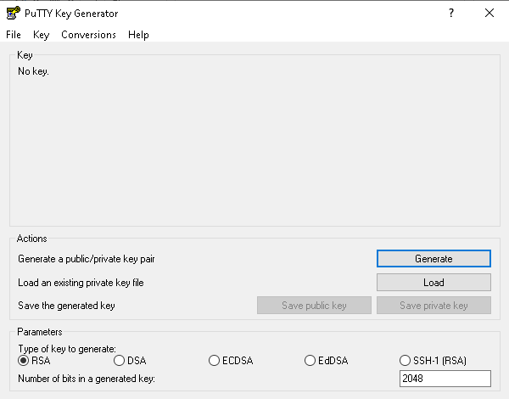

Under Type of key to generate, choose RSA. [If your version of PuTTYgen does not include this option, choose SSH-2 RSA.]

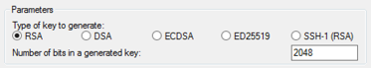

Choose Load. [By default, PuTTYgen displays only files with the extension .ppk. To locate your .pem file, choose the option to display files of all types.]

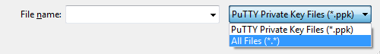

Select your .pem file for the key pair that you specified when you launched your instance and choose Open. PuTTYgen displays a notice that the .pem file was successfully imported. Choose OK.

To save the key in the format that PuTTY can use, choose Save private key. PuTTYgen displays a warning about saving the key without a passphrase. Choose Yes.

Step 3: Open Putty

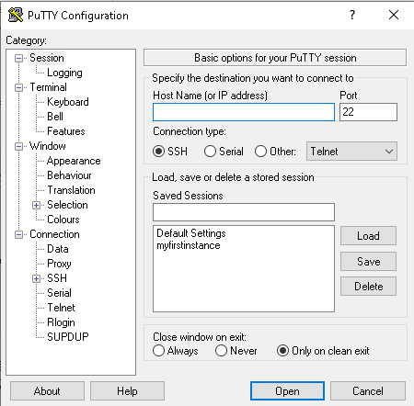

In the Category pane, choose Session and complete the following fields:

In the Host Name box, do one of the following:

* (Public DNS) To connect using your instance's public ipv4 address
* Ensure that the Port value is 22.
* In the Category pane, choose Connection, and then enter the required interval – 180 - in the Seconds between keepalives field.

Click on session from category pane. Under Connection type, select SSH.

In the Category pane, expand Connection, expand SSH, and then choose Auth. Complete the following:

* Choose Browse.
* Select the .ppk file that you generated for your key pair and choose Open.
* (Optional) If you plan to start this session again later, you can save the session information for future use. Under Category, choose Session, enter a name for the session in Saved Sessions, and then choose Save.

Choose Open.

It will open terminal. And ask login as. Type ubuntu and hit enter

It will give your prompt with private IP address as follows

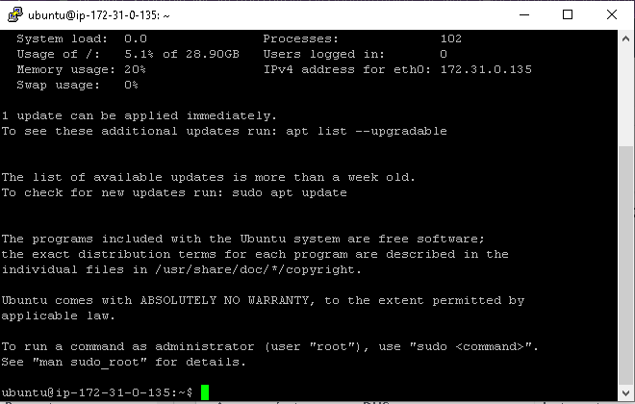

**Chapter-3**

**Configure your EC2 Instance**

Login to root user

sudo su (If you are logged into ubuntu user)

Step 1:- Set up passwords for users

passwd [provide “password123” as password]

passwd ubuntu [provide “password123” as password]

Step 2:- To add the user ubuntu to the sudoers file, you need to open the file in a text editor. You can use the nano command to do this

nano /etc/sudoers

Once the file is open, you need to add the following line to the end of the file:

ubuntu ALL=(ALL:ALL) ALL (If these lines are already there no need add)

This line gives the user ubuntu full sudo privileges. This means that they will be able to run any command as root, without having to type in the root password.

Save the file and exit the text editor.

ctrl+x

enter

passwd ubuntu

You will now need to restart the sudo service for the changes to take effect. You can do this by running the following command:

sudo service sudo restart

Once the sudo service has restarted, the user ubuntu will be able to run sudo commands.

**For Labs 1,2,3, and 4 of Module 2, and Module 1 Lab, you need to create a new EC2 instance from AMI from the custom AMI list. The name of AMI will be instructed by the instructor. Follow Instructions in Appendix 1 for instance creation from custom AMI.**

**Once you are ready with new instance follow instructions below to execute the Labs**

**Chapter-4**

**Executing Lab Experiments**

**Module 1- Lab 1**

This runs a credit card fraud detection algorithm on the Swarm Learning platform. It uses Keras and TensorFlow.

The following image illustrates a cluster setup that uses only one host:

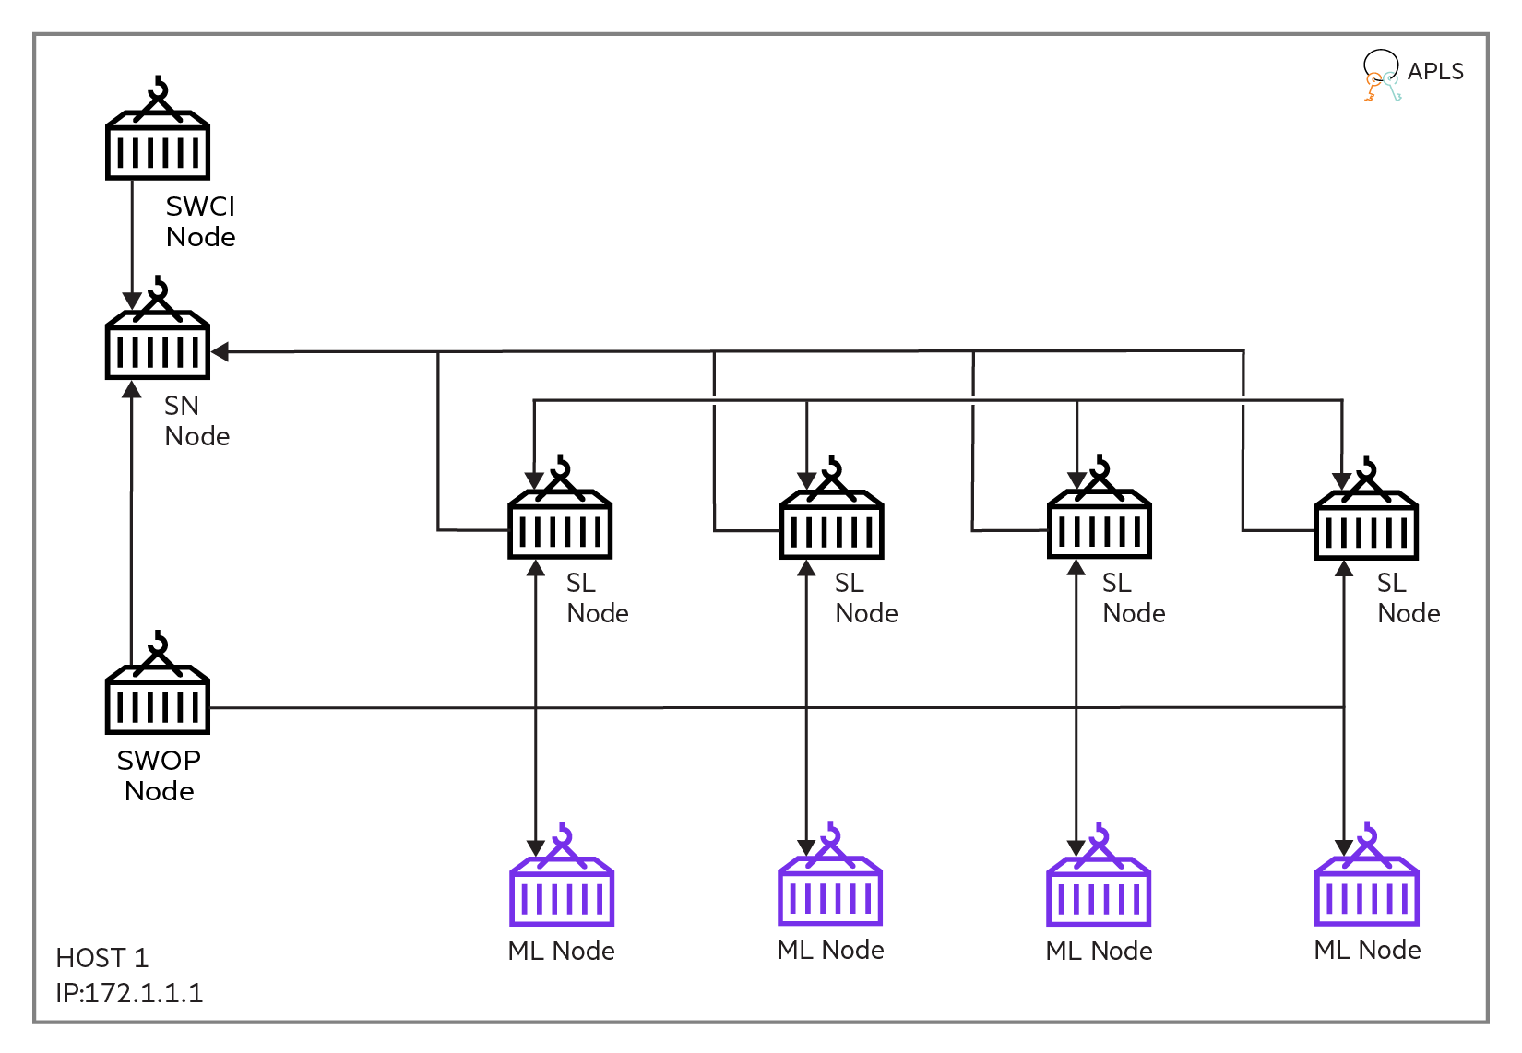

Step 1: Connect to instance as ubuntu user

Step 2: Change directory to

cd /home/ubuntu/environments

Step 3: activate virtual environment

source hpepyspark/bin/activate

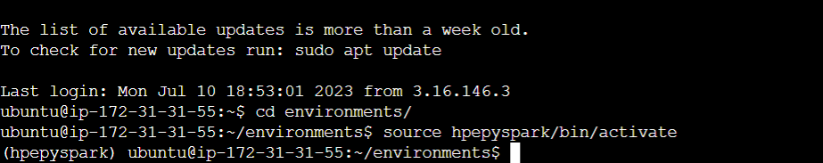

Step 4: change directory to

cd ..

cd hpe/swarm-learning/ swarm-learning/

Step 5: open jupyter notebook

jupyter notebook --ip=*

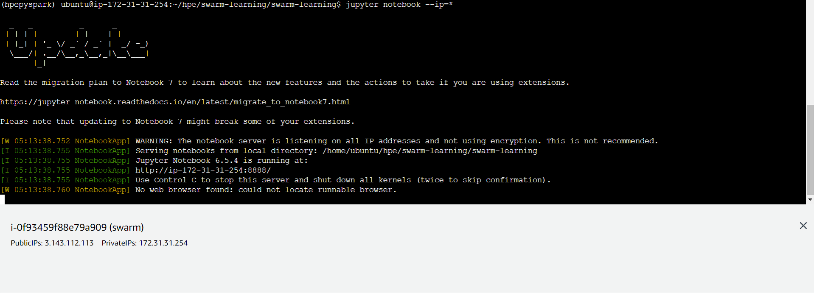

Step 6: Open new browsing tab and in address bar put url

<your publicip>:8888 enter password – 12345

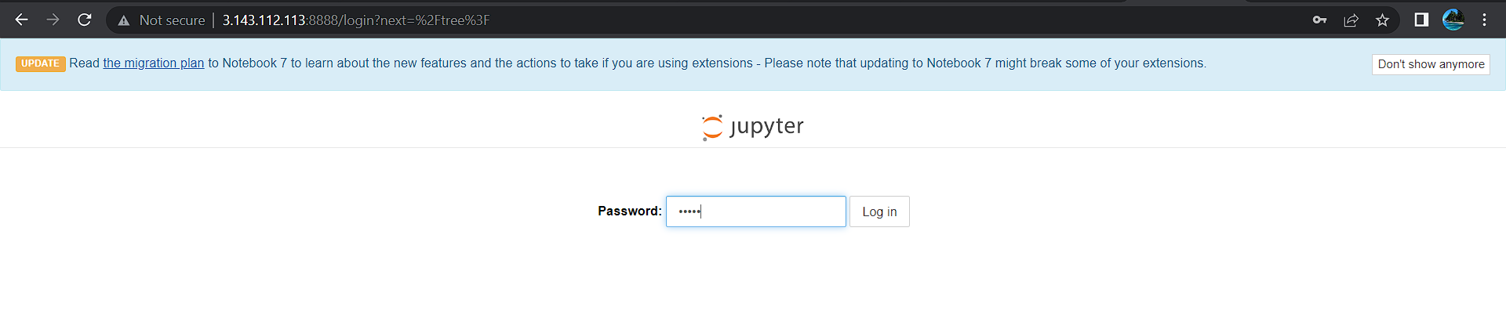

Step 7: Open “setup_swarm_learning.ipynb” file

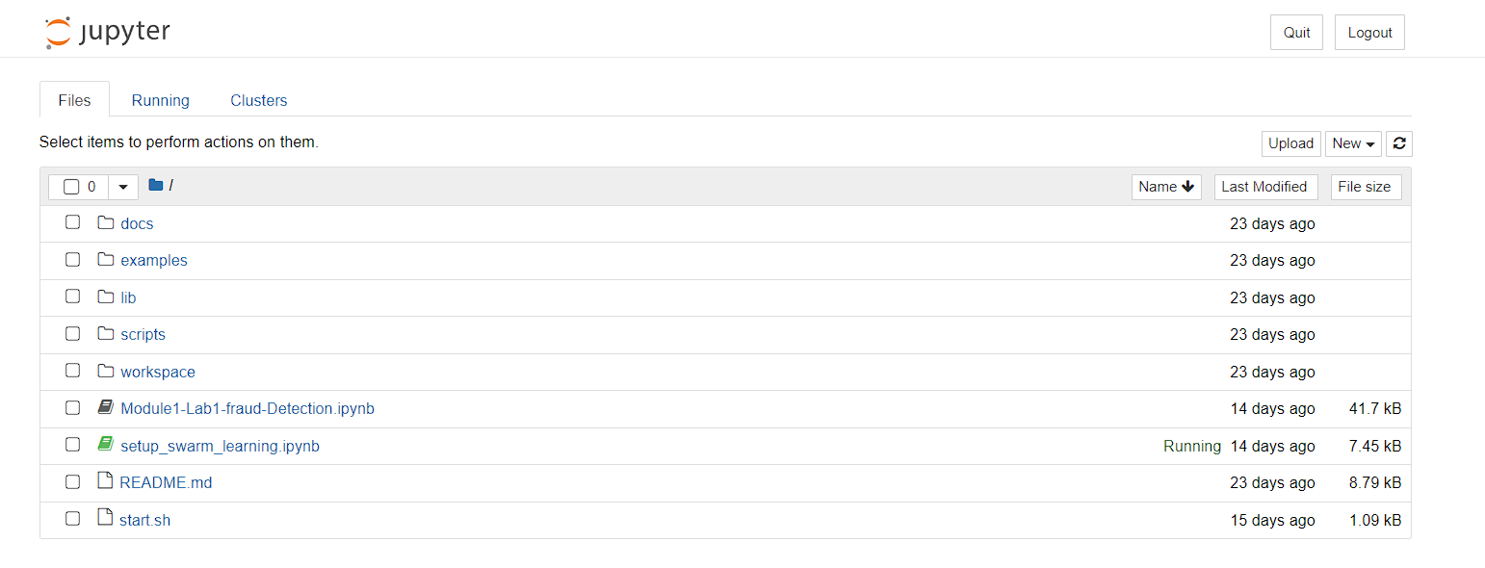

Step 8: Follow Instruction in Notebook

Step 9: Click on Module1-Lab1-fraud-Detection.ipynb

Step 10: Follow Instruction in Notebook

Step 11: Once finish with execution close the notebook and jupyter lab

Step 12: press ctrl+C in SSH in instance connect or putty prompt

Step 13: Enter following command

Deactivate

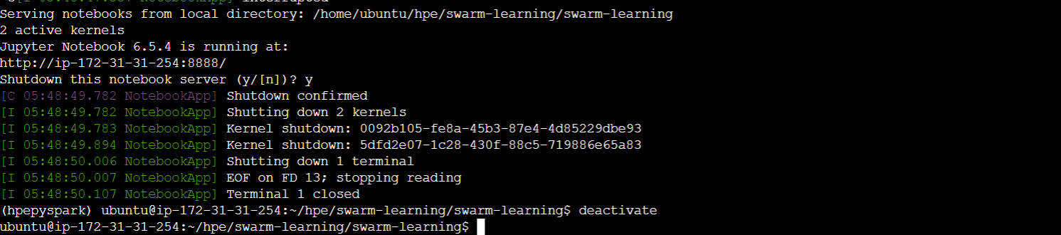

Step 14: Close terminal

**Done!!!**

|  |  |
| --- | --- |
| **Module2-Lab-SmartSim**   * The AMI’s are pre-Installed with Smartsim and necessary dependencies. The procedure of Installation to create your own lab environment is listed in Appendix 1 * There are 4 Notebook examples are there in this section * To run these notebook - run following command in a sequence   source /home/ubuntu/environments/hpesmartsimenv/bin/activate  cd /home/ubuntu/environments/ModuleWisenotebook/  jupyter notebook --ip=*  open browser - in address bar enter <yourpublicip>:8888  [enter password 12345]  open folder Module4-Lab-SmartSim | |
| **SmartSim Fundamentals** | **Module2-Lab2a-SmartSim_Fundamentals**  open notebook file  execute cells in notebook  once finish execution close notebook |
| **Execute Python Script** | **Module2-Lab2b-Execute_Python_Scipt**  open notebook file  execute cells in notebook  once finish execution close notebook |
|  | |
| **Online Training** | **Module2-Lab3-Online_Training**  open notebook file  execute cells in notebook  once finish execution close notebook |
| **Online Analysis** | **Module2-Lab4-Online_Analysis**  open notebook file  execute cells in notebook  once finish execution close notebook |

**Module 2 – Lab5**

|  |  |
| --- | --- |
| There are 5 Notebook examples are there in this section | |
|  | To run these notebook - run following command in a sequence on AWS ec2 connect shell or putty shell  source /home/ubuntu/environments/hpepyspark/bin/activate  cd ModuleWisenotebook/  jupyter notebook --ip=*  open browser - in address bar enter <yourpublicip>:8888  enter password 12345  open folder Module2-Lab5-Anomaly_Detection  open notebook – Module2-Lab5-Anomaly_Detection.ipynb  follow instructions in notebook cells  once execution finished - close notebook  close jupyter  in shell press CTRL+X  shutdown Kernel - y  you get prompt ubuntu@<instancename>:$  **Module 2 – Lab6**   * + execute following command in shell   source /home/ubuntu/environments/hpeoutliervenv/bin/activate  jupyter notebook --ip=*   * + open new browsing tab and enter url   <your public ip>:8888  press enter  it ask you to enter password  12345   * + in jupyter - click on folder named as   Module2-Lab6-Outlier_Detection_with_alibi-detect   * + open notebook file named as   Outlier Detection with alibi-detect .ipynb   * + Follow the instructions in Notebook cells   + Once finish execution - close the notebook   + in SSH-in-browser   press CTRL+C  press y  it will shutdown sever and give prompt back   * + type below command   deactivate |

**Module 3 Labs**

|  |  |  |
| --- | --- | --- |
| There are 8 Notebook examples are there in this section  To run these notebook – Login to ubuntu user on the machine run following command in a sequence  cd environments/  source hpepyspark/bin/activate  cd ModuleWisenotebooks/  jupyter notebook --ip=*  open browser - in address bar enter <yourpublicip>:8888  enter password 12345 | | |
| **Image Classification** | **Module3-Lab1-Image_Classification**  open notebook file  execute cells in notebook  once finish execution close notebook | |
| **Natural Language Processing - Text based** | **Module3-Lab2a-Text_Processing**  open notebook file  execute cells in notebook  once finish execution close notebook | |
| **Module3-Lab2b-NEWS_Classification**  open notebook file  execute cells in notebook  once finish execution close notebook | |
| **Module3-Lab2c-Sentiment_Analysis**  open notebook file  execute cells in notebook  once finish execution close notebook | |
| **Natural Language Processing - audio** | **Module3-Lab3-Speech**  open notebook file  execute cells in notebook  once finish execution close notebook | |
| **AI Use Cases** | | |
| **Credit Card Fraud Detection** | **Module3-Lab4a-Credit_Card_Fraud_Detection**  open notebook file  execute cells in notebook  once finish execution close notebook | |
| **Spam SMS Classification** | **Module3-Lab4b-spam_SMS**  open notebook file  execute cells in notebook  once finish execution close notebook | |
| **Fake NEWS Identification** | **Module3-Lab4c-fake_NEWS**  open notebook file  execute cells in notebook  once finish execution close notebook | |
| **Module 3 Lab 5 Drift Detection**  To run these notebook – Login to ubuntu user on the machine run following command in a sequence  cd environments/  source hpedriftenv/bin/activate  cd ModuleWisenotebooks/  jupyter notebook --ip=*  open browser - in address bar enter <yourpublicip>:8888  enter password 12345  Open the folder Module3-Lab5-DriftDetection and execute Module3-Lab5-DriftDetection.ipynb notebook  Follow the instructions in Notebook cells  Once finish execution - close the notebook  in SSH-in-browser  press CTRL+C  press y  it will shutdown sever and give prompt back  type below command  deactivate | |
|  | |

|  |  |
| --- | --- |
|  | |
|  |  |
|  |  |
|  | |
|  |  |
|  |  |

**For Lab 5, and 6 of Module 4, You need to create a new EC2 instance from AMI from the custom AMI list. The name of AMI will be instructed by the instructor. Follow Instructions in Appendix 1 for instance creation from custom AMI. Please note the Instance size should be “G3S.Xlarge”**

**Once you are ready with new instance follow instructions below to execute the labs 5, and 6 of Module 4.**

**Module3-Lab-6- GPT-2 based custom chatbot**

To run these notebook - run following command in a sequence on AWS ec2 connect shell or putty shell

source /home/ubuntu/environments/hpepytorch/bin/activate

cd environments/

jupyter notebook --ip=*

open browser - in address bar enter <yourpublicip>:8888

enter password 12345

open folder Module3-Lab6- GPT-2 based custom chatbot

open notebook –chatbot.ipynb

follow instructions in notebook cells

once execution finished - close notebook

close jupyter

in shell press CTRL+X

shutdown Kernel - y

you get prompt ubuntu@<instancename>:$

**Module3-Lab-7- GPU Training of Custom Data for YOLO Object Detection**

To run these notebook - run following command in a sequence on AWS ec2 connect shell or putty shell

source /home/ubuntu/environments/hpepytorch/bin/activate

cd environments/

jupyter notebook --ip=*

open browser - in address bar enter <yourpublicip>:8888

enter password 12345

open folder Module3-Lab7-GPU_training

open notebook – YOLO_train.ipynb

once training is completed

open notebook YOLO_prediction.ipynb

follow instructions in notebook cells

once execution finished - close notebook

close jupyter

in shell press CTRL+X

shutdown Kernel - y

you get prompt ubuntu@<instancename>:$

**Module 4 - Lab 1,2, and 3**

In this lab section we have three notebook files

* Module2-Lab1.ipynb
  + Open ec2 instance terminal as ubuntu user
  + change directory

cd /home/ubuntu/environments/ModuleWisenotebook/ Module4-Lab1-4-SparkPipelines

* + activate virtual environment

source /home/ubuntu/environments/hpepyspark/bin/activate



* + launch jupyter notebook

jupyter notebook --ip=*

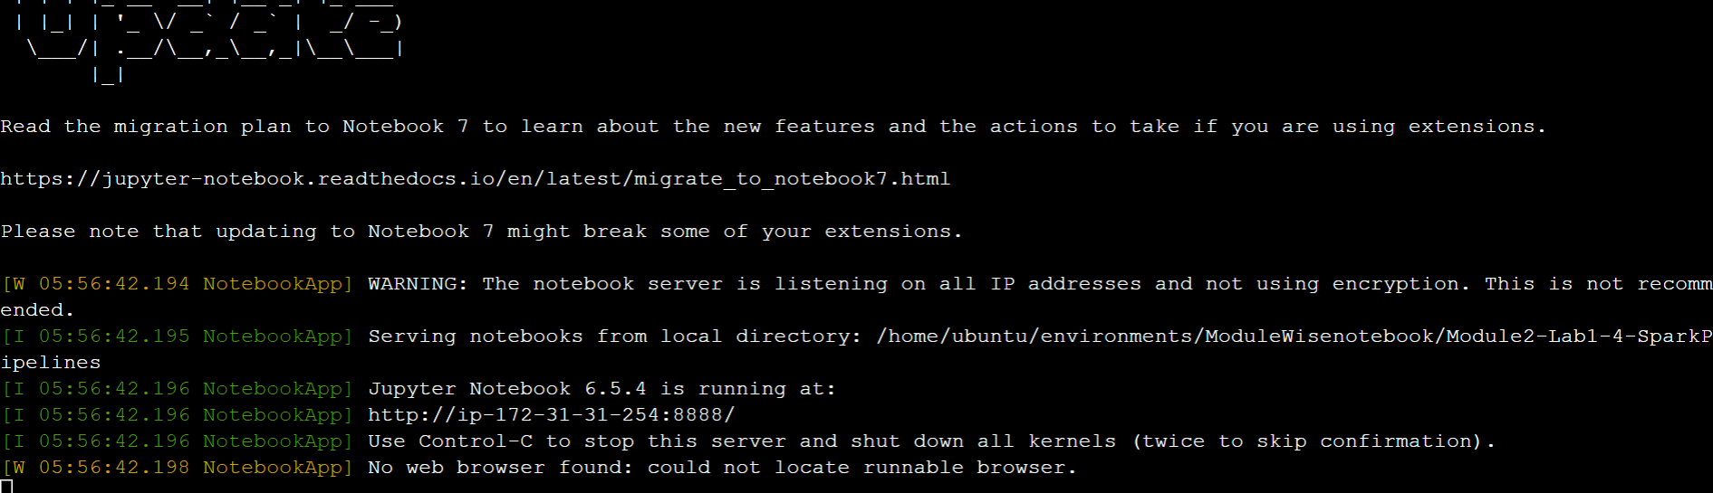

open new tab in browser and enter url <yourpublicip>:8888

press enter

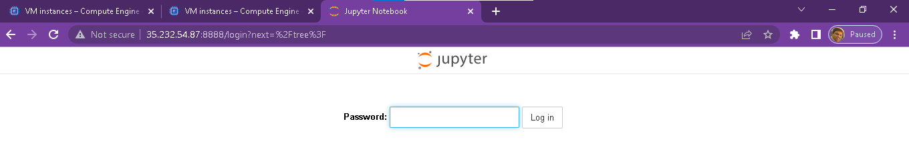

* + enter password 12345

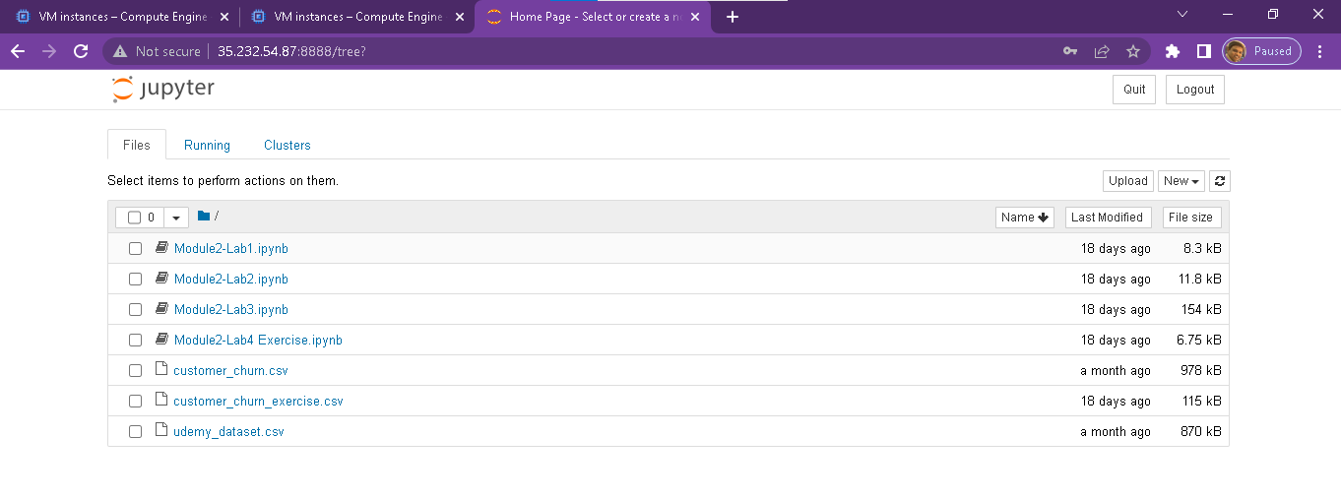

* + click on Module4-Lab1.ipynb
  + it will open file in new browsing window
  + follow the instructions as mentioned in notebook
  + once done close the notebook - by closing browsing tab
* Module4-Lab2.ipynb

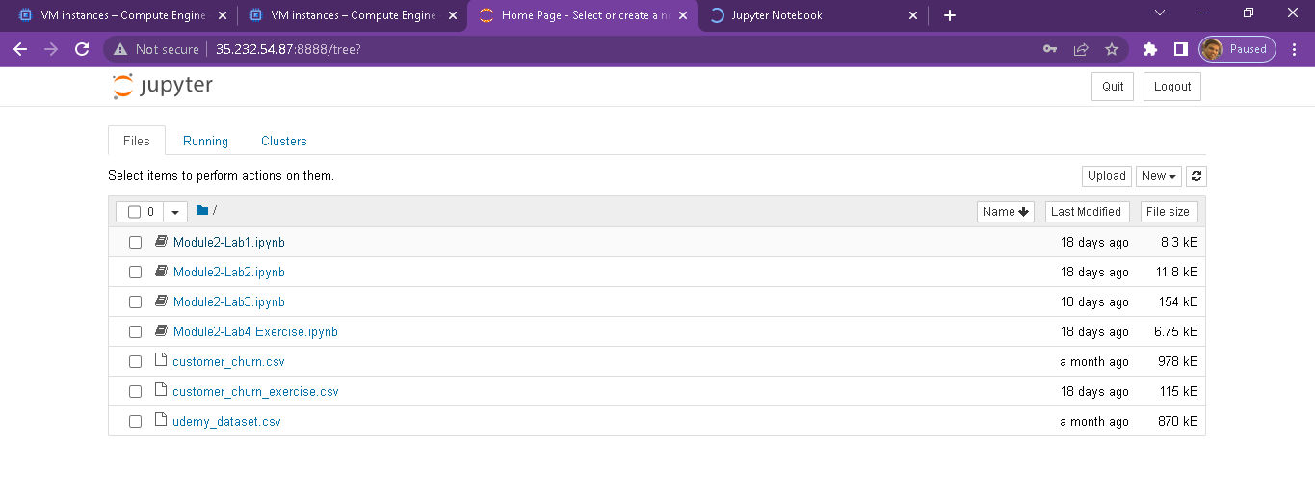

* + click on Module4-Lab2.ipynb
  + it will open file in new browsing window
  + follow the instructions as mentioned in notebook
  + once done close the notebook - by closing browsing tab
* Module4-Lab3.ipynb



* + click on Module4-Lab3.ipynb
  + it will open file in new browsing window
  + follow the instructions as mentioned in notebook
  + once done close the notebook - by closing browsing tab
* Module4-Lab4.ipynb



* + click on Module4-Lab4 Excercises.ipynb
  + it will open file in new browsing window
  + follow the instructions as mentioned in notebook
  + once done close the notebook - by closing browsing tab

Shutdown the jupyter kernel session

* in ec2 conncect window, press ctrl+c key
* type y, to accept shutdown
* it will return to your prompt
* then deactivate virtual environment, by typing command

deactivate

**You are done with Module4-Lab 1,2,3 and 4 !!!**

**For Lab 5,6, and 7 of Module 4, You need to create a new EC2 instance and install Kubernetes and Pachyderm as per the instructions in Appendix 3 and Appendix 4.**

**Once you are ready with new instance follow instructions below to execute the labs 5,6, and 7.**

**Module 4 - Lab 5, 6, and 7**

* Connect to root user of the new instance you have created
* Enable hpepyspark environment by entering

source /home/ubuntu/environments/hpepyspark/bin/activate

jupyter notebook --ip=* --allow-root

to start the jupyter kernel

* open new browser tab and enter url <yourpublicip>:8888

enter password 12345

* Open Module4-Lab5-Intro_to_Pachyderm.ipynb

follow the cell-by-cell execution of file

after successful execution of file. close the browsing tab

* Open Module4-Lab6-Edge_Detection_with_pacyderm.ipynb

follow the cell-by-cell execution of file

after successful execution of file. close the browsing tab

* in jupyter kernel home page

click on Module4-Lab7-ML_Pipeline_Pachyderm

Open ML pipeline for Iris Classification.ipynb

follow the cell-by-cell execution of file

after successful execution of file. close the browsing tab

Resource Clean Up

* Shutdown jupyter kernel
  + press CTRL+C
  + type y
  + it will shutdown running server and give your prompt back
* Delete all
  + pachctl delete all

**You are done with Module 4 - Lab 5,6 ,and 7!!!**

**Module 4 - Lab 8 – PDK Integration**

**For this lab create a ec2 instance with size g4dn.4xlarge with AMI as instructed by the instructor with 200 GB Storage. Once the machine is ready Login as root on EC2 Connect and type the command**

sudo passwd ubuntu

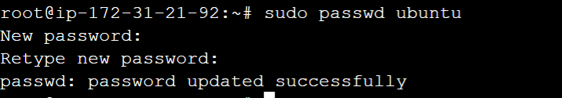

curl ifconfig.me



**Login to RDP using public IP, user and password**

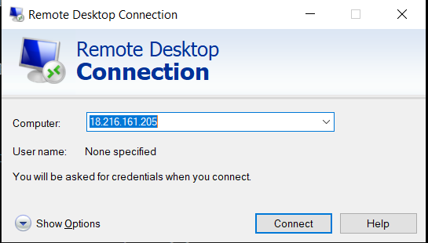

**Once logged into machine open Terminal Application, hit Control + C to avoid screen getting stuck on .bashrc and enter to ubuntu home directory**

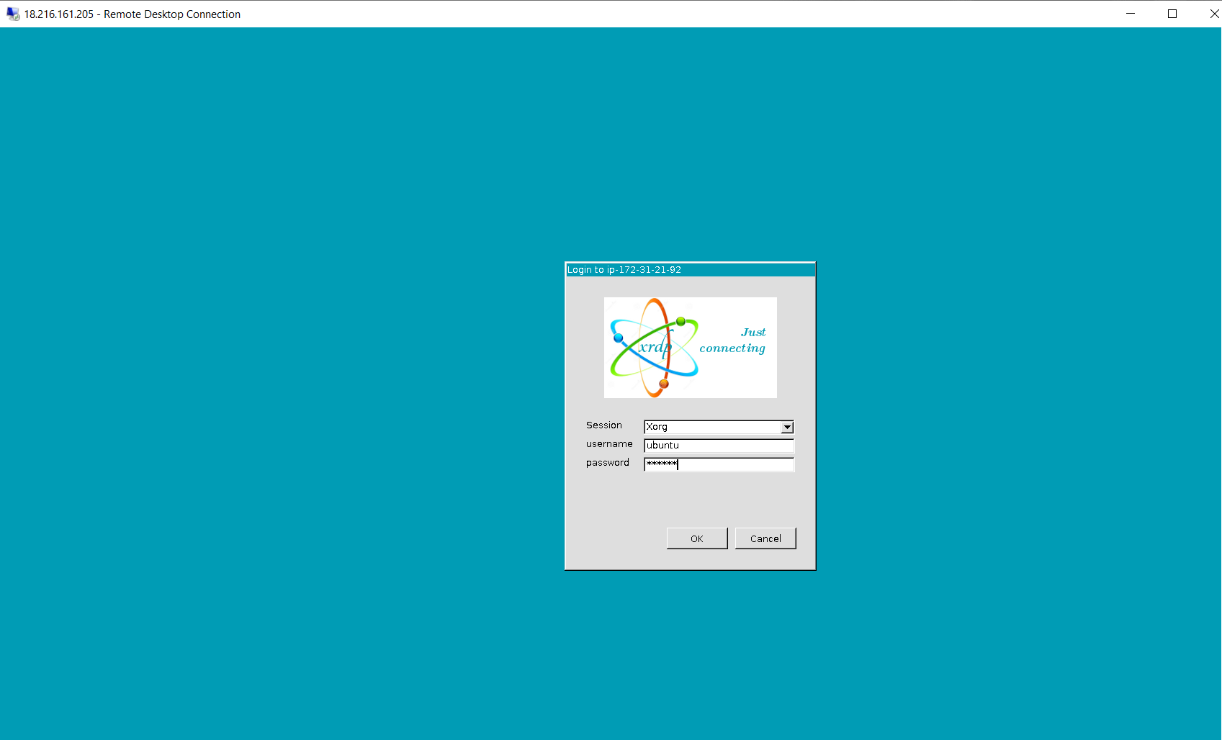

Open terminal from GUI

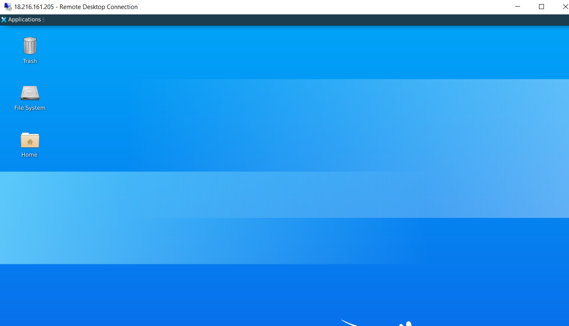

Type following commands on terminal

cd /home/ubuntu

**### Reconfigure Kube Config for root ####**

chmod 600 .kube/config

microk8s config > .kube/config

chmod 400 .kube/config

ls /mnt/efs/shared_fs/

sudo chmod -R 777 /mnt/efs/shared_fs/

sudo find /mnt/efs/shared_fs \( -type d -exec sudo chmod u+rwx,g+rwx,o+rx {} \; -o -type f -exec sudo chmod u+rw,g+rw,o+r {} \; \)

kubectl get nodes

kubectl delete node microk8s

kubectl get nodes

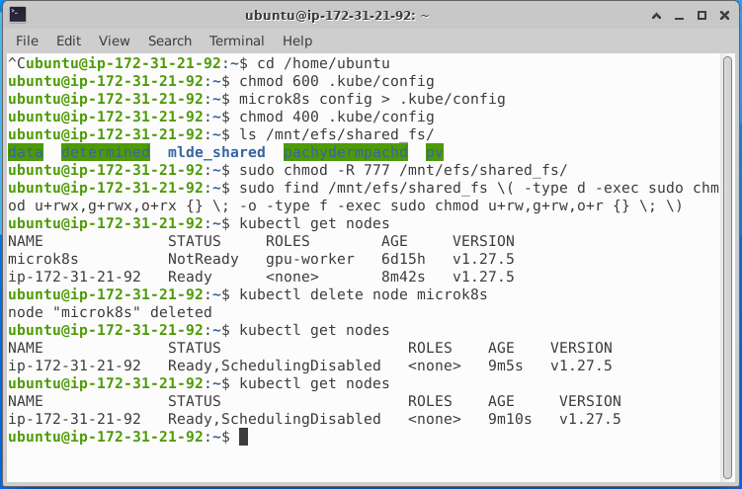

kubectl get pods -A

kubectl get nodes -o custom-columns=NAME:.metadata.name | grep '^ip' | xargs -I {} kubectl label node {} node-role.kubernetes.io/gpu-worker=worker

kubectl get nodes -o custom-columns=NAME:.metadata.name | grep '^ip' | xargs -I {} kubectl label node {} nodegroup-role=gpu-worker

kubectl get nodes --show-labels | grep -i gpu

kubectl get pods

kubectl get svc

kubectl run psql -it --rm=true --image=postgres:13 --env=PGPASSWORD=your-database-password --command -- psql -h postgres-service -U postgres postgres

**### Hit "Enter" if you don't see a prompt for SQL, Paste below steps one by one ###**

CREATE DATABASE pachyderm;

CREATE DATABASE dex;

CREATE DATABASE determined;

GRANT ALL PRIVILEGES ON DATABASE pachyderm TO postgres;

GRANT ALL PRIVILEGES ON DATABASE dex TO postgres;

GRANT ALL PRIVILEGES ON DATABASE determined TO postgres;

\q

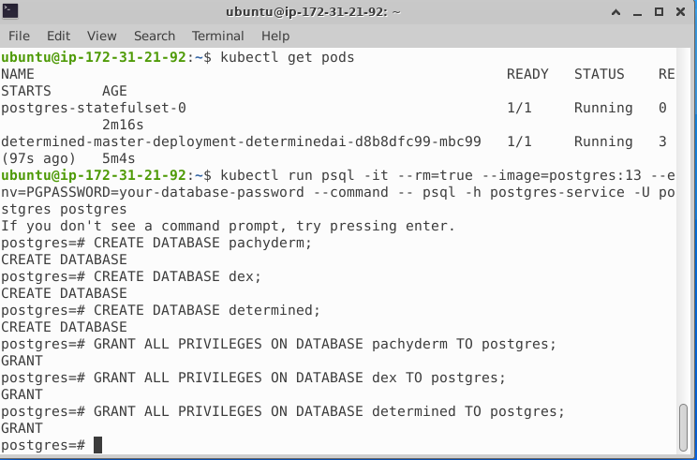

kubectl get pods -A

**### Hit Control and C if getting Stuck #####**

**### Go to browser and verify Pachyderm and Determined (user admin, password blank) are opening in FireFox browser, remove all unwanted projects if any are present #####**

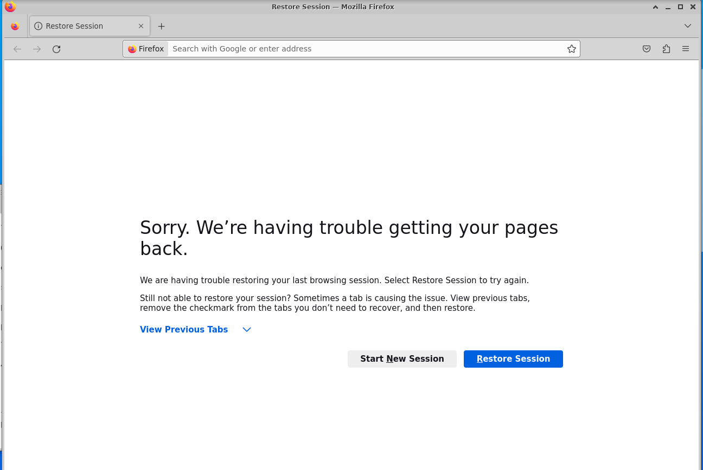

Open both GUI’s of Pachyderm (http://192.168.0.105:9090/) and determined(http://192.168.0.107:8080/)

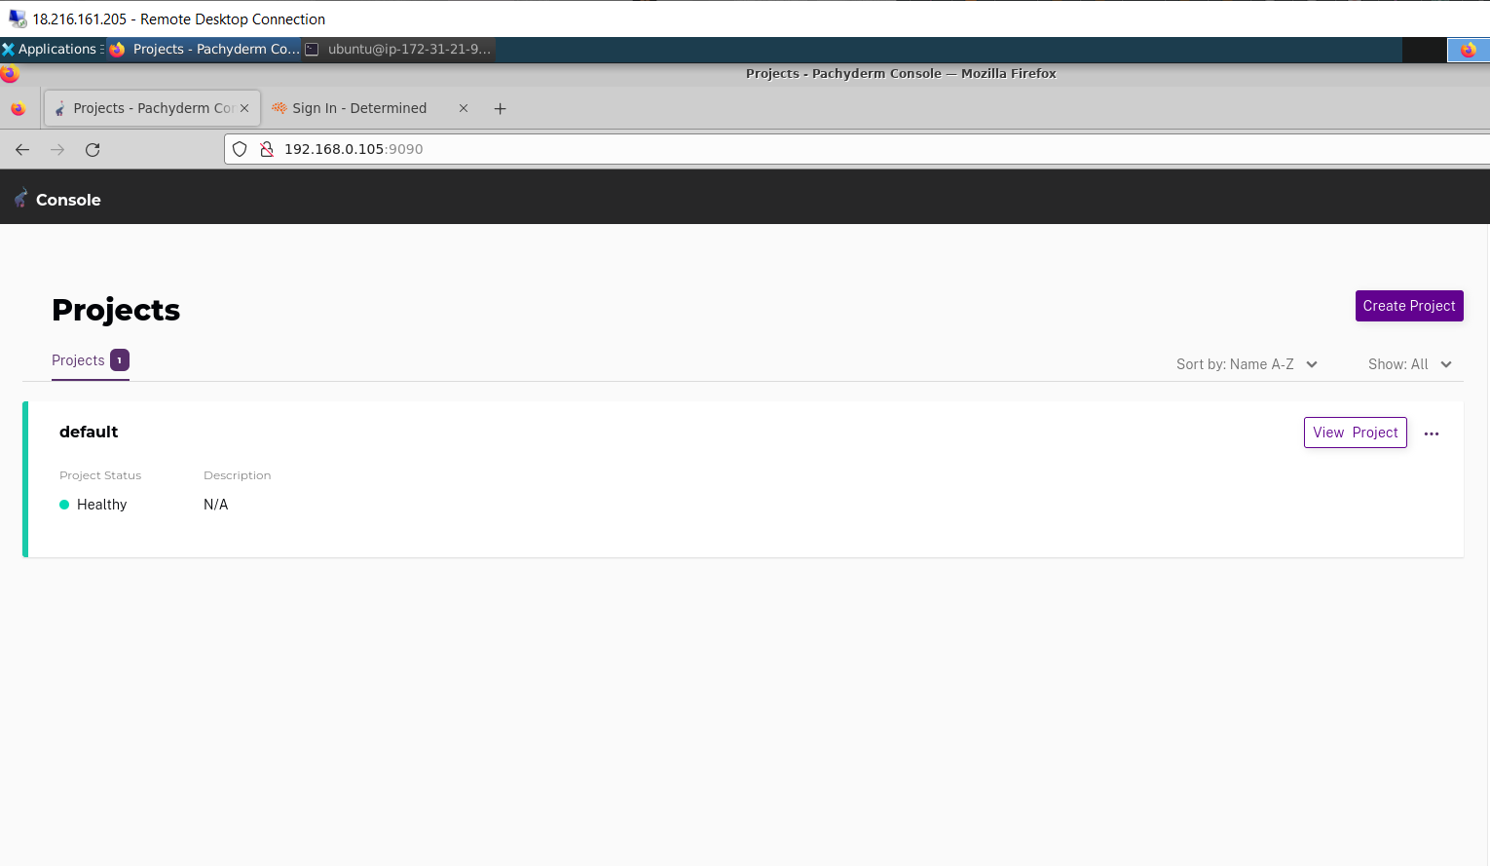

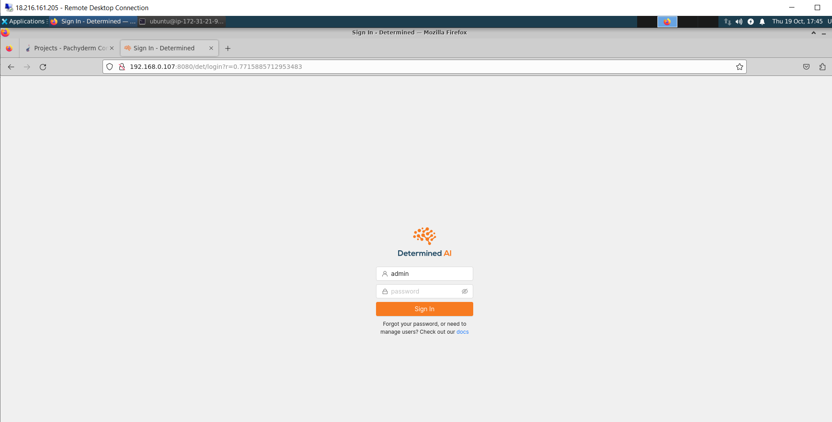

Login with user name admin and keep password blank

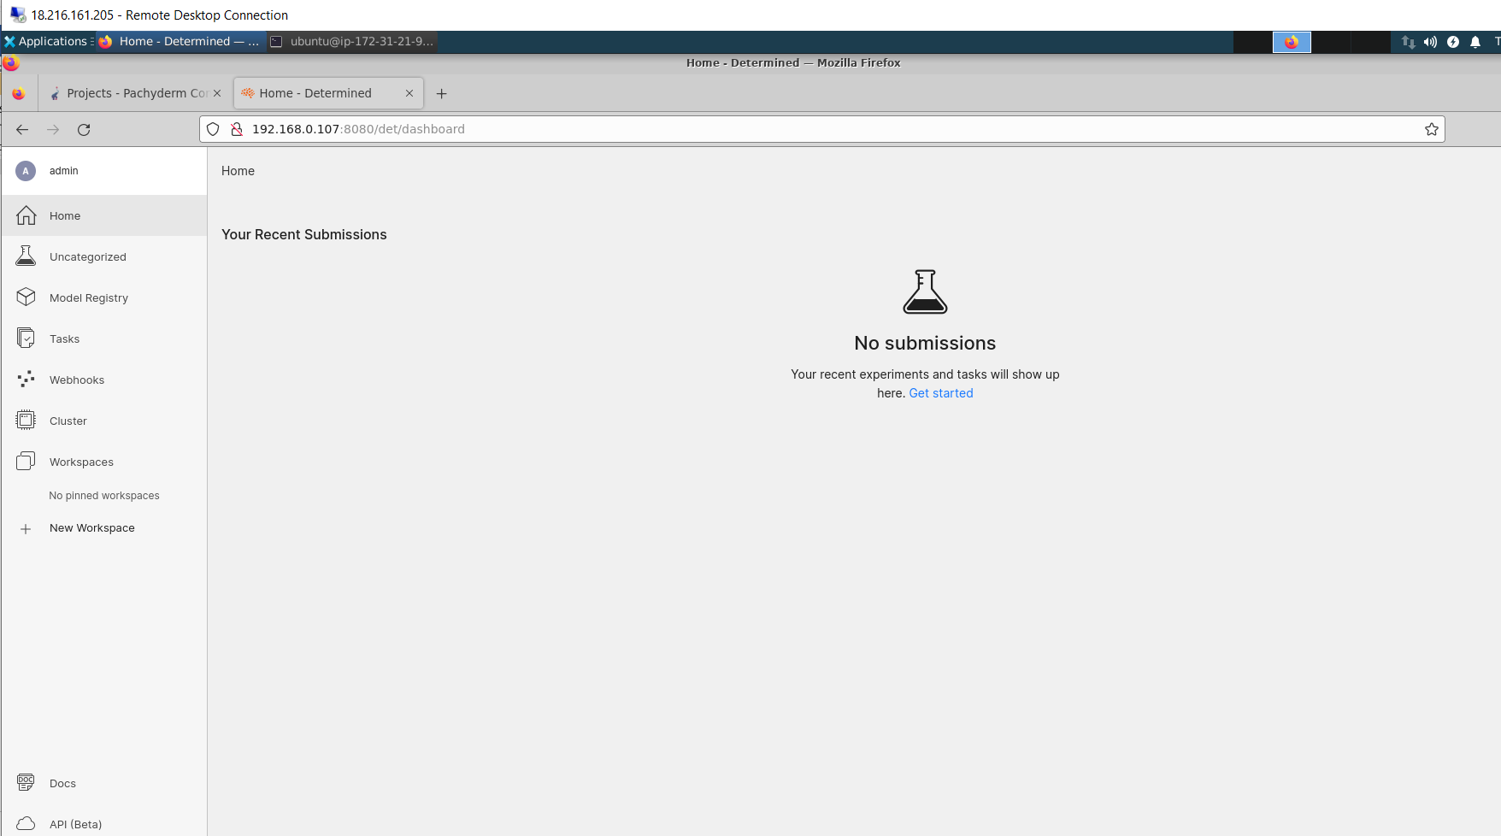

**#### create a newfile and add the below code, Control + S and Control + X to save nano #####**

**Open terminal and copy the below code**

nano setenv.sh

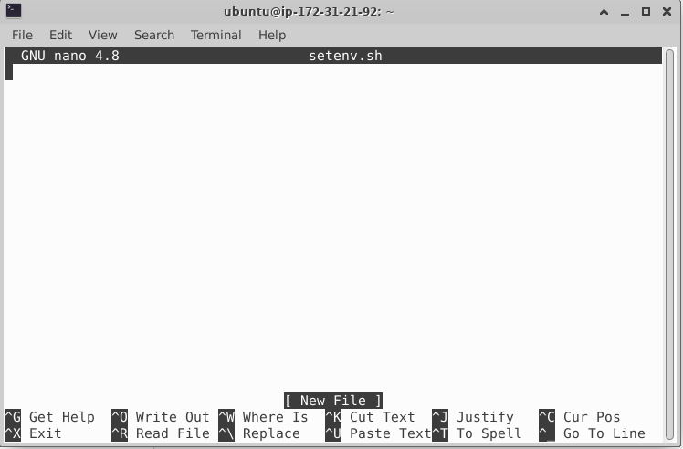

Copy the below code and save the file

#!/bin/bash

export NAME="your-name-pdk"

export DB_CONNECTION_STRING="postgres-service.default.svc.cluster.local."

export DB_ADMIN_PASSWORD="your-database-password"

export MLDM_NAMESPACE="pachyderm"

export KSERVE_MODELS_NAMESPACE="models"

export MLDM_HOST=$(kubectl get svc --namespace ${MLDM_NAMESPACE} pachyderm-proxy --output jsonpath='{.status.loadBalancer.ingress[0].ip}')

export MLDM_URL="http://${MLDM_HOST}:9090"

echo $MLDM_URL

export MLDE_HOST=$(kubectl get svc determined-master-service-determinedai --output jsonpath='{.status.loadBalancer.ingress[0].ip}')

export MLDE_URL="http://${MLDE_HOST}:8080"

echo $MLDE_URL

export DET_MASTER=${MLDE_HOST}:8080

echo $DET_MASTER

export INGRESS_HOST=$(kubectl -n istio-system get service istio-ingressgateway -o jsonpath='{.status.loadBalancer.ingress[0].ip}')

export INGRESS_PORT=$(kubectl -n istio-system get service istio-ingressgateway -o jsonpath='{.spec.ports[?(@.name=="http2")].port}')

export SERVICE_HOSTNAME=$(kubectl get inferenceservice sklearn-iris -n ${KSERVE_MODELS_NAMESPACE} -o jsonpath='{.status.url}' | cut -d "/" -f 3)

echo $INGRESS_HOST

echo $INGRESS_PORT

echo $SERVICE_HOSTNAME

export MLDE_SVC=determined-master-service-determinedai.default.svc.cluster.local

export MLDM_SVC=pachyderm-proxy.${MLDM_NAMESPACE}.svc.cluster.local

export AZ_REGION=$(kubectl get cm pdk-config -o=jsonpath='{.data.region}') && echo $AZ_REGION

export MLDM_NAMESPACE=$(kubectl get cm pdk-config -o=jsonpath='{.data.mldm_namespace}') && echo $MLDM_NAMESPACE

export MLDM_BUCKET_NAME=$(kubectl get cm pdk-config -o=jsonpath='{.data.mldm_bucket_name}') && echo $MLDM_BUCKET_NAME

export MLDM_HOST=$(kubectl get cm pdk-config -o=jsonpath='{.data.mldm_host}') && echo $MLDM_HOST

export MLDM_PORT=$(kubectl get cm pdk-config -o=jsonpath='{.data.mldm_port}') && echo $MLDM_PORT

export MLDM_URL=$(kubectl get cm pdk-config -o=jsonpath='{.data.mldm_url}') && echo $MLDM_URL

export MLDM_PIPELINE_SECRET=$(kubectl get cm pdk-config -o=jsonpath='{.data.mldm_pipeline_secret}') && echo $MLDM_PIPELINE_SECRET

export MLDE_BUCKET_NAME=$(kubectl get cm pdk-config -o=jsonpath='{.data.mlde_bucket_name}') && echo $MLDE_BUCKET_NAME

export MLDE_HOST=$(kubectl get cm pdk-config -o=jsonpath='{.data.mlde_host}') && echo $MLDE_HOST

export MLDE_PORT=$(kubectl get cm pdk-config -o=jsonpath='{.data.mlde_port}') && echo $MLDE_PORT

export MLDE_URL=$(kubectl get cm pdk-config -o=jsonpath='{.data.mlde_url}') && echo $MLDE_URL

export MODEL_ASSETS_BUCKET_NAME=$(kubectl get cm pdk-config -o=jsonpath='{.data.kserve_model_bucket_name}') && echo $MODEL_ASSETS_BUCKET_NAME

export KSERVE_MODELS_NAMESPACE=$(kubectl get cm pdk-config -o=jsonpath='{.data.kserve_model_namespace}') && echo $KSERVE_MODELS_NAMESPACE

export INGRESS_HOST=$(kubectl get cm pdk-config -o=jsonpath='{.data.kserve_ingress_host}') && echo $INGRESS_HOST

export INGRESS_PORT=$(kubectl get cm pdk-config -o=jsonpath='{.data.kserve_ingress_port}') && echo $INGRESS_PORT

export DB_CONNECTION_URL=$(kubectl get cm pdk-config -o=jsonpath='{.data.db_connection_string}') && echo $DB_CONNECTION_URL

export REGISTRY_URI=$(kubectl get cm pdk-config -o=jsonpath='{.data.registry_uri}') && echo $REGISTRY_URI

export NAME=$(kubectl get cm pdk-config -o=jsonpath='{.data.pdk_name}') && echo $NAME

######################################################################################################

**Now Execute following commands one by one on the terminal**

chmod +x setenv.sh

source setenv.sh

sudo pip3 install determined

det w create "PDK Demos"

det p create "PDK Demos" pdk-dogs-and-cats

pachctl connect ${MLDM_URL}

pachctl config set active-context ${MLDM_URL}

pachctl create project pdk-dogs-and-cats

pachctl config update context --project pdk-dogs-and-cats

pachctl create repo dogs-and-cats-data

pachctl list repo

cd /home/ubuntu/pdk/examples/dog-cat/pipelines

pachctl create pipeline -f _on_prem_training-pipeline.json

kubectl get pods -n pachyderm

kubectl patch replicationcontroller pdk-dogs-and-cats-dogs-and-cats-model-v1 -n pachyderm --type='json' -p='[

{

"op": "remove",

"path": "/spec/template/spec/containers/0/resources/requests/cpu"

},

{

"op": "remove",

"path": "/spec/template/spec/containers/0/resources/requests/memory"

},

{

"op": "remove",

"path": "/spec/template/spec/containers/1/resources/requests/cpu"

},

{

"op": "remove",

"path": "/spec/template/spec/containers/1/resources/requests/memory"

},

{

"op": "remove",

"path": "/spec/template/spec/initContainers/0/resources/requests/cpu"

},

{

"op": "remove",

"path": "/spec/template/spec/initContainers/0/resources/requests/memory"

}

]'

kubectl scale replicationcontroller pdk-dogs-and-cats-dogs-and-cats-model-v1 -n pachyderm --replicas=0

kubectl get pods -n pachyderm -l app=pipeline,component=worker,pipelineName=dogs-and-cats-model,pipelineProject=pdk-dogs-and-cats,pipelineVersion=1

pachctl create pipeline -f _on_prem_deployment-pipeline.json

pachctl list pipeline

kubectl patch replicationcontroller pdk-dogs-and-cats-dogs-and-cats-deploy-v1 -n pachyderm --type='json' -p='[

{

"op": "remove",

"path": "/spec/template/spec/containers/0/resources/requests/cpu"

},

{

"op": "remove",

"path": "/spec/template/spec/containers/0/resources/requests/memory"

},

{

"op": "remove",

"path": "/spec/template/spec/containers/1/resources/requests/cpu"

},

{

"op": "remove",

"path": "/spec/template/spec/containers/1/resources/requests/memory"

},

{

"op": "remove",

"path": "/spec/template/spec/initContainers/0/resources/requests/cpu"

},

{

"op": "remove",

"path": "/spec/template/spec/initContainers/0/resources/requests/memory"

}

]'

kubectl scale replicationcontroller pdk-dogs-and-cats-dogs-and-cats-deploy-v1 -n pachyderm --replicas=0

kubectl get pods -n pachyderm -l app=pipeline,component=worker,pipelineName=dogs-and-cats-deploy,pipelineProject=pdk-dogs-and-cats,pipelineVersion=1

kubectl get pods -n pachyderm

pachctl list pipelines

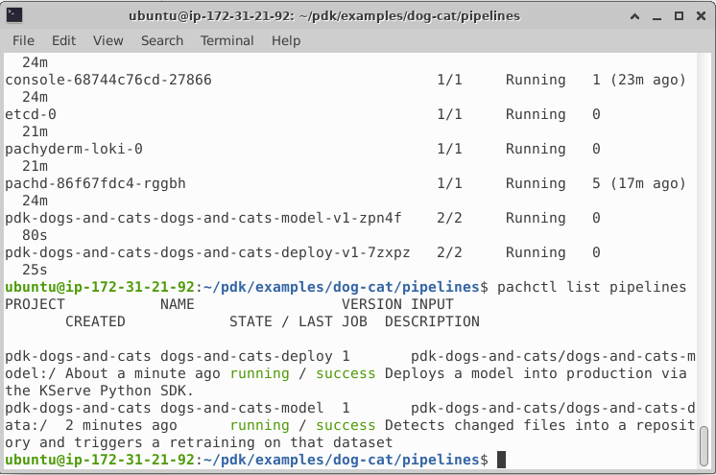

**#### Verify the pipelines are running in firefox and Jobs are success in GUI ####**

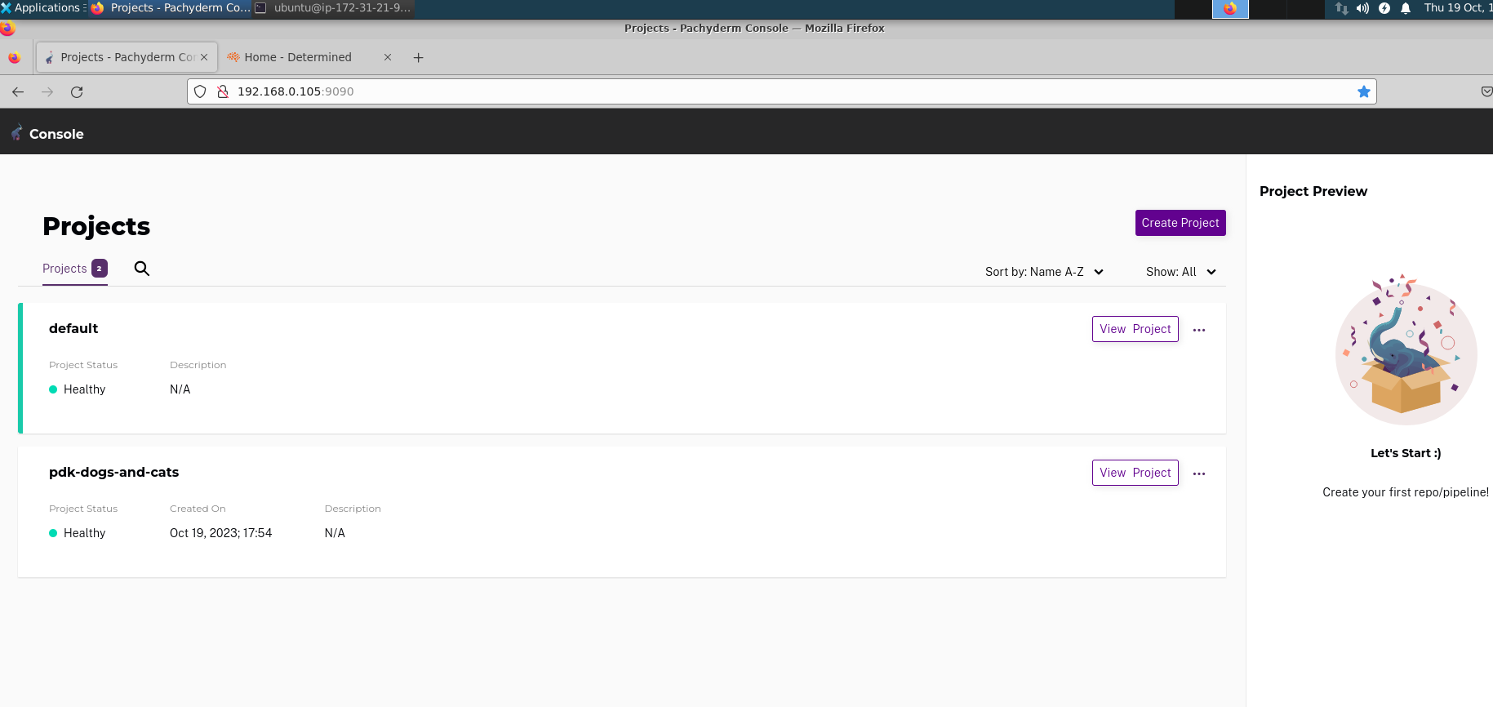

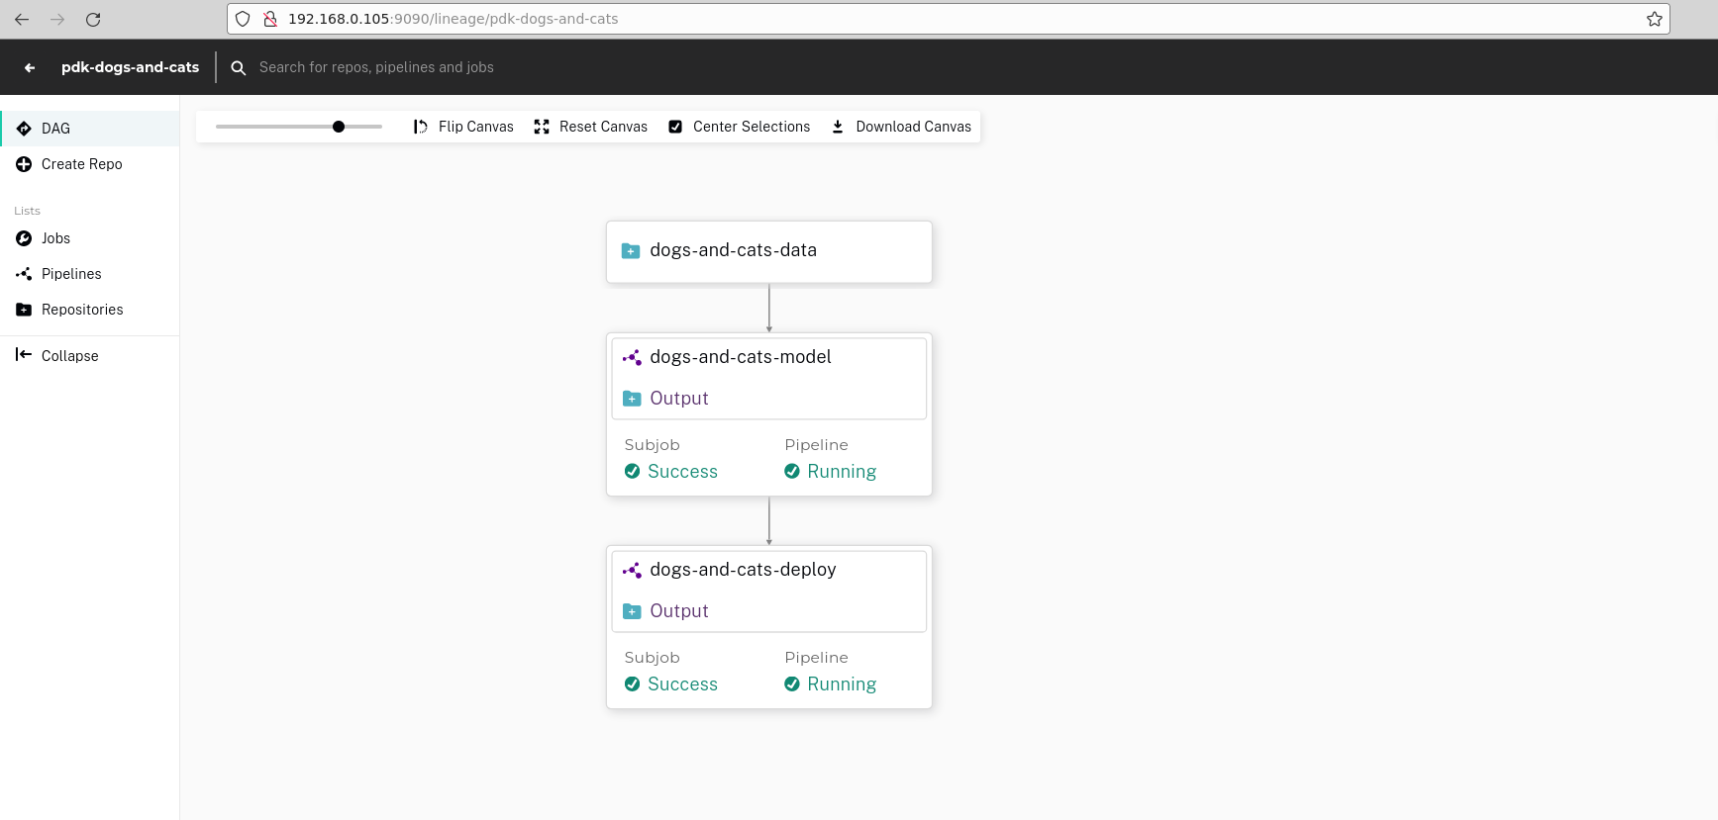

**Now Execute following commands one by one on the terminal**

cd /home/ubuntu/pdk/examples/dog-cat/sample-data

pachctl put file dogs-and-cats-data@master:/data1 -f ./dog-cat -r

pachctl list commits

kubectl get pods -A

**Now the pipeline starts executing, we have loaded repo with data**

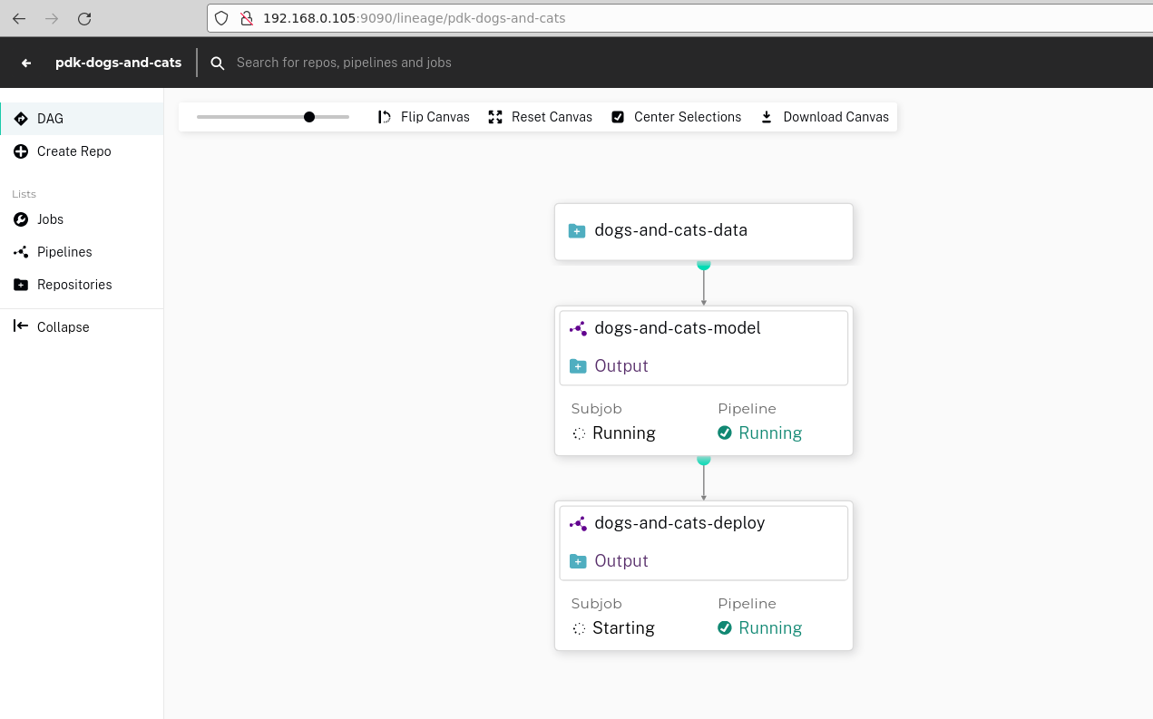

**### See the experiment runs in GUI of dertermined ####**

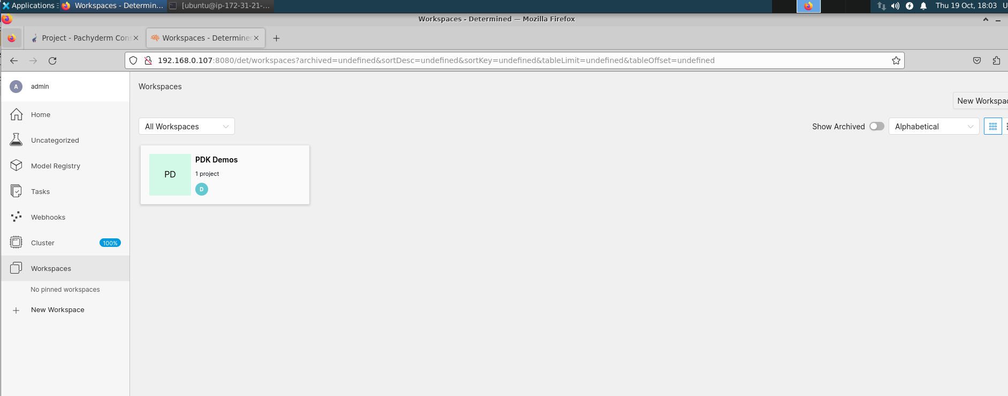

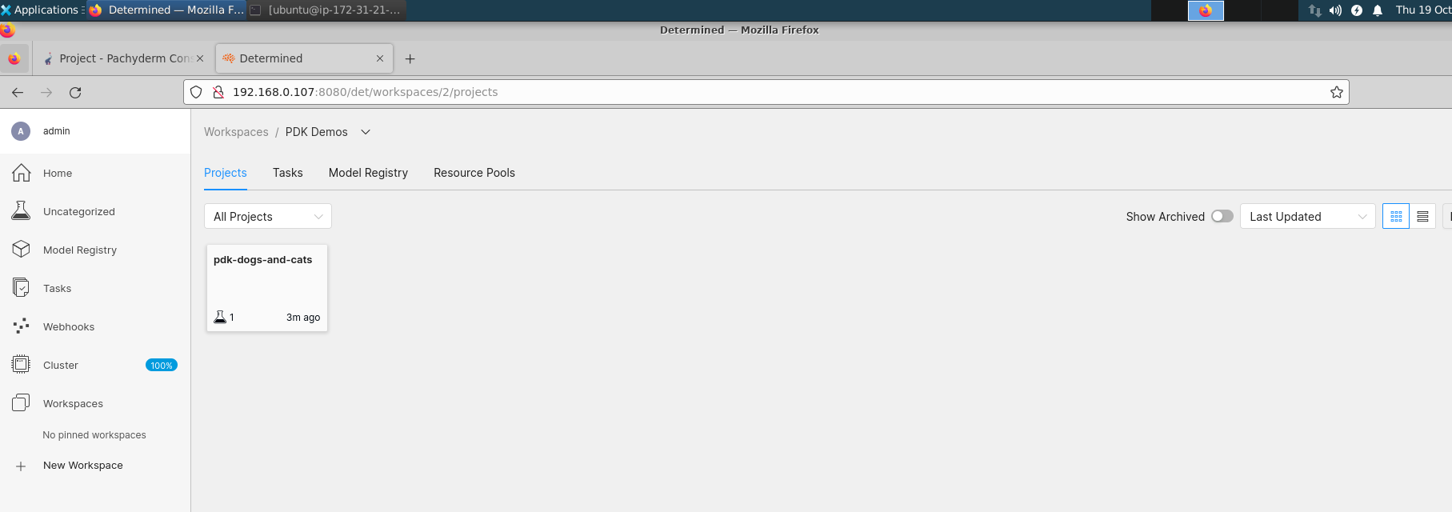

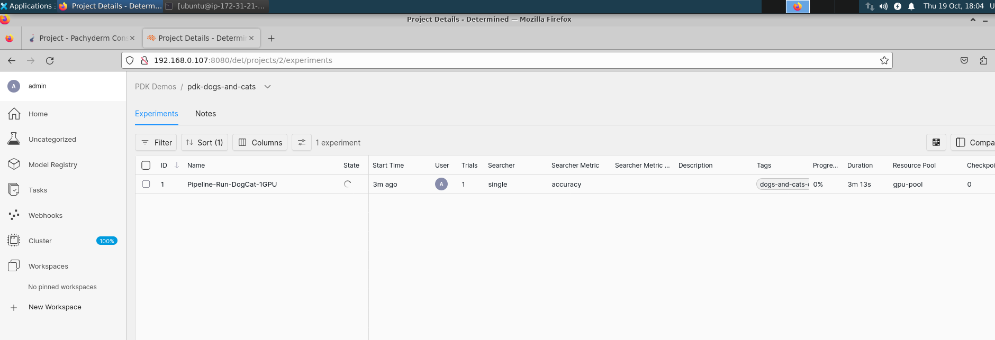

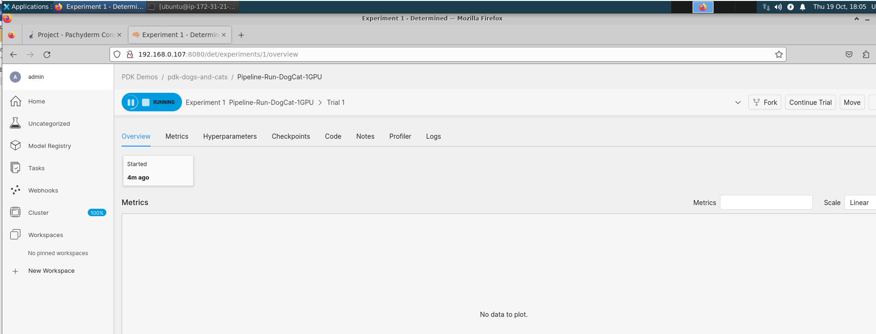

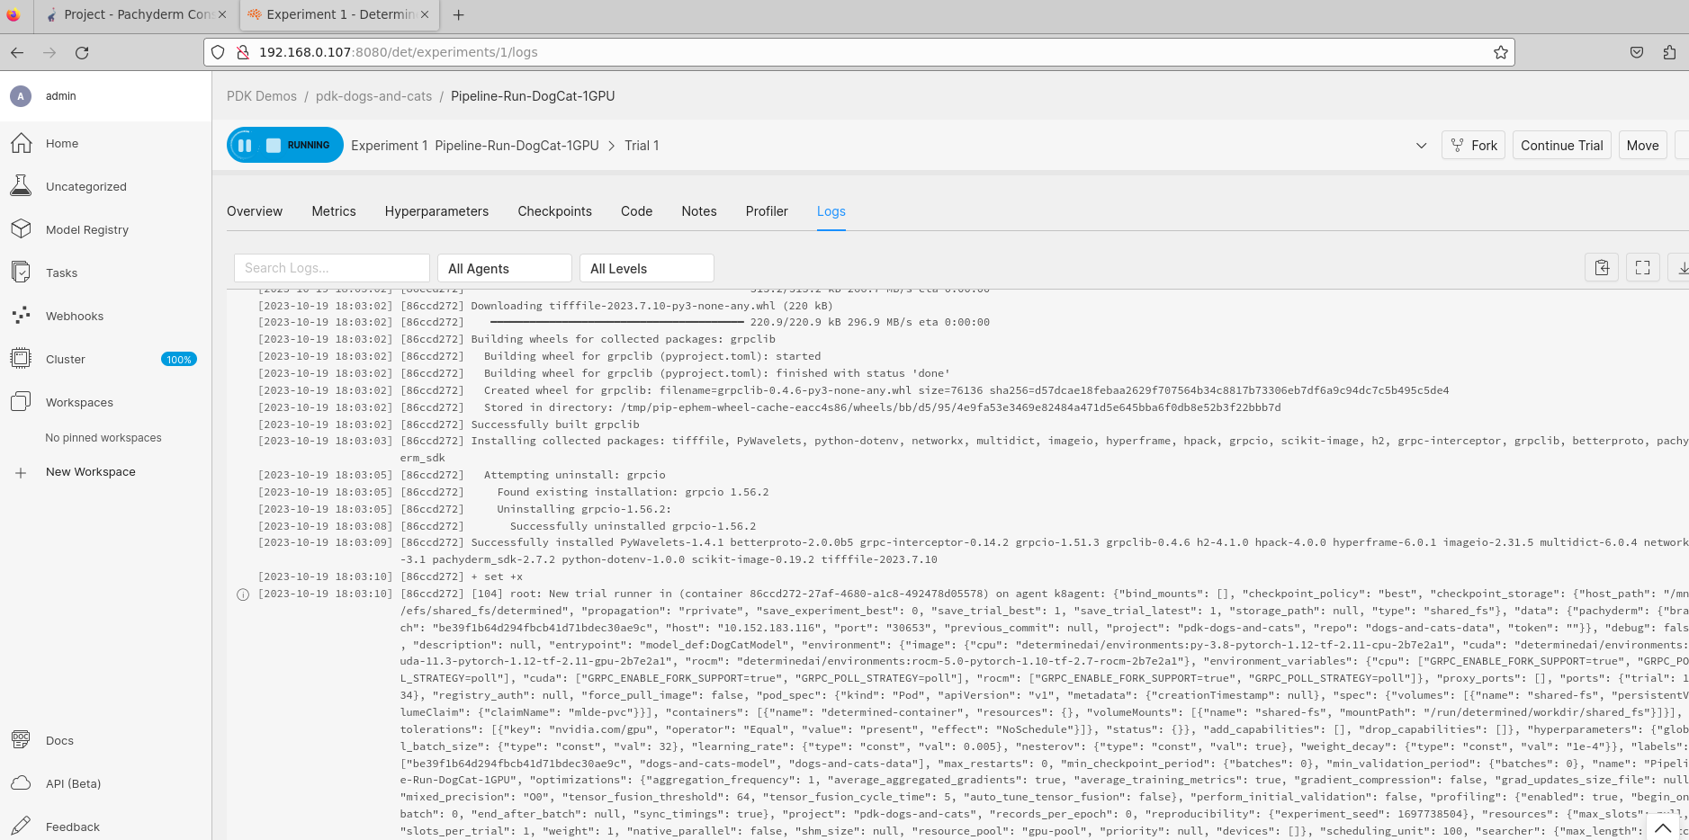

**Once the training is over the determined GUI look like**

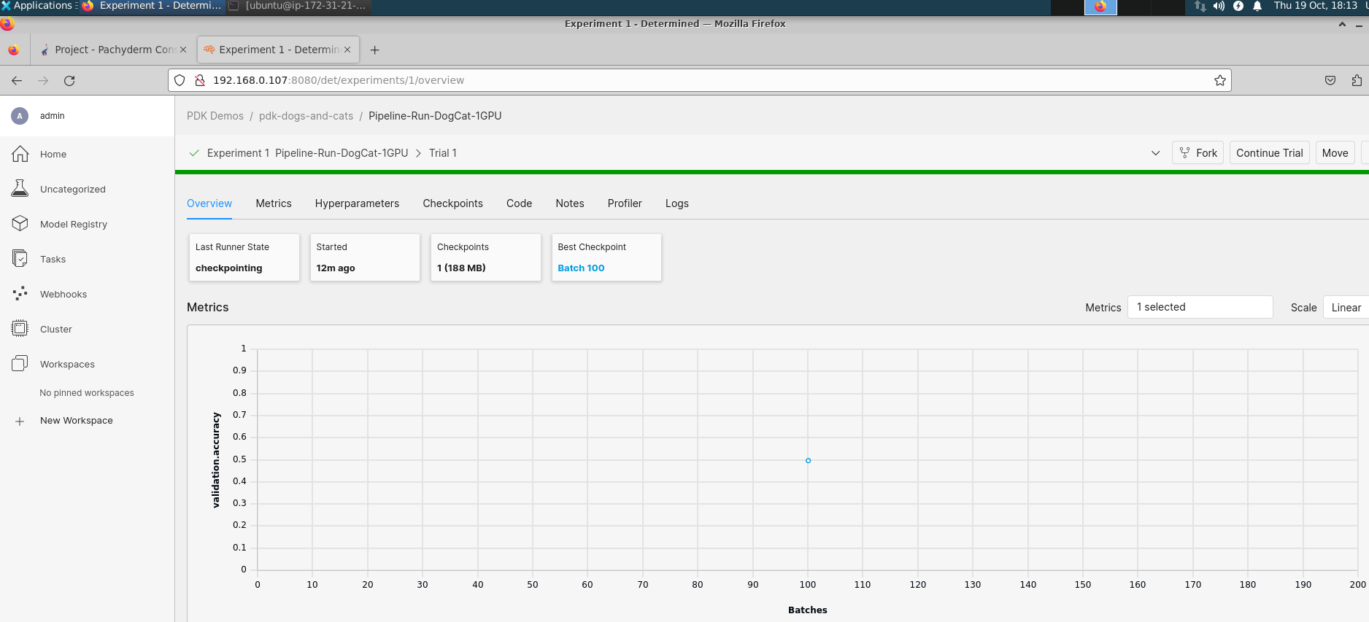

**The pachyderm GUI look like following now the deployment pipeline will start executing it uses K-Serve to deploy the trained model on the Kubernetes cluster.**

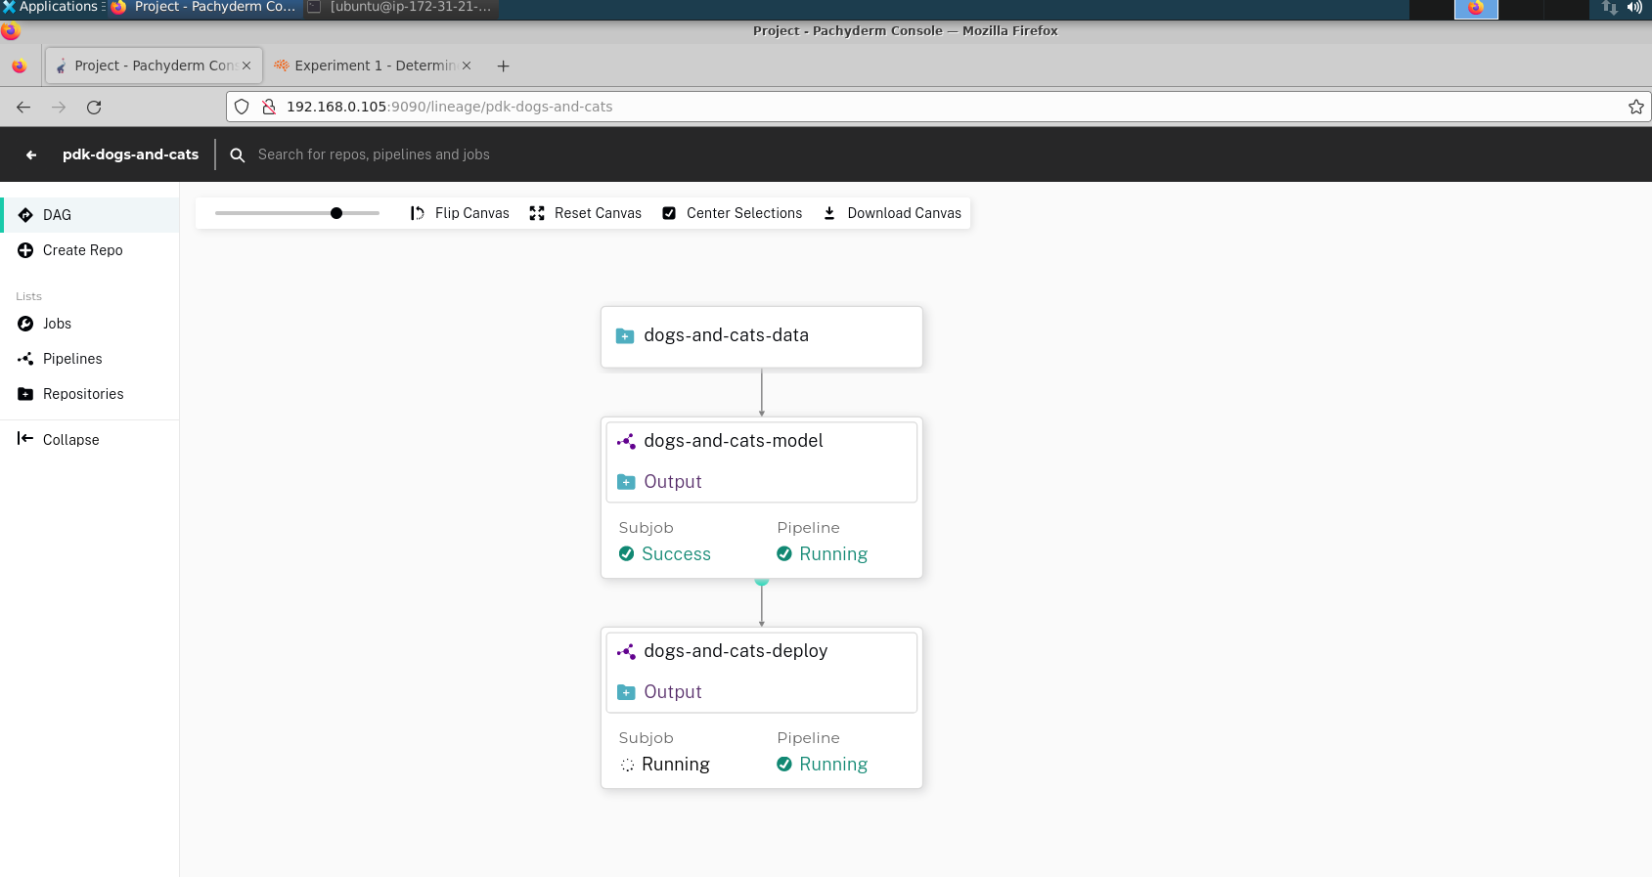

**Once the deployment is success the pipeline looks like**

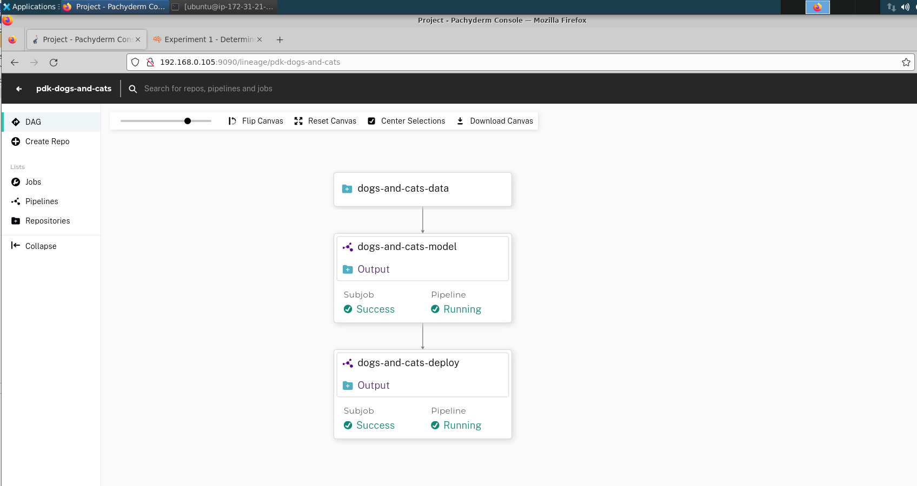

**### Now you can access the deployed models using curl command on the terminal ####**

kubectl -n ${KSERVE_MODELS_NAMESPACE} get inferenceservices



curl -v -H "Host: dogcat-deploy.models.example.com" http://${INGRESS_HOST}:${INGRESS_PORT}/v1/models/dogs-and-cats:predict -d @./cat.json | jq

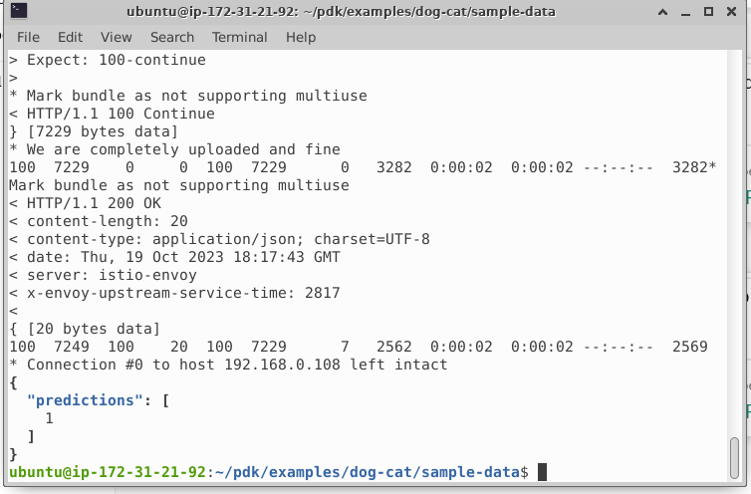

curl -v -H "Host: dogcat-deploy.models.example.com" http://${INGRESS_HOST}:${INGRESS_PORT}/v1/models/dogs-and-cats:predict -d @./dog.json | jq

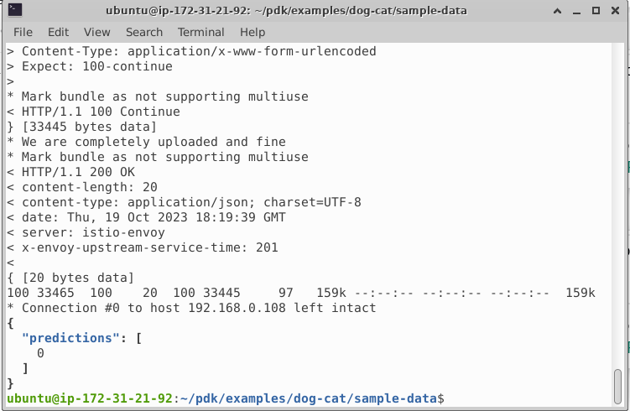

**Appendix 1**

**Install Necessary Applications and Packages for Lab Environments**

Step 1: Update

sudo apt update

sudo apt-get upgrade

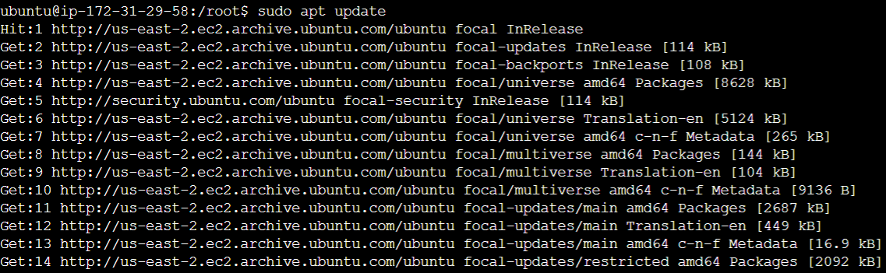

These commands will update the system packages to the latest versions. This is important to do before installing any new software, as it ensures that you are using the most up-to-date versions of the dependencies.

Step 2: Spark Env

sudo apt install -y python3.8

sudo apt install -y pip

sudo apt install -y build-essential libssl-dev libffi-dev python3-dev

sudo apt install -y python3-venv

mkdir environments

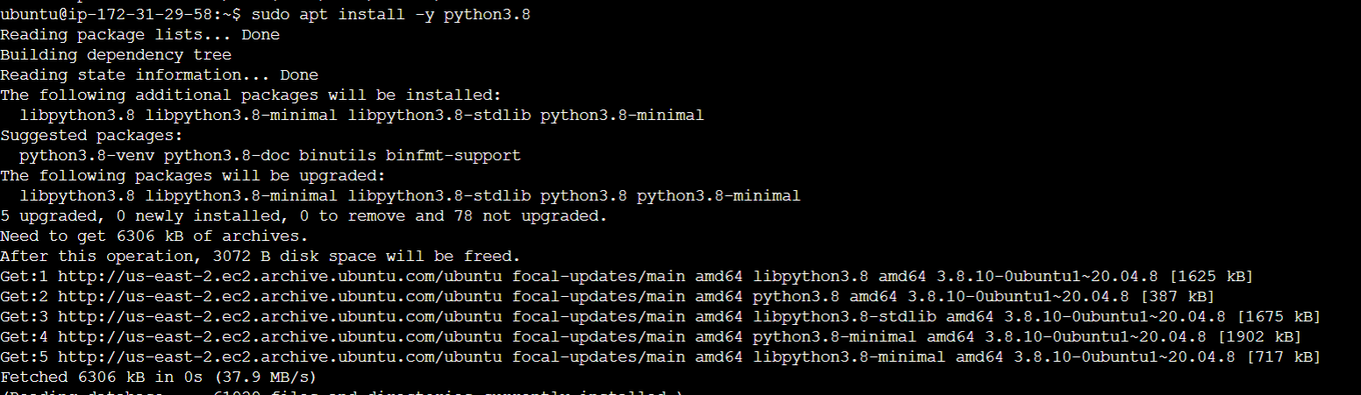

These commands will install Python 3.8, pip, and other dependencies needed for Spark. They will also create a directory called environments to store virtual environments.

Step 3: JDK 8

sudo apt-get update

sudo apt-get install -y openjdk-8-jdk

export JAVA_HOME=/usr/lib/jvm/java-8-openjdk-amd64

These commands will install Java 8 and set the JAVA_HOME environment variable. Java 8 is required for Spark to run.

Step 4: Spark 3.1.2

wget https://archive.apache.org/dist/spark/spark-3.1.2/spark-3.1.2-bin-hadoop3.2.tgz

sudo mkdir /opt/spark

sudo tar -xf spark*.tgz -C /opt/spark --strip-component 1

sudo chmod -R 777 /opt/spark

echo "export SPARK_HOME=/opt/spark" >> ~/.bashrc

echo "export PATH=$PATH:$SPARK_HOME/bin:$SPARK_HOME/sbin" >> ~/.bashrc

echo "export PYSPARK_PYTHON=/usr/bin/python3" >> ~/.bashrc

source ~/.bashrc

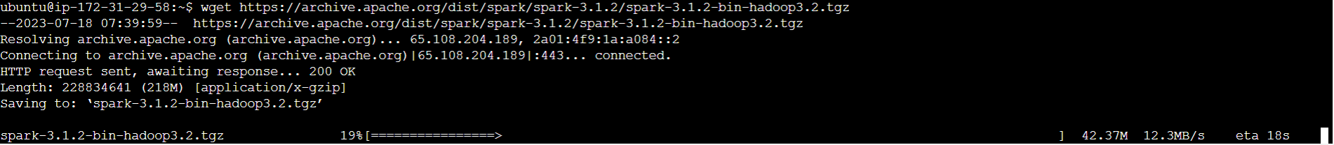

These commands will download Spark 3.1.2, extract it to the /opt/spark directory, and set the SPARK_HOME, PATH, and PYSPARK_PYTHON environment variables. The SPARK_HOME environment variable tells the system where Spark is installed. The PATH environment variable tells the system where to look for Spark commands. The PYSPARK_PYTHON environment variable tells the system which Python interpreter to use for Spark commands.

Step 5: Spark Env

cd environments

python3 -m venv hpepyspark

source hpepyspark/bin/activate

pip install pandas

pip install numpy==1.20

pip install scikit-learn

pip install matplotlib

pip install seaborn

pip install tensorflow

pip install findspark

pip install pyspark==3.1.2

pip install jupyter

deactivate

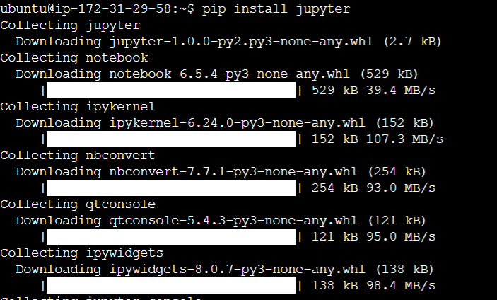

These commands will create a virtual environment called hpepyspark and install the necessary Python packages for Spark. A virtual environment is a way to isolate Python packages from the rest of the system. This is useful for keeping different projects' dependencies separate.deactivate will deactivate the hpepyspark virtual environment. This is useful if you want to switch to a different virtual environment or if you want to exit the shell.

Step 7: SmartSim

SmartSim Env

python3 -m venv hpesmartsim

source hpesmartsim/bin/activate

pip install matplotlib

pip install -U tensorflow==2.5.2

pip install smartsim

sudo apt-get install git-lfs

sudo snap install cmake --classic

smart build --device cpu --no_pt

pip install tensorflow==2.5.2

pip install Jinja2==3.0.3

pip install markupsafe==2.0.1

pip install jupyter

deactivate

These commands will create a virtual environment called hpesmartsim and install the necessary Python packages for SmartSim. SmartSim is a machine learning platform that can be used to train and deploy machine learning models.

**Appendix 2**

**Open Jupyter Notebook**

Step 1: Login to Console

**If using EC2 Instance Connect - follow step no 2 - 4**

**else**

**if using Putty - then skip step no 2-4 and directly jump to step no 5**

Step 2: Click on EC2. It will redirect to EC2 Dashboard. Click on Instances (Running)

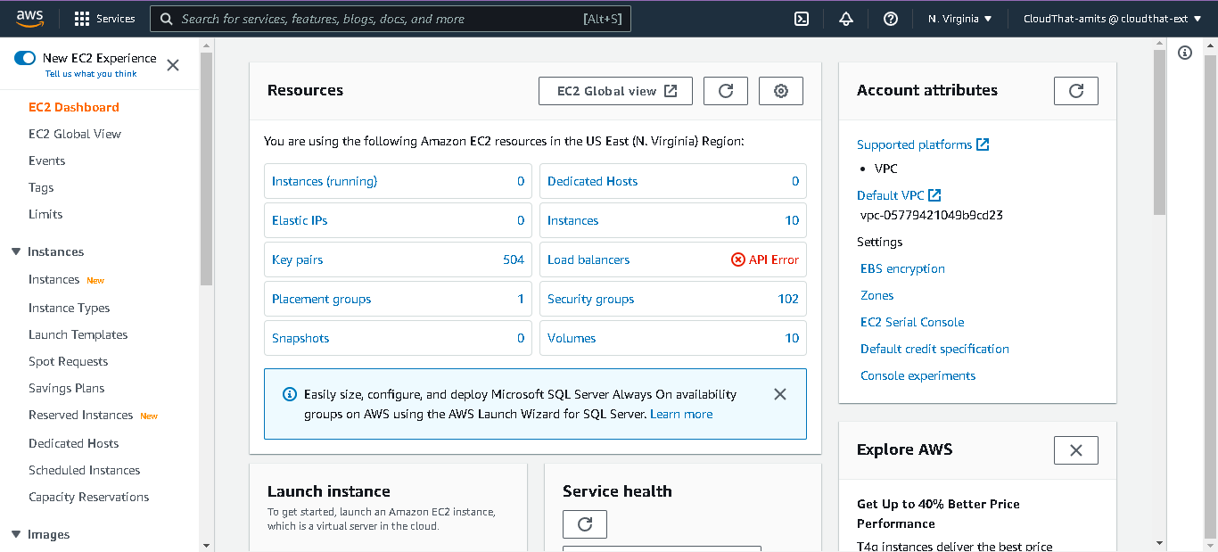

Step 3: It shows you running instances. Scroll vertically and locate your instance with name *“<yourfirstname>hpe”* click on Instance ID

Step 4: Click on Connect

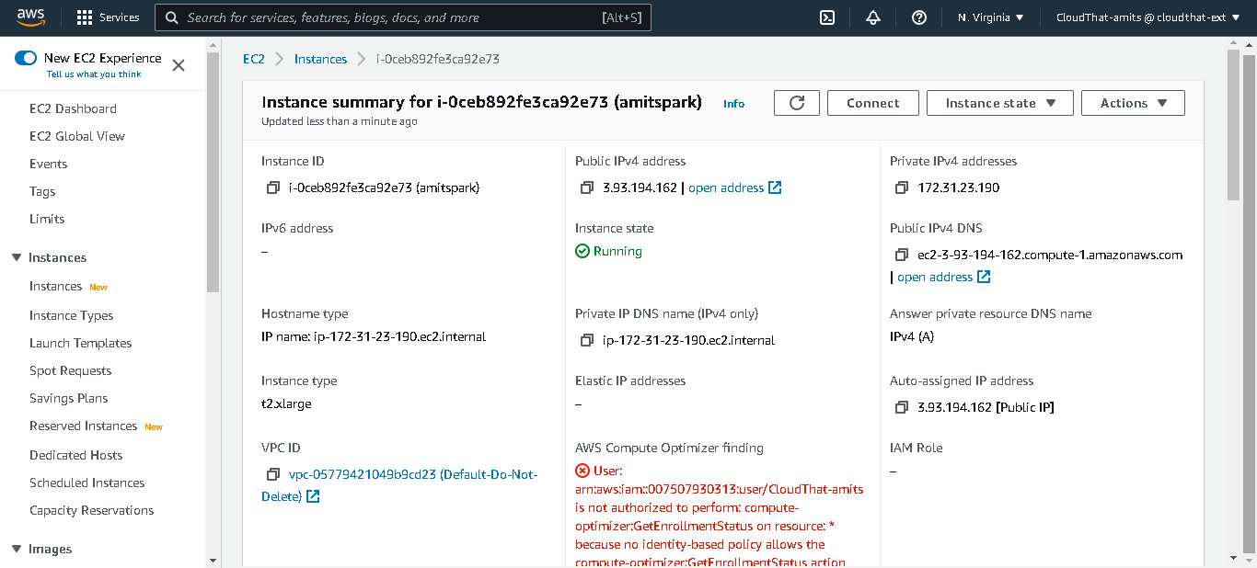

Again, Click on Connect

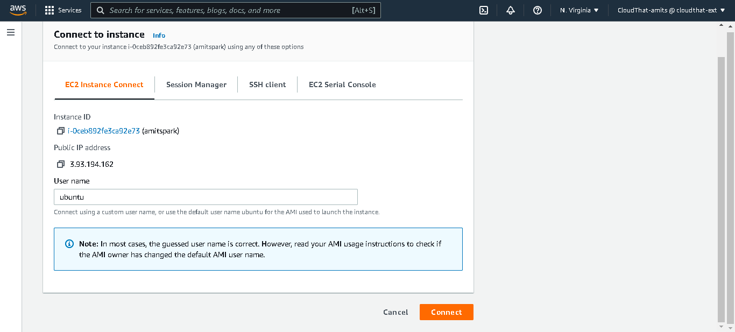

Step 5: open putty

Enter Public Ip address

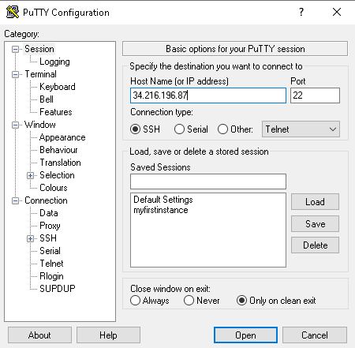

Click on Connection from category pane and enter 180 in Seconds between keepalive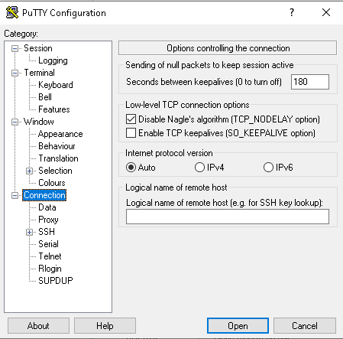

Expand SSH from category pane and select Auth. Click on Brows and select .ppk file

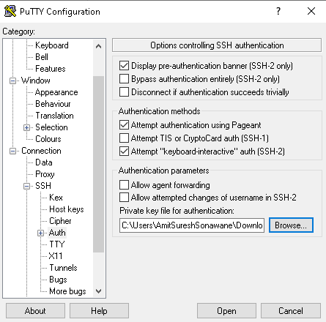

Click Open

It open CLI

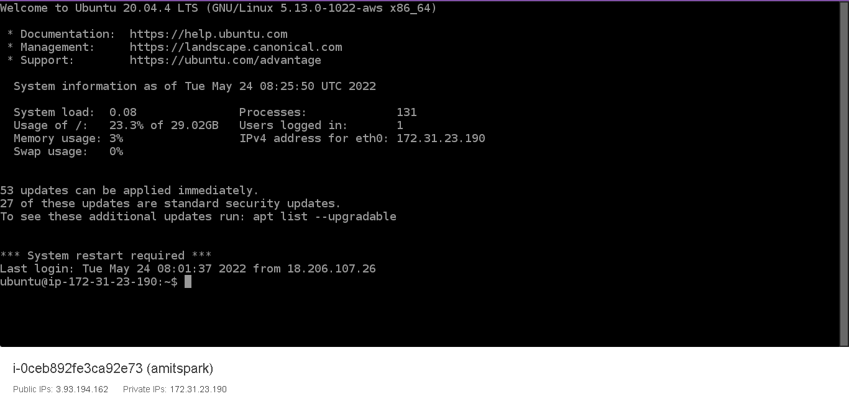

Enter and execute following command

cd ~/environments

source <environment name>/bin/activate

Type following command

jupyter notebook --ip=*

Open new browsing session

Enter <public ip>:8888 in address bar and hit enter

It will open Jupyter authentication section – get token from cli

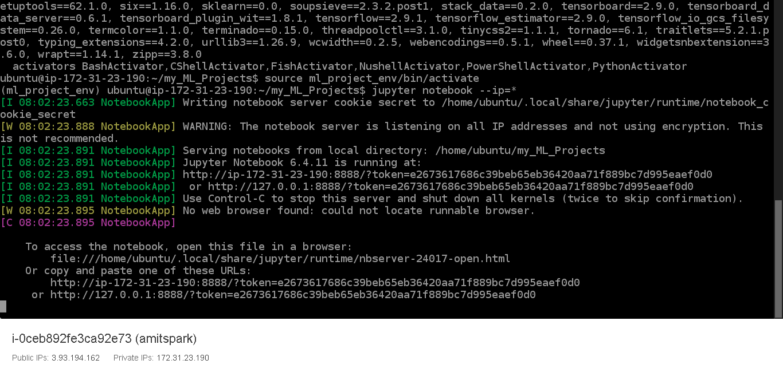

Paste it in token box and press ok

It will take you to jupyter file tree page

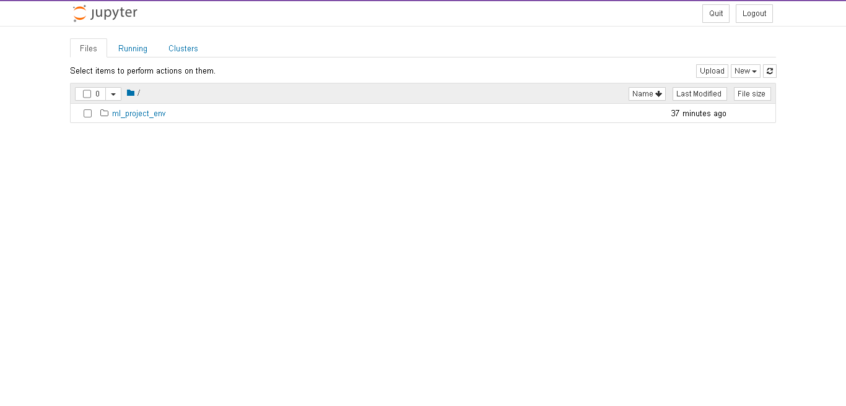

Click on New and select Terminal.

New browsing tab for Jupyter terminal is open now

**Appendix 3**

**Install Kubernetes Cluster on EC2 Instance Ubuntu 22.04**

* Create kubeadm.sh script file

vi kubeadm.sh

* Paste following script to file opened

#!/bin/sh

echo "\$nrconf{restart} = 'a';" | sudo tee -a /etc/needrestart/needrestart.conf

sudo apt-get update

sudo apt-get install -y apt-transport-https ca-certificates curl

curl -fsSLo containerd-config.toml \

https://gist.githubusercontent.com/oradwell/31ef858de3ca43addef68ff971f459c2/raw/5099df007eb717a11825c3890a0517892fa12dbf/containerd-config.toml

sudo mkdir /etc/containerd

sudo mv containerd-config.toml /etc/containerd/config.toml

curl -fsSLo containerd-1.6.14-linux-amd64.tar.gz \

https://github.com/containerd/containerd/releases/download/v1.6.14/containerd-1.6.14-linux-amd64.tar.gz

# Extract the binaries

sudo tar Cxzvf /usr/local containerd-1.6.14-linux-amd64.tar.gz

# Install containerd as a service

sudo curl -fsSLo /etc/systemd/system/containerd.service \

https://raw.githubusercontent.com/containerd/containerd/main/containerd.service

sudo systemctl daemon-reload

sudo systemctl enable --now containerd

curl -fsSLo runc.amd64 \

https://github.com/opencontainers/runc/releases/download/v1.1.3/runc.amd64

sudo install -m 755 runc.amd64 /usr/local/sbin/runc

curl -fsSLo cni-plugins-linux-amd64-v1.1.1.tgz \

https://github.com/containernetworking/plugins/releases/download/v1.1.1/cni-plugins-linux-amd64-v1.1.1.tgz

sudo mkdir -p /opt/cni/bin

sudo tar Cxzvf /opt/cni/bin cni-plugins-linux-amd64-v1.1.1.tgz

cat <<EOF | sudo tee /etc/modules-load.d/k8s.conf

overlay

br_netfilter

EOF

sudo modprobe -a overlay br_netfilter

# sysctl params required by setup, params persist across reboots

cat <<EOF | sudo tee /etc/sysctl.d/k8s.conf

net.bridge.bridge-nf-call-iptables = 1

net.bridge.bridge-nf-call-ip6tables = 1

net.ipv4.ip_forward = 1

EOF

# Apply sysctl params without reboot

sudo sysctl --system

# Add Kubernetes GPG key

curl -fsSL https://packages.cloud.google.com/apt/doc/apt-key.gpg | sudo gpg --dearmor -o /etc/apt/keyrings/kubernetes-archive-keyring.gpg

# Add Kubernetes apt repository

echo "deb [signed-by=/etc/apt/keyrings/kubernetes-archive-keyring.gpg] https://apt.kubernetes.io/ kubernetes-xenial main" | sudo tee /etc/apt/sources.list.d/kubernetes.list

# Fetch package list

sudo apt-get update

sudo apt-get install -y kubelet kubeadm kubectl

# Prevent them from being updated automatically

sudo apt-mark hold kubelet kubeadm kubectl

# See if swap is enabled

swapon --show

# Turn off swap

sudo swapoff -a

# Disable swap completely

sudo sed -i -e '/swap/d' /etc/fstab

sudo kubeadm init --pod-network-cidr=10.244.0.0/16

mkdir -p $HOME/.kube

sudo cp -i /etc/kubernetes/admin.conf $HOME/.kube/config

sudo chown $(id -u):$(id -g) $HOME/.kube/config

kubectl taint nodes --all node-role.kubernetes.io/control-plane-

kubectl apply -f https://raw.githubusercontent.com/coreos/flannel/master/Documentation/kube-flannel.yml

curl https://raw.githubusercontent.com/helm/helm/master/scripts/get-helm-3 | bash

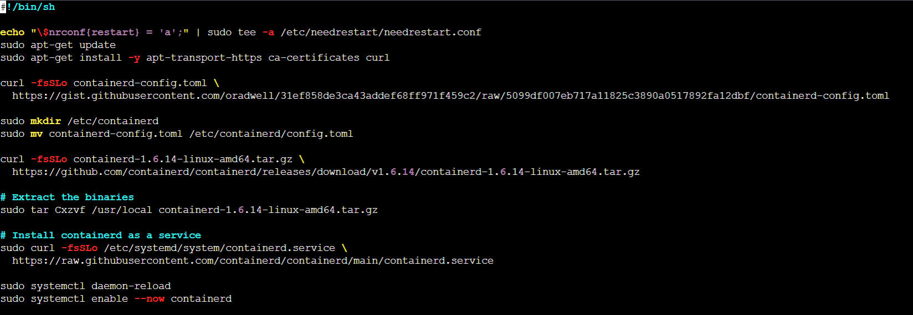

#save the file using "ESCAPE + :wq!"

Run the script to setup and configure kubeadm.

sudo bash kubeadm.sh (If not working use sudo bash kubeadm.sh)

* Check the cluster status

kubectl get nodes



If the node status is reads. Your cluster is running successfully

**Appendix 4**

**Install Pachyderm on Kubernetes Cluster**

* After successfully installing kubernetes cluster and helm by following Appendix 2 steps

run following commands one by one

* Download the Pachyderm client package:

curl -o /tmp/pachctl.deb -L https://github.com/pachyderm/pachyderm/releases/download/v2.6.5/pachctl_2.6.5_amd64.deb && sudo dpkg -i /tmp/pachctl.deb

Note: The version used in this example is 2.6.5. Adjust the version number as needed.

* Add the Pachyderm Helm repository

helm repo add pach https://helm.pachyderm.com

* Add the Rimusz Helm repository. Which can create host path provisioner. The "hostpath-provisioner" is a Kubernetes volume provisioner that allows the creation of PersistentVolumes on the host's local filesystem.

helm repo add rimusz https://charts.rimusz.net

* Update the Helm repositories:

helm repo update

* Install the hostpath-provisioner using Helm:

helm upgrade --install hostpath-provisioner --namespace kube-system rimusz/hostpath-provisioner

* Check the storage classes available in Kubernetes:

kubectl get sc

* Check the pods in the kube-system namespace:

kubectl get pods -n kube-system

* Apply the test PersistentVolumeClaim (PVC) configuration:

wget https://raw.githubusercontent.com/ismayilsiyad/HPE_AI_ML_INTER/main/test-pvc.yaml

kubectl apply -f test-pvc.yaml

* Check the created PVC:

kubectl get pvc

* Install Pachyderm using Helm, with additional configuration options:

helm install --wait --timeout 10m pachd pach/pachyderm --set proxy.enabled=true --set proxy.service.type=NodePort --set deployTarget=LOCAL

* Import the Kubernetes context for Pachyderm:

pachctl config import-kube local --overwrite

* Set the active context to the local cluster:

pachctl config set active-context local

* Check the Pachyderm service:

kubectl get svc

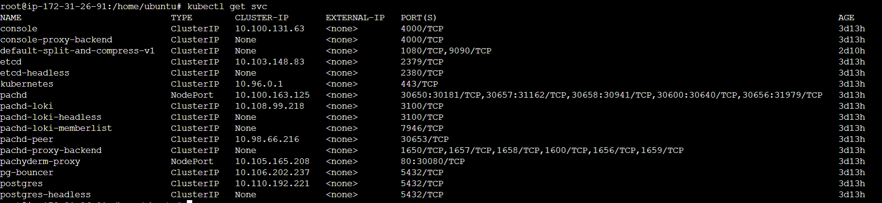

* open new browser and enter url <yourpublicip>:30080. you can see the Pachyderm Console

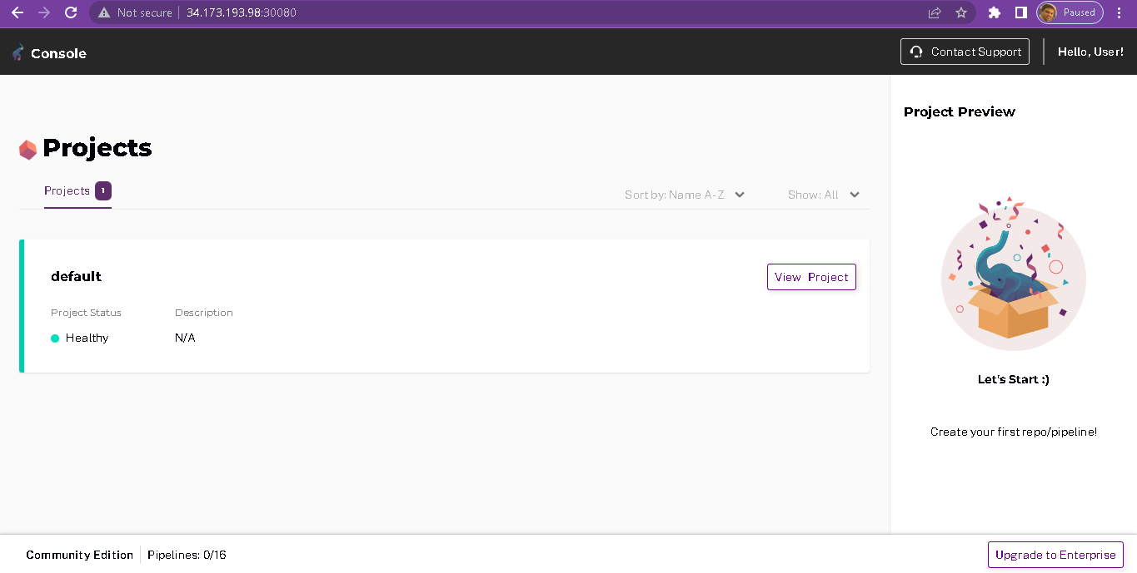

You are done with installation pachyderm installation.

**To execute the labs, you need to execute following steps**

sudo apt install -y pip

sudo apt install -y python3-venv

python3 -m venv hpepachyderm

source hpepachyderm/bin/activate

pip install pandas

pip install numpy

pip install jupyter

git clone <https://github.com/ismayilsiyad/pachyderm.git>

cd pachyderm

jupyter notebook –ip=* --allow-root

open jupyter notebook

Now execute Module 4 Labs 5,6, and 7 ipynb notebooks

**Appendix 5**

**Install Swarm Learning on EC2 Instance**

Step 1- Create an AWS EC2 Instance

Step 2- Start Remote Desktop Connection, paste external IP while connecting, click on connect and yes for certificate warning

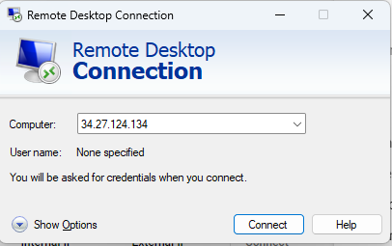

and put username and password to log in into instance. You will see the Ubuntu desktop

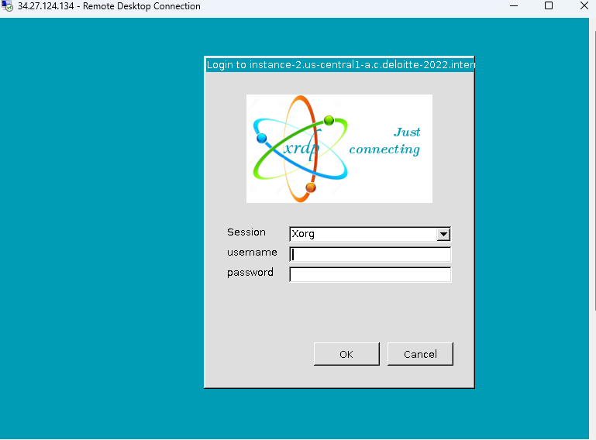

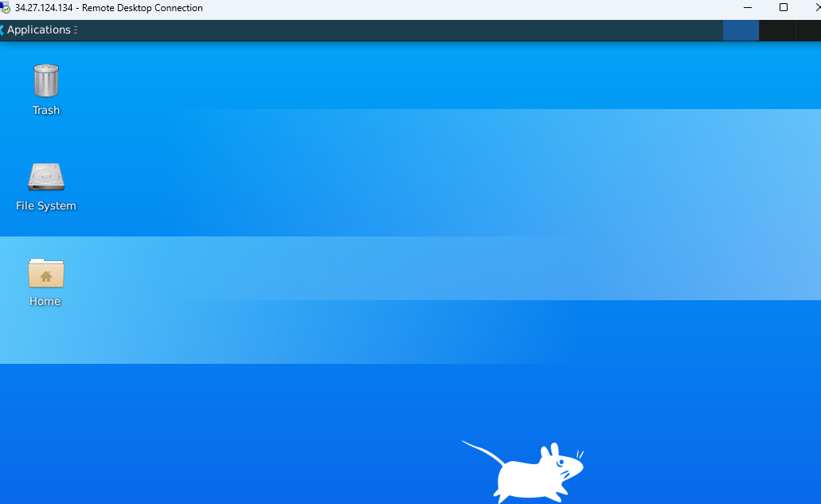

**Part 1 – Download the License Server**

Step 1 - Go to [https://myenterpriselicense.hpe.com](https://myenterpriselicense.hpe.com/) – HPE My Software Centre and Click on **create account** [use your personal Email Id]

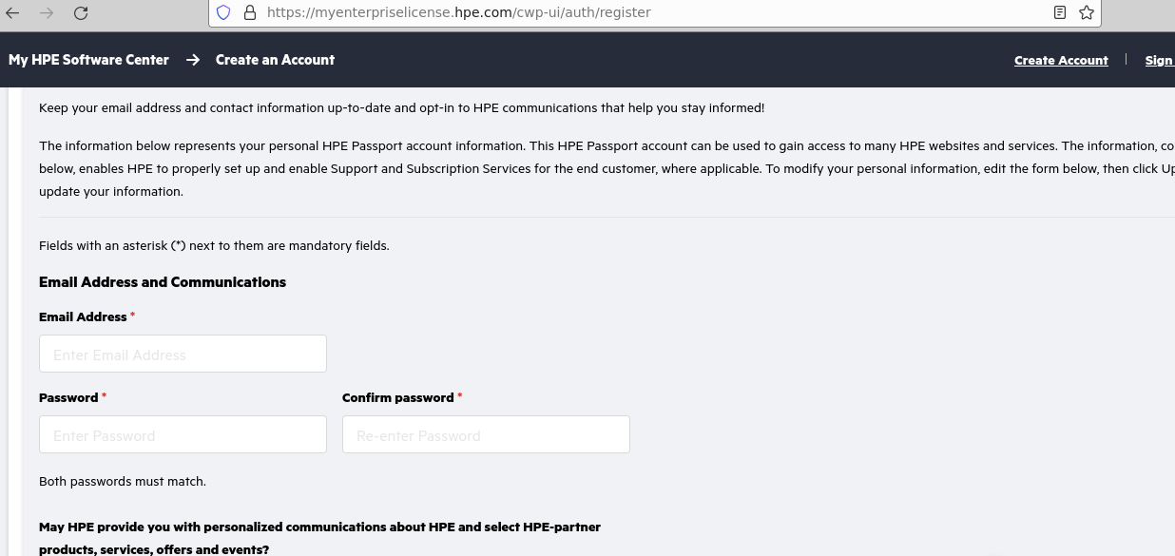

Step 2: After log in **Click on Software** from left hand side menu list

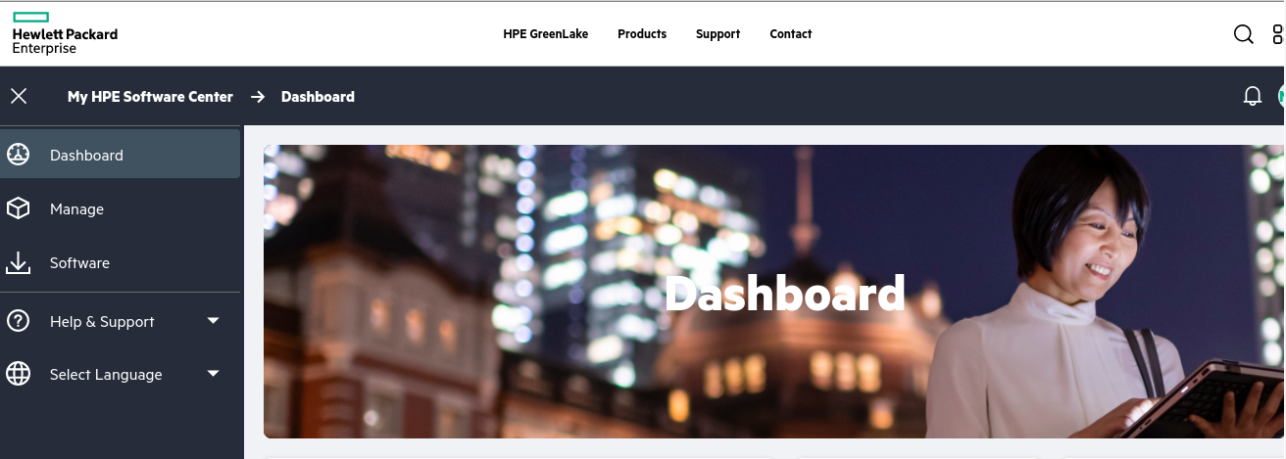

Step 3- In product Info Search for apls

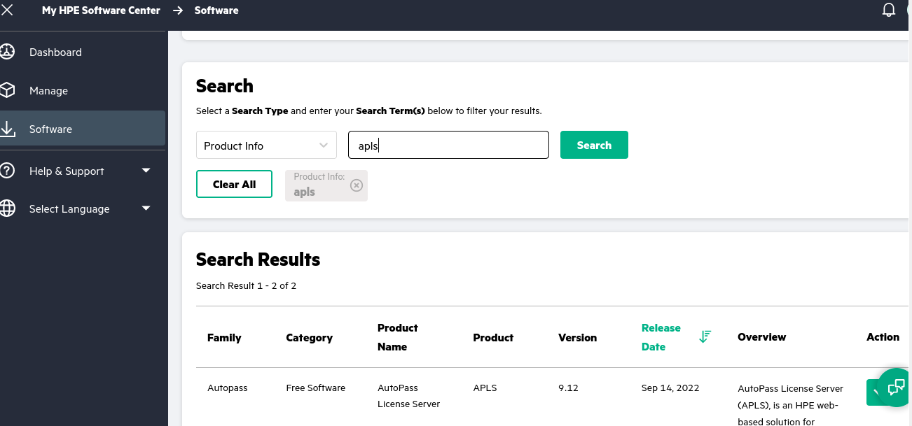

Step 4- Click on Action widget in front of **Free software APLS 9.2** and Click on Get Downloads

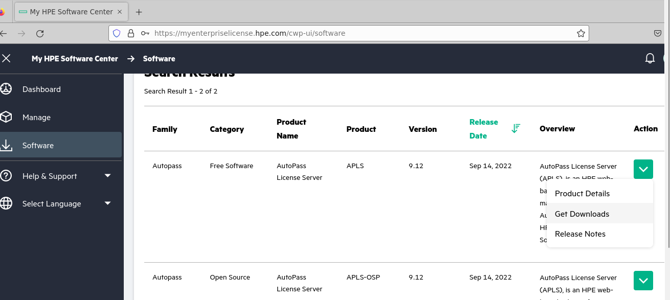

Step 6- Click on Download and your download will begin [471 MB]

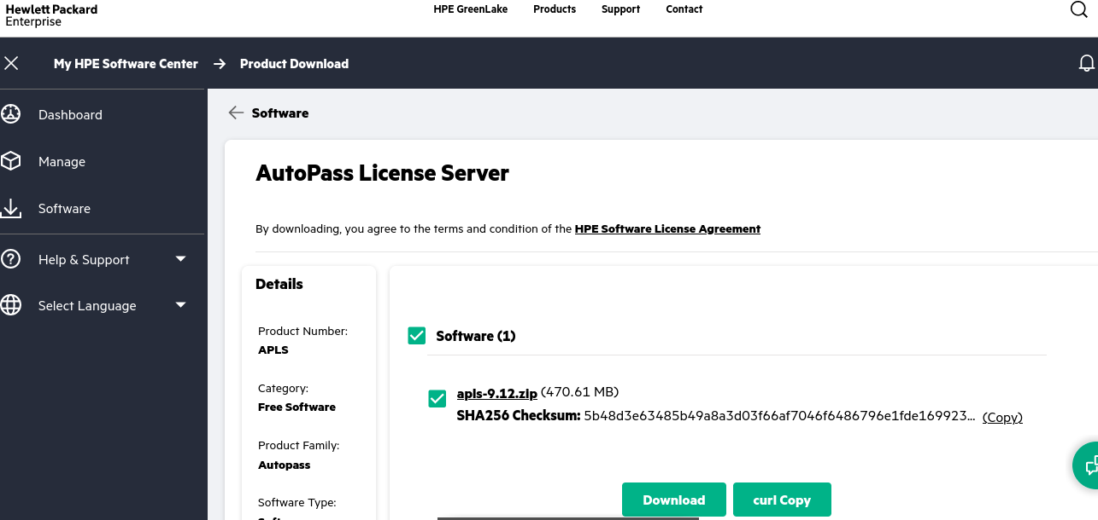

Step 7: open new terminal and execute following commands

sudo apt install unzip / sudo yum install unzip

cd Downloads

unzip apls-9.12.zip -d /home/amits/apls9.12

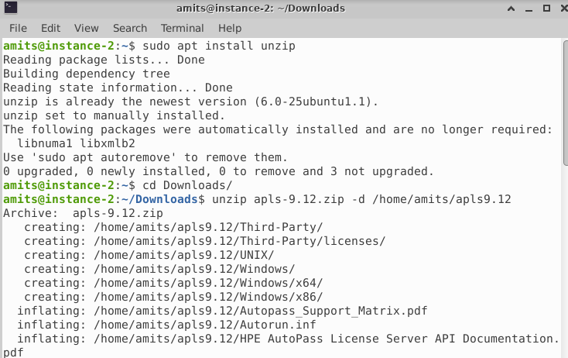

cd /home/amits/apls/ UNIX/

chmod +x ./setup.bin

sudo ./setup.bin [If the installer is not running then try using root user]

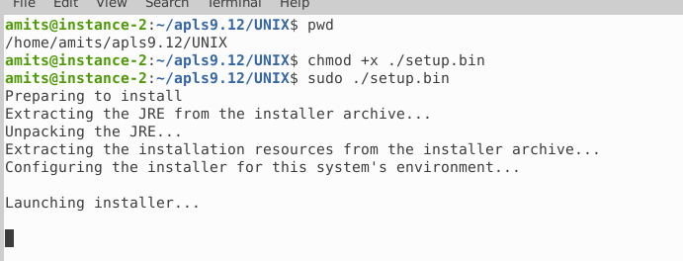

At the end you will see following lines printed

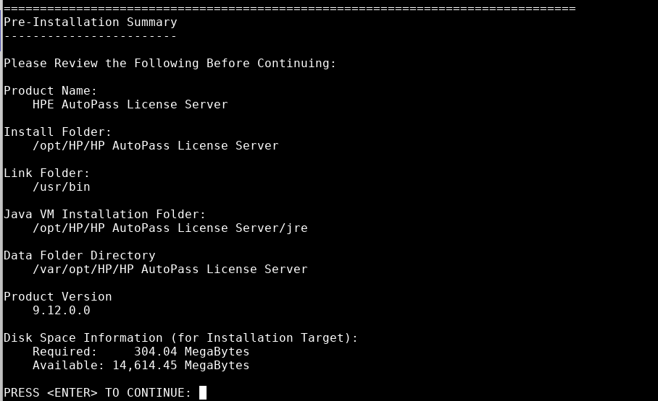

PRESS <ENTER> to start installation

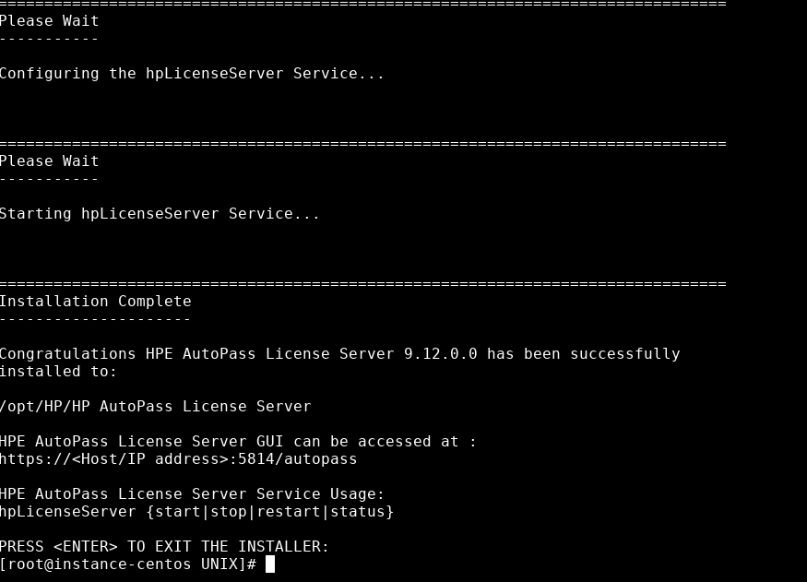

Step- 8 Execute Following Commands

cd /home/amits/

cd /opt/HP/

cd 'HP AutoPass License Server'/

cd 'HP AutoPass License Server'/

cd 'HP AutoPass License Server'/

cd bin

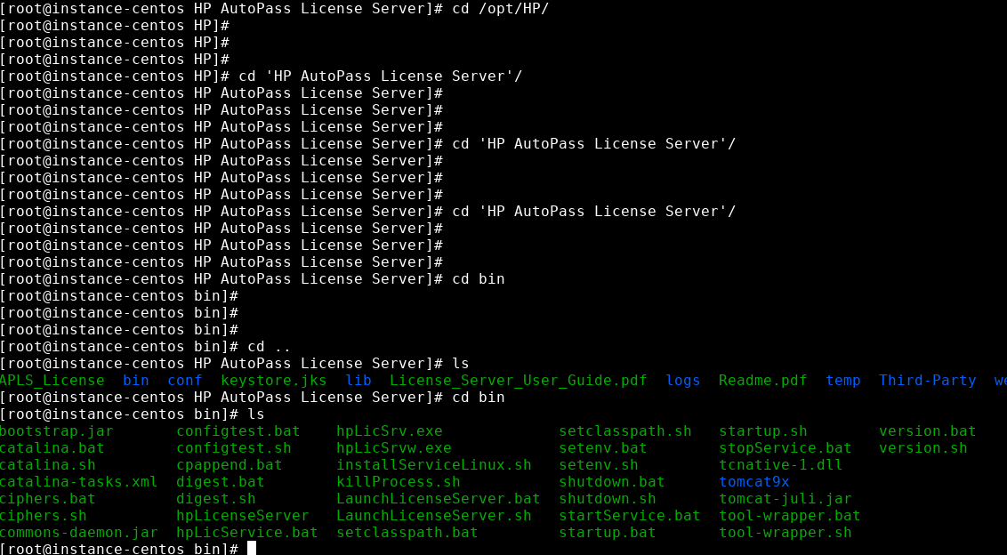

And execute command to start APLS

./hpLicenseServer start

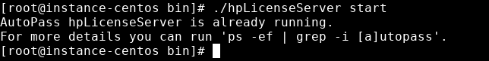

Your APLS Server started successfully.

Step – 9 Open Firefox new browsing tab and enter url - [https://localhost:5814](https://localhost:5814/)

[it might ask - Warning: Potential Security Risk Ahead click Advanced tab

it will extend dialog – localhost:5814 uses invalid certificate -ignore and click on – Accept Risk and Continue]

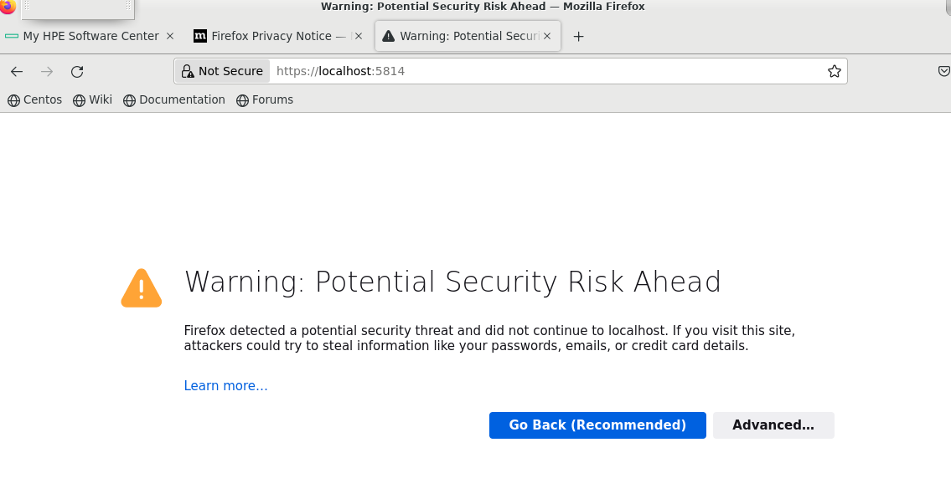

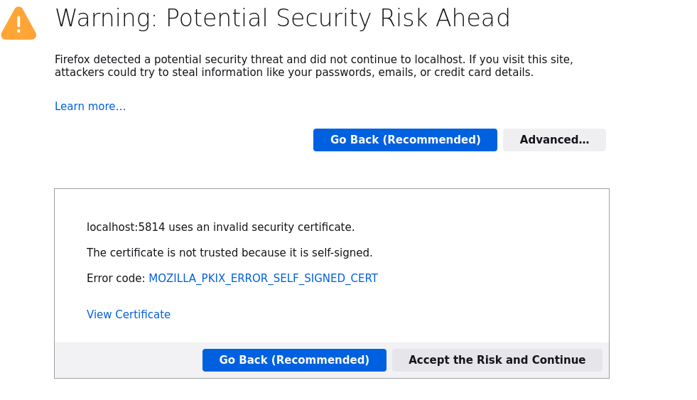

it will take you to login input page

username – admin

password – password

Click on LOGIN

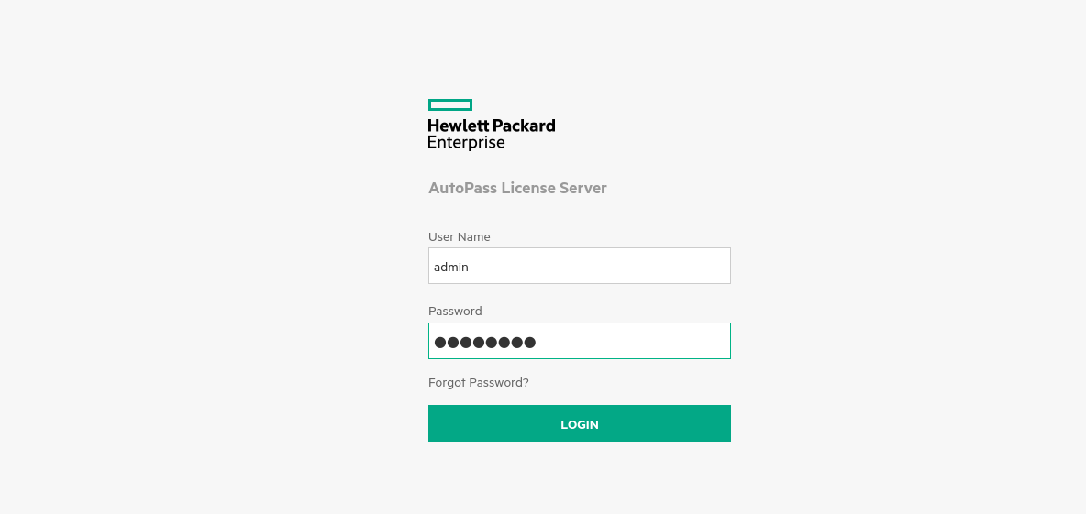

It will ask you to change password to password123

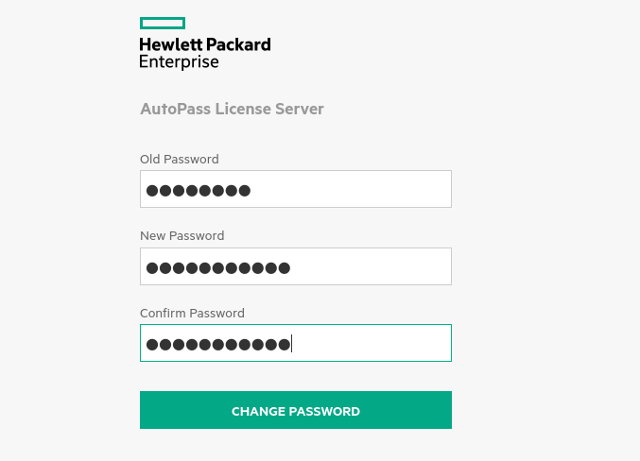

Please remember new password and after clicking on CHANGE PASSWORD , You will be redirected to following page

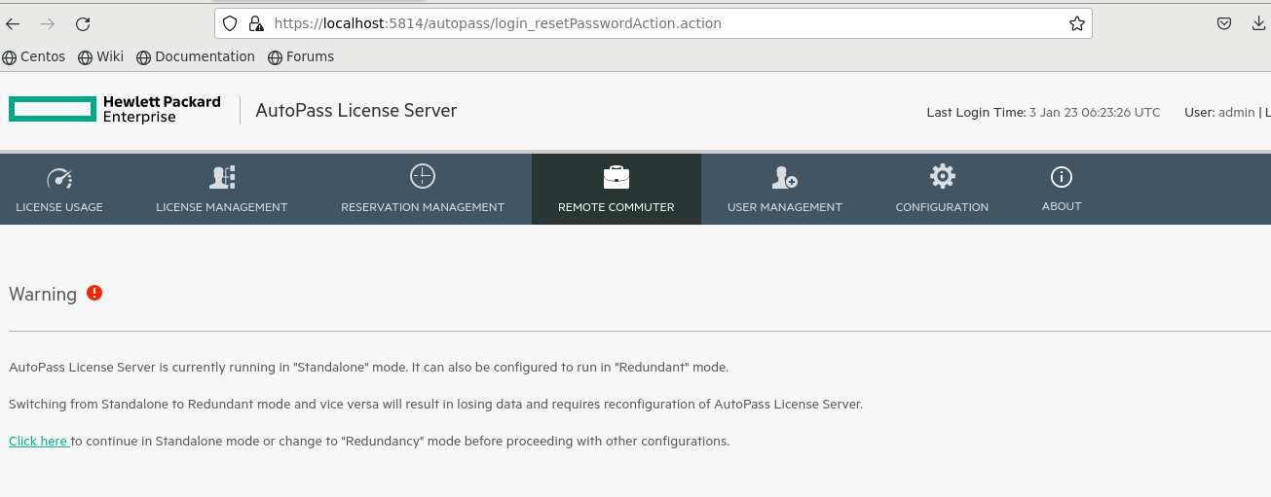

Step 10- click on LICENSE MANAGEMENT and then Click on Install Licence [Note Lock Code]

[ Ex. Lock Code: F671E87-EC8EA2A] This is your HPE Serial number

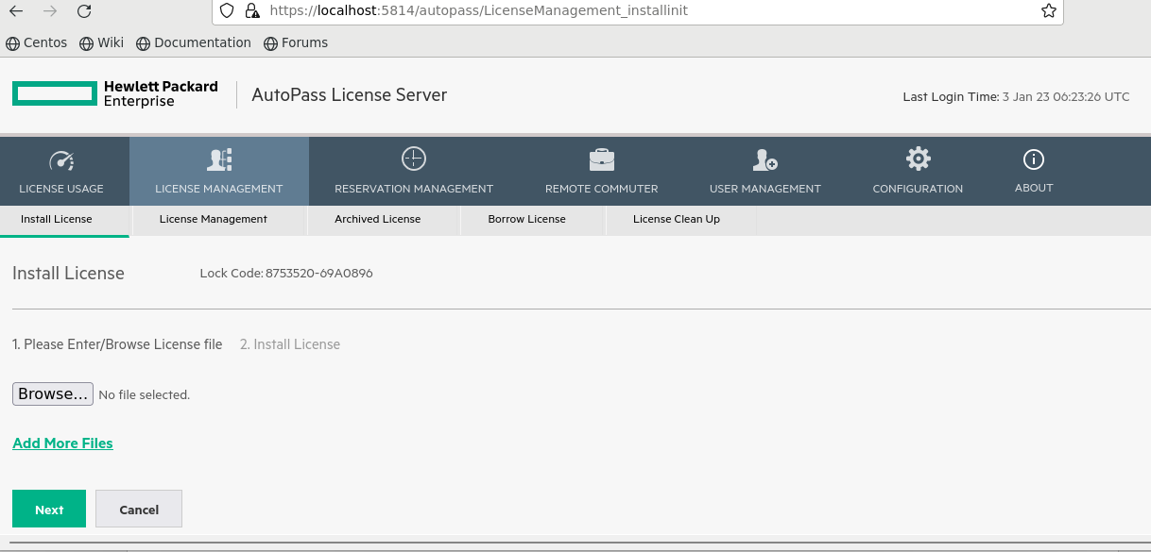

Step 11- Go back to your HPE Software Centre( [https://myenterpriselicense.hpe.com](https://myenterpriselicense.hpe.com/)), if not logged in – please login with HPE credentials and click on software and search ‘swarm learning’ in product info search bar

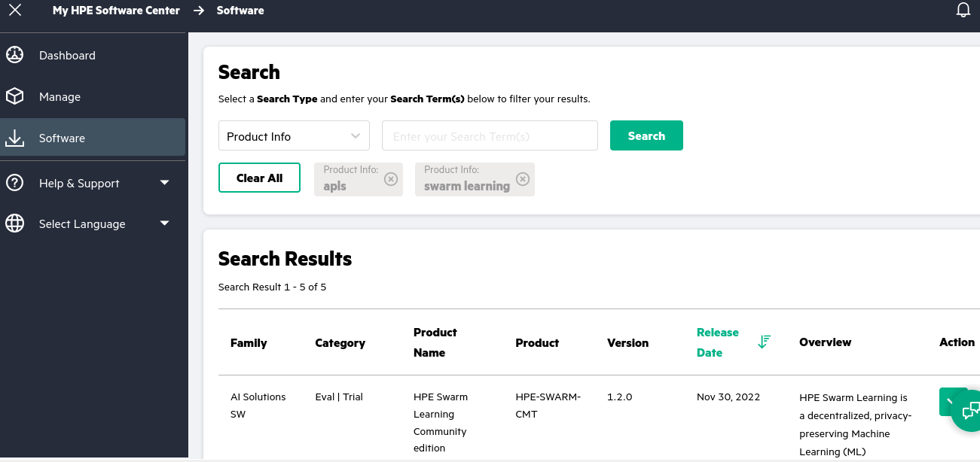

Step 12- In front of HPE swarm Learning Community edition, version 1.2.0, Click on Action Button and Click on Get License

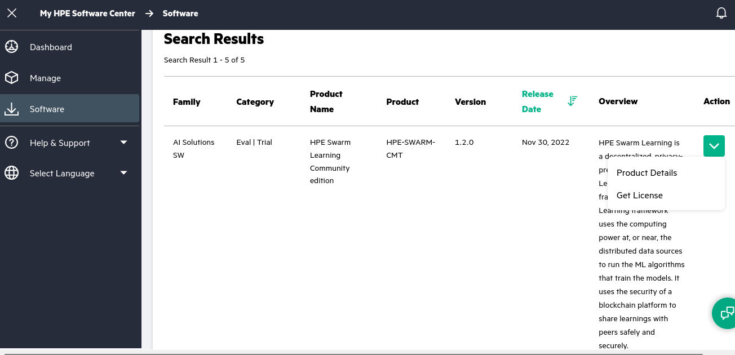

It will display following dialogue, Click on Next

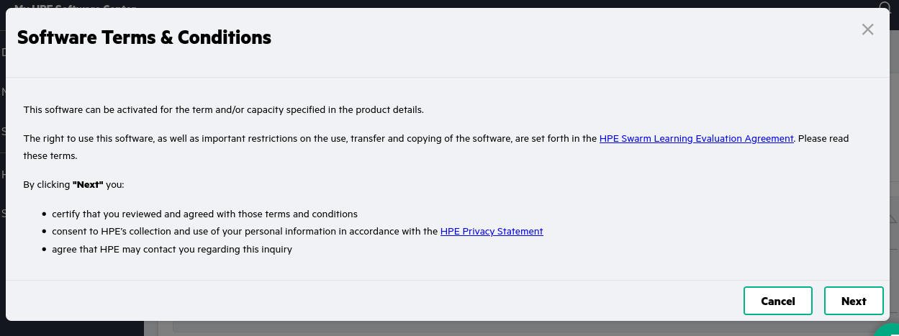

You will see the activate EON page

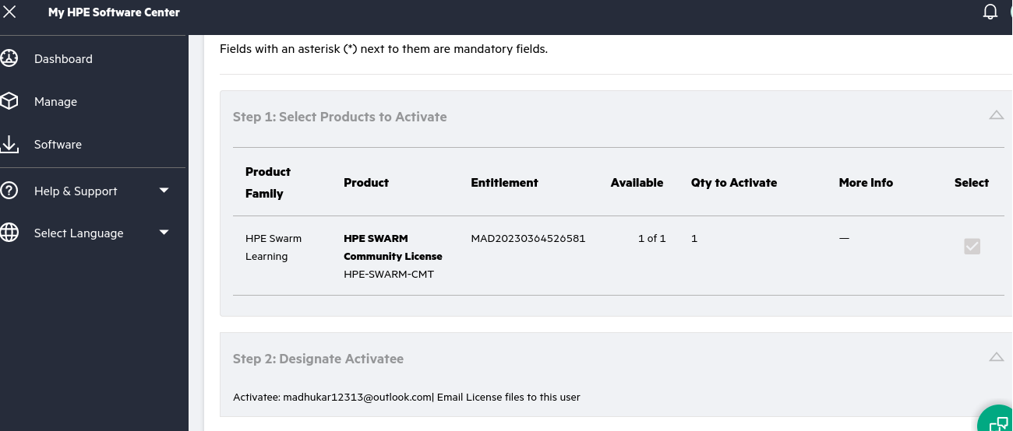

Step 13- Scroll down to step 3 and enter your lock code in – HPE serial number field scroll below

click on Activate

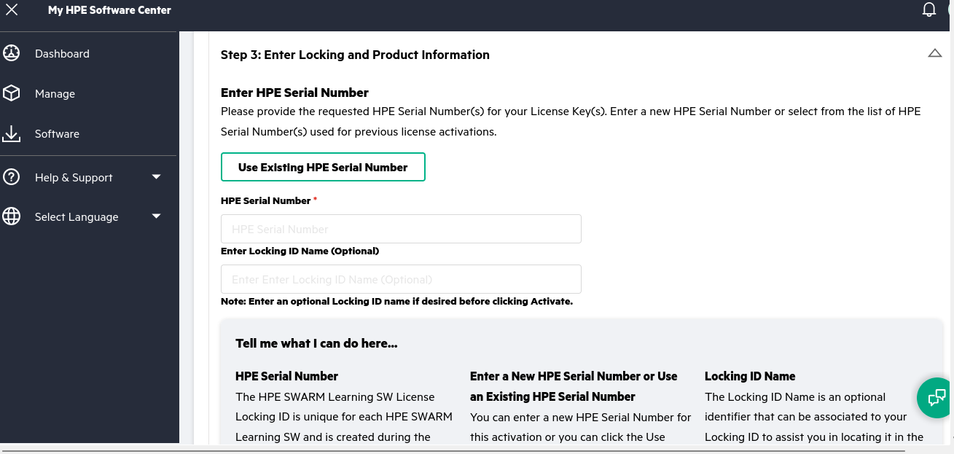

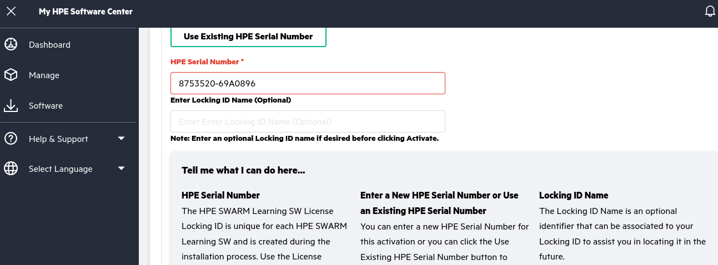

Scroll down and click on Activate

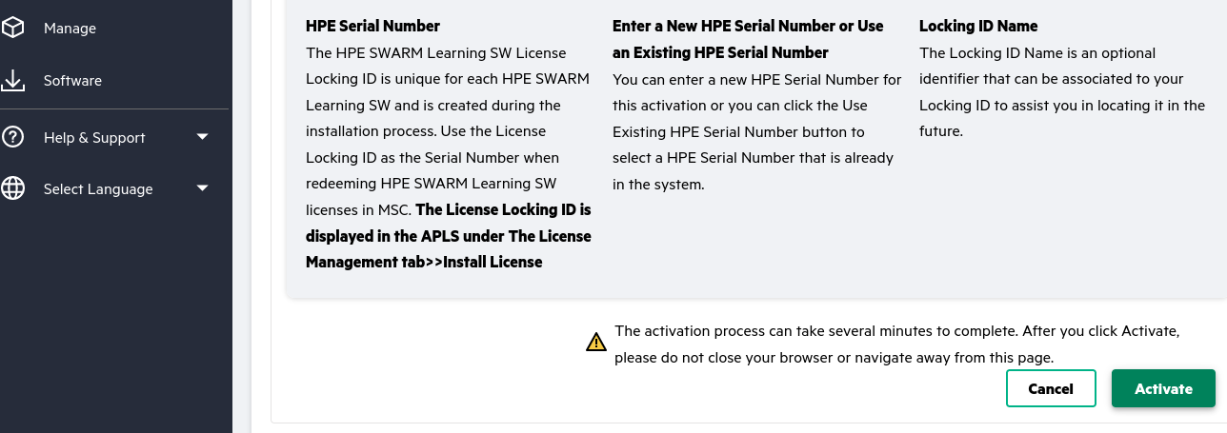

The activation process can take several minutes to complete. After you click Activate, please do not close your browser, or navigate away from this page.

After successful activation,it will take you to HPE Swarm Learning community licence page

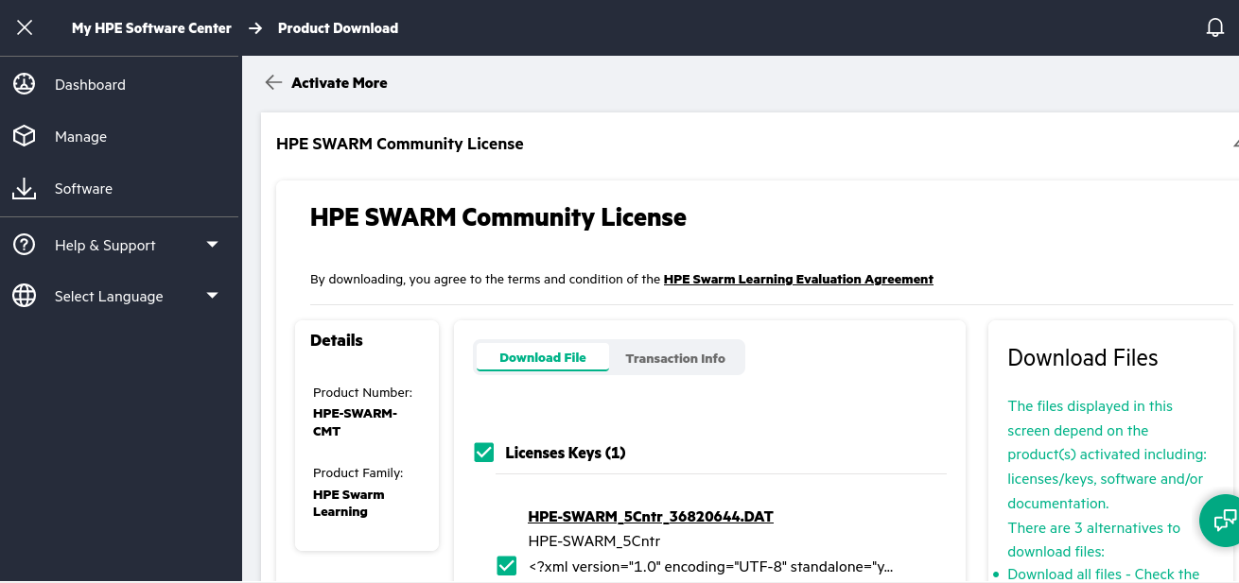

Step 14- Below Download file tab you will see the License keys(1)and Sofware (7) are listed

Please check in the box Infront of software (7) and click download and wait till download gets completed [Disable popup blockers]

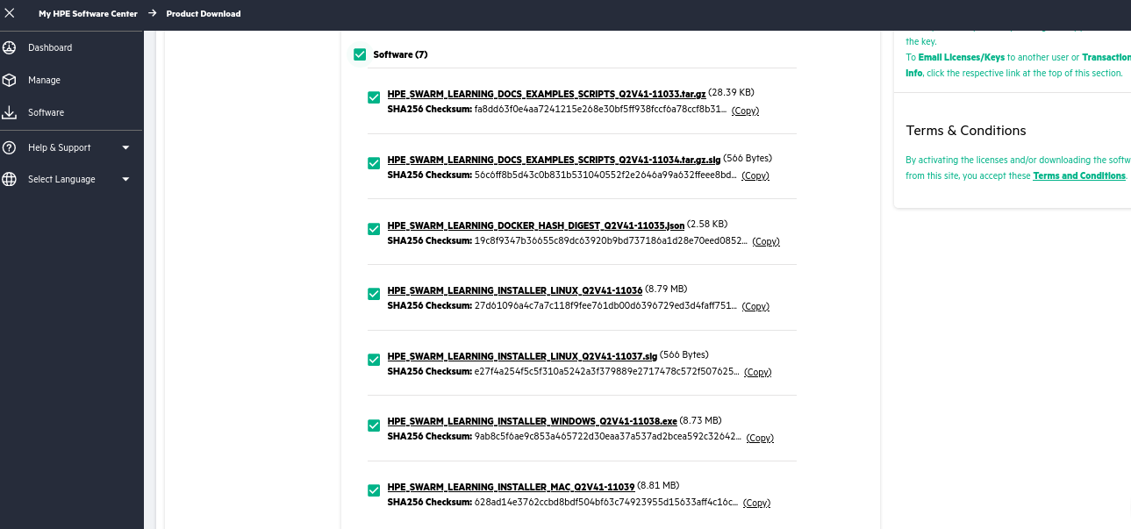

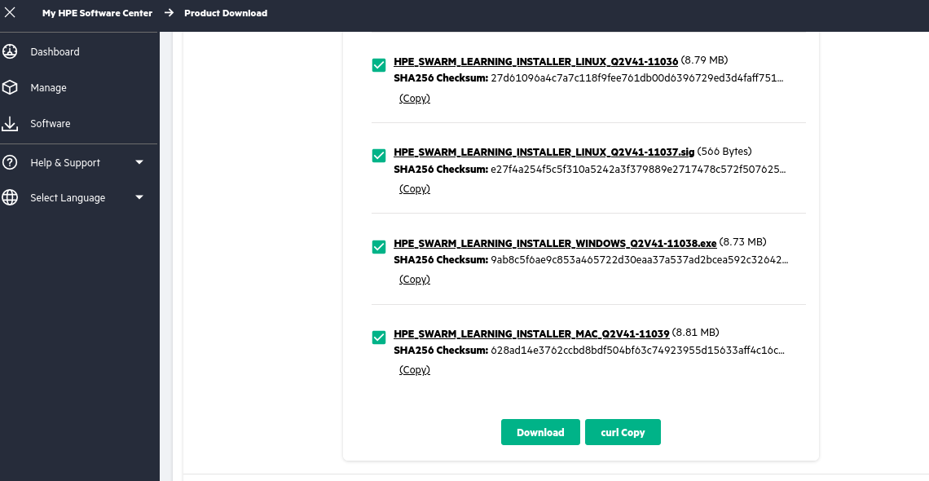

Step 16- After completion of download, Go to Downloads folder and see all the files

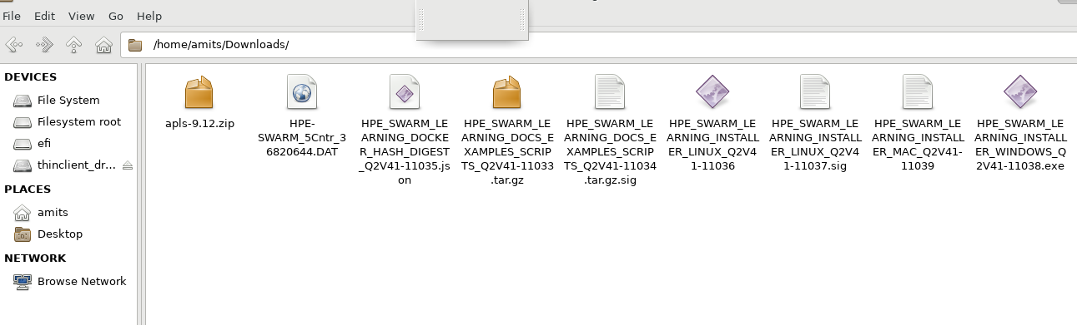

Step 17- Go back to your Auto pass license server browser Tab from where we have copied the Lock Code and click on browse button under Install Licenses

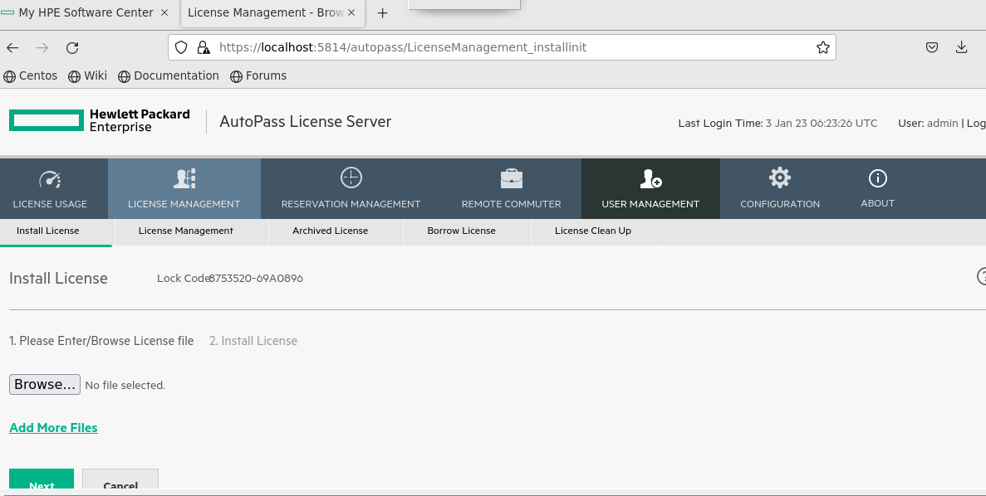

Step 18- select ‘HPE-SWARM_5Cntr_********.DAT’ file from download folder and click next

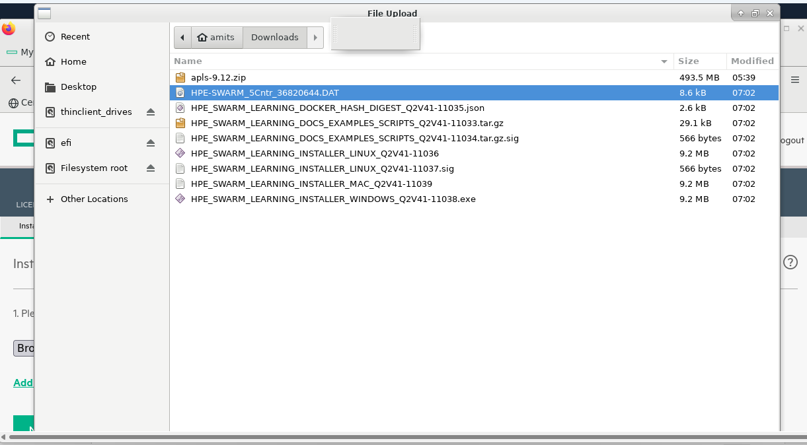

And Click on Next

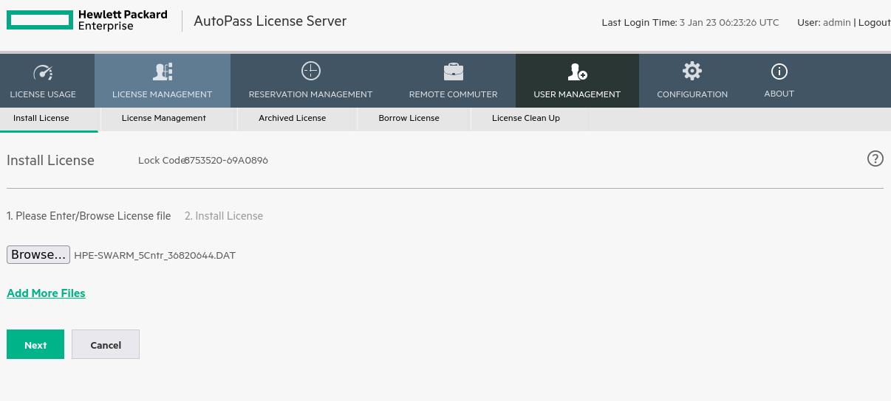

Step 20- select all four licenses – check in all four boxes and click on Install Licenses

You will see 1100000390:1 1100000388:1 1100000:378:1 1100000380:1 licenses successfully installed.

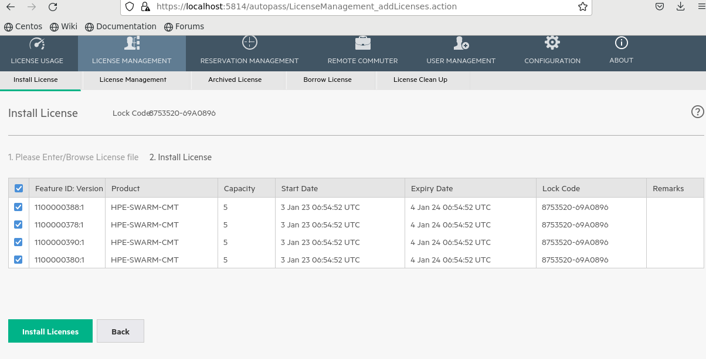

After Clicking on Install Licenses, you will see following page saying

“4 licenses added successfully “

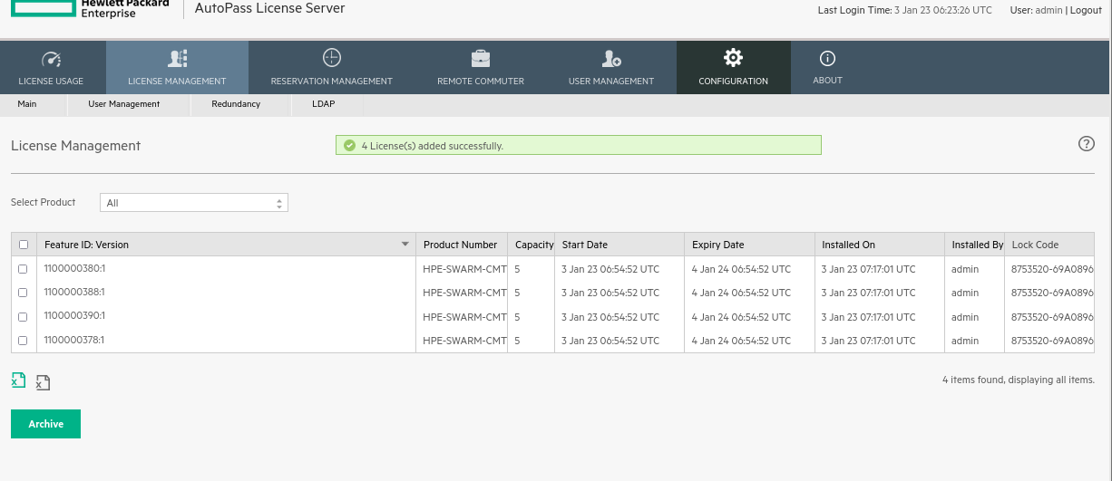

Step 21- Now Create folder to install swarm learning and run swarm learning installer for linux

Execute following commands

mkdir /home/amits/hpe

cd /home/amits/hpe

mkdir swarm-learning

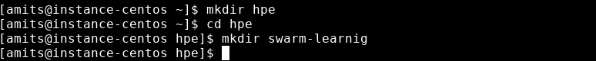

cd /home/amits/Downloads

chmod +x HPE_SWARM_LEARNING_INSTALLER_LINUX_Q2V41-11036

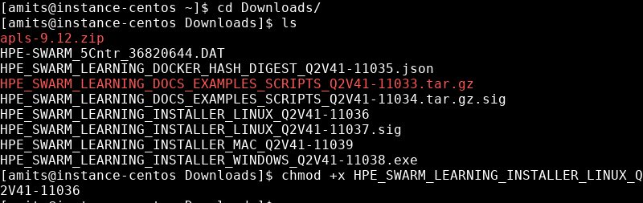

Step 22- From file manager/explorer **Double click** on executable file names as **HPE_SWARM_LEARNING_INSTALLER_LINUX_Q2V41-11036**

It will open WebUI installer in browser [if not then open new browsing tab – and Enter URL 127.0.0.1:30302]

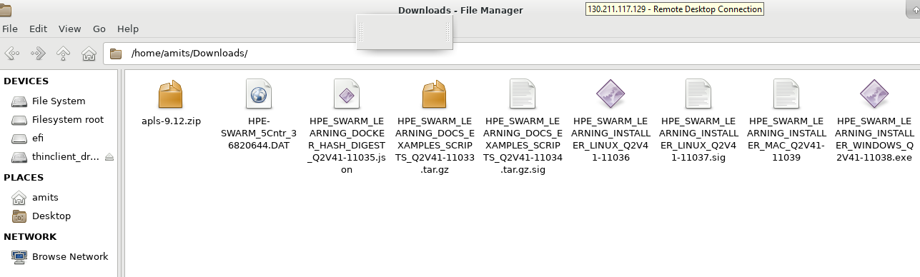

Click on Next

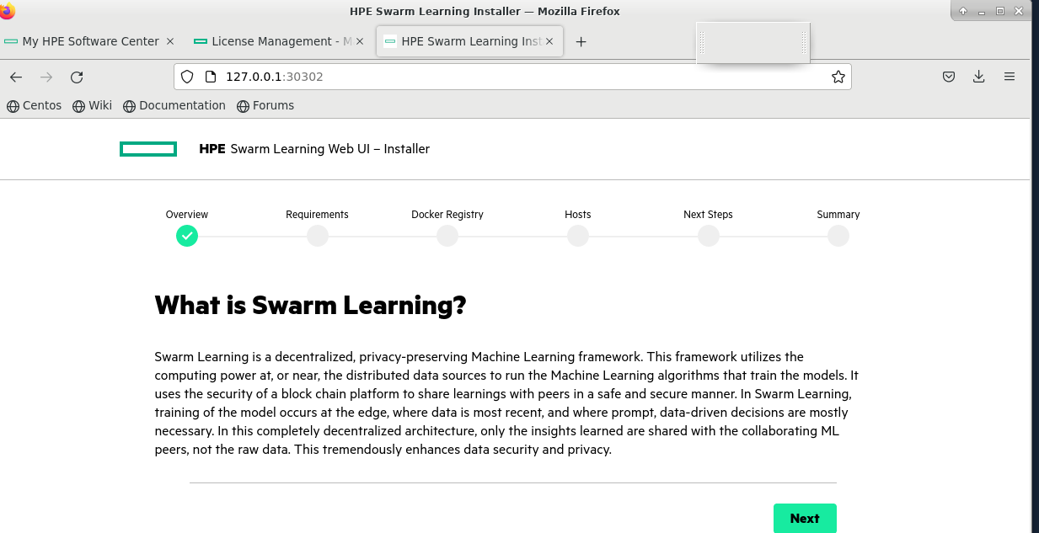

Scroll down and Click on Next

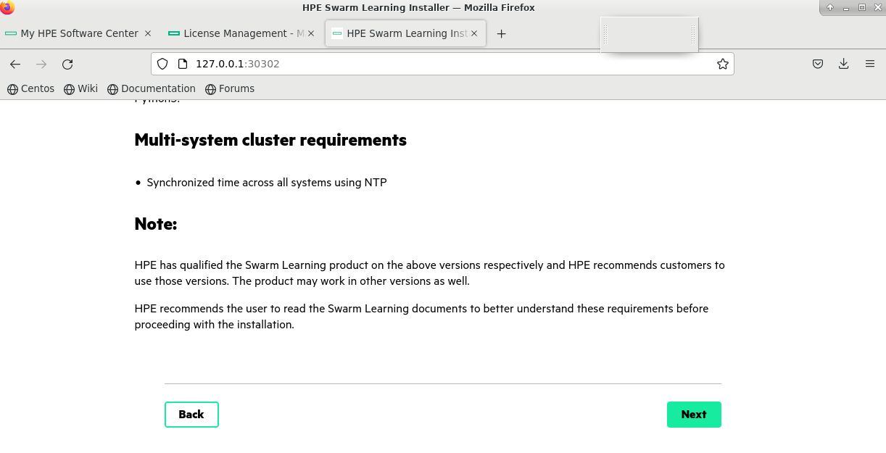

After that Enter your HPE Passport Username (Email-Id) and click on Next

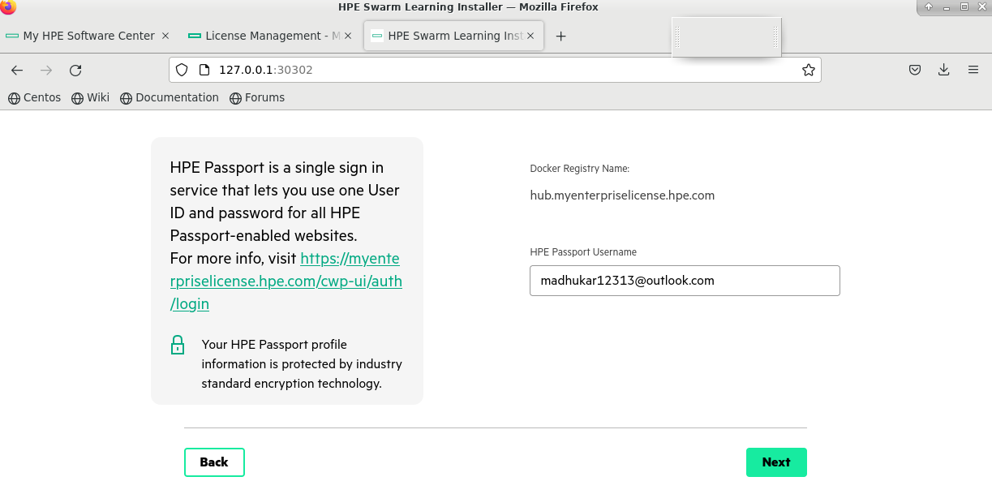

Enter directory path to install swarm learning and enter Internal IP [Private IP of Machine] with username and password

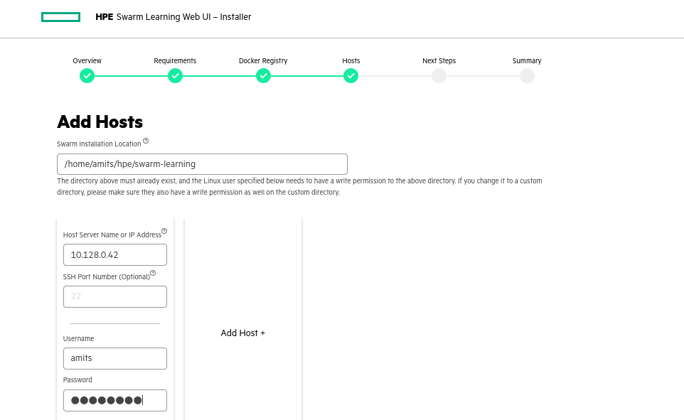

And Click on Next

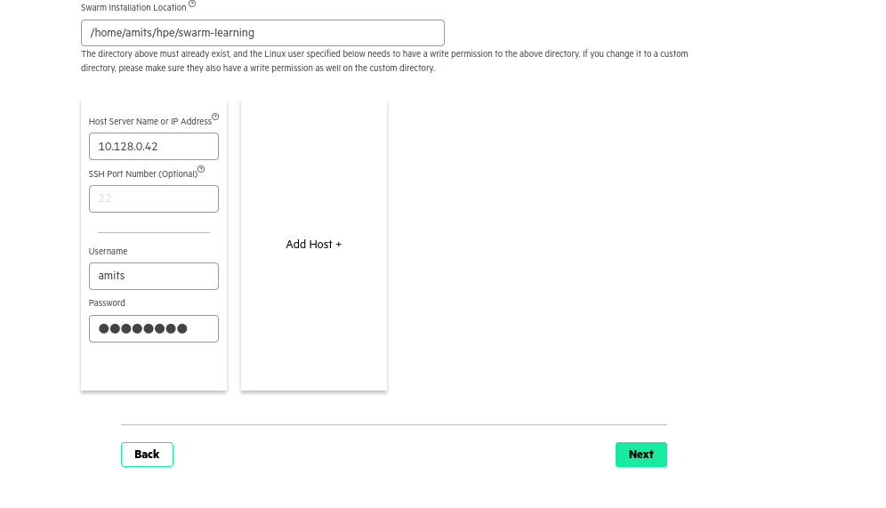

If there is an error message, click **Click here for more info**. Close the error message dialog, **Retry** or **Configure** the host, and click **Next**.

**Click Next**

Review **Next Steps** and click **Next**.

Review the **Summary** screen, which displays all the installed hosts. Click **Finish**.

An installation confirmation message is displayed. Click **Close Window**.

After successful installation, the Swarm Learning docker containers are installed on each of the host; the documentation, the sample code, and the scripts for running Swarm Learning are installed in the Swarm installation location (the default location is (/opt/hpe/swarm-learning))

**If web UI installer is giving some issues you can go for manual installation process**

1. As we have already downloaded the following file from HPE My Support Center(MSC) on a host system (HPE_SWARM_LEARNING_DOCS_EXAMPLES_SCRIPTS_Q2V41-11033.tar.gz) and the signature file for the above tar file.
2. Untar the tar file under /opt/hpe/swarm-learning.

sudo tar -xzvf HPE_SWARM_LEARNING_DOCS_EXAMPLES_SCRIPTS_Q2V41-11033.tar.gz -d /home/amits/hpe/swarm-learning

If this command giving any error, you can execute following commands

cd Downloads

sudo tar -zxvf HPE_SWARM_LEARNING_DOCS_EXAMPLES_SCRIPTS_Q2V41-11033.tar.gz

You will find lib folder after extracting above file, copy it in /home/amits/hpe/swarm-learning manually or using following command

1. Do a docker login from your machine terminal:

 docker login hub.myenterpriselicense.hpe.com –u <YOUR-HPE-PASSPORT-EMAIL> -p hpe_eval

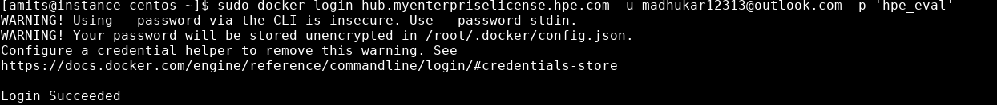

1. Pull the signed Swarm Learning images from HPEs Docker Trust Registry (DTR):

docker pull hub.myenterpriselicense.hpe.com/hpe_eval/swarm-learning/sn:1.2.0

docker pull hub.myenterpriselicense.hpe.com/hpe_eval/swarm-learning/sl:1.2.0

docker pull hub.myenterpriselicense.hpe.com/hpe_eval/swarm-learning/swci:1.2.0

docker pull hub.myenterpriselicense.hpe.com/hpe_eval/swarm-learning/swop:1.2.0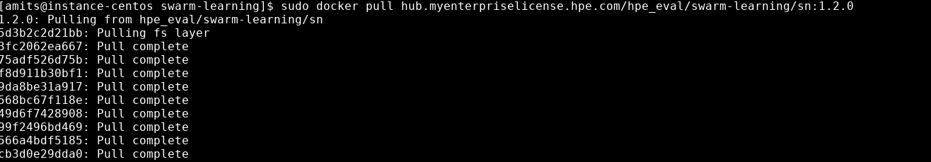

This completes the swarm learning installation.

**Appendix 6**

**Install Docker on Ubuntu**

Docker is a popular platform that allows you to create, deploy, and run applications using containerization. Containers are lightweight, portable, and isolated environments that package an application and all its dependencies, making it easy to distribute and run consistently across different environments. In this guide, we will walk you through the process of installing Docker on Ubuntu 22.04.

**Prerequisites**

Before proceeding with the installation, ensure you have the following:

1. A EC2 instance running Ubuntu 22.04
2. Internet access to download and install the Docker package.

Step 1: Update Package Repository

Open a terminal on your Ubuntu 22.04 system. To ensure you have the latest package information, run the following command to update the package repository:

sudo apt update

Step 2: Install Required Dependencies

Docker uses the apt package manager to install its components and dependencies. Before installing Docker, you need to install some prerequisite packages. Run the following command:

sudo apt install apt-transport-https ca-certificates curl software-properties-common

Step 3: Add Docker Repository

Next, you need to add Docker's official GPG key and repository to your system. This will allow apt to verify the authenticity of Docker packages. Run the following command:

curl -fsSL https://download.docker.com/linux/ubuntu/gpg | sudo gpg --dearmor -o /usr/share/keyrings/docker-archive-keyring.gpg

Then, add the Docker repository to apt sources:

echo "deb [signed-by=/usr/share/keyrings/docker-archive-keyring.gpg] https://download.docker.com/linux/ubuntu $(lsb_release -cs) stable" | sudo tee /etc/apt/sources.list.d/docker.list > /dev/null

Step 4: Install Docker

With the repository added, you can now install Docker. Run the following command:

sudo apt update

sudo apt install docker-ce

The installation process will prompt you to confirm, type 'Y,' and press Enter to proceed.

Step 5: Start and Enable Docker

Once Docker is installed, you need to start the Docker service and enable it to start on boot. Run the following commands:

sudo systemctl start docker

sudo systemctl enable docker

Step 6: Verify Docker Installation

To ensure Docker is installed correctly, run the following command to check the version:

docker --version

You should see the Docker version information displayed in the terminal

**Appendix 7**

**Install and Configure SWARM NODE**

**Establish Connectivity between instance on which autopass licence server is running and instance that you created.**

Prerequisite:

Step 1: Open Instance Where you want to configure swarm learning

Step 2:

execute following command one by one

cd ~/.ssh

ssh-keygen -t rsa -P ""

It will ask you - Enter file in which to save the key (/home/amits/.ssh/id_rsa): press enter key

cat id_rsa.pub

and copy the key

[wait for instructors’ instruction after this - instructor will collect your key and paste it in authorized_keys folder of instance -2]

[once done - instructor will notify you - then start executing follwing]

Step 3:

sudo service ssh restart

Step 4:

sudo su

passwd

Step 5:

Open SSH-in-Browser for the instance that you created.

cd /home/ubuntu

ssh user@<public-ip>

our license server is running in GCP machine with user amits so you can try.

ssh amits@ 35.193.101.82 ]



type yes

press enter

**Appendix 8**

**Install and Configure Pachyderm-Determined-K-Serve Integration – Cheat sheet**

This document provides step-by-step instructions for installing the PDK integration on an Ubuntu 20.04, with a control plane instance of type t2.2xlarge, GPU Node instance type g4dn.xlarge, and a single node instance type g4dn.12xlarge. The minimum recommended single node instance type is g4dn.4xlarge, and the disk size should be set to 200 GB. This guide assumes that you have already set up your AWS environment and necessary permissions.

**Ubuntu 20.04 AMI - Control Plane t2.2xlarge,**

**GPU Node - g4dn.xlarge or Single node g4dn.12xlarge**

**### Minimum Single Node should be g4dn.4xlarge and is recommeded ############## Open RDP for Anywhere, disk size 200 GB ########**

sudo apt update

sudo hostnamectl set-hostname microk8s

sudo su ubuntu

####edit /etc/hosts if needed

sudo snap install microk8s --classic --channel=1.27

#### If needed

microk8s add-node

####

Refer Documentation ###

https://github.com/determined-ai/pdk/blob/main/deploy/deploy_k8s.md

#####

**### Create Role with below policies and attach ####**

AmazonEC2ContainerRegistryFullAccess

AmazonEC2ContainerRegistryPowerUser

AmazonElasticContainerRegistryPublicFullAccess

AmazonS3FullAccess

STSPublic

{

"Version": "2012-10-17",

"Statement": [

{

"Effect": "Allow",

"Action": [

"ecr-public:GetAuthorizationToken",

"sts:GetServiceBearerToken"

],

"Resource": "*"

}

]

}

**#### Enable GUI and RDP ####**

sudo apt install xfce4 xfce4-goodies -y

sudo systemctl status xrdp

sudo apt install xrdp -y

sudo systemctl status xrdp

sudo cat /etc/xrdp/xrdp.ini

cd ~

echo "xfce4-session" | tee .xsession

sudo systemctl restart xrdp

sudo passwd ubuntu

curl ifconfig.me

**#### Open Windows RDP and Connect #####**

sudo apt install firefox -y

history > history_1_GUI_Install.txt

sudo usermod -a -G microk8s $USER

su - $USER

microk8s status --wait-ready

curl -LO "https://dl.k8s.io/release/$(curl -L -s https://dl.k8s.io/release/stable.txt)/bin/linux/amd64/kubectl"

curl -LO "https://dl.k8s.io/release/$(curl -L -s https://dl.k8s.io/release/stable.txt)/bin/linux/amd64/kubectl.sha256"

echo "$(cat kubectl.sha256) kubectl" | sha256sum --check

sudo install -o root -g root -m 0755 kubectl /usr/local/bin/kubectl

kubectl get nodes

cd $HOME

### if needed do #### mkdir .kube

microk8s config > .kube/config

sudo chown -R ubuntu:ubuntu .kube/

sudo chown ubuntu:ubuntu .kube/config

sudo chmod 755 .kube/

sudo chmod 400 .kube/config

kubectl get nodes

**############## If needed add another node ####**

microk8s add-node

#Add gpu node as worker node

cd ~

microk8s status

microk8s enable gpu hostpath-storage metallb metrics-server

kubectl get pods -A -w

### Hit Control and C together to come back to shell ####

microk8s status

curl -fsSL -o get_helm.sh https://raw.githubusercontent.com/helm/helm/main/scripts/get-helm-3

chmod 700 get_helm.sh

./get_helm.sh

helm repo list

**##### Start PDK Installation #####**

### Paste the below commads to your shell

export NAME="your-name-pdk"

export DB_CONNECTION_STRING="postgres-service.default.svc.cluster.local."

export DB_ADMIN_PASSWORD="your-database-password"

export MLDM_NAMESPACE="pachyderm"

export KSERVE_MODELS_NAMESPACE="models"

### For persistence

### Add these line to .bashrc using nano .bashrc and save Control + S then exit using Control + X

printenv

**### Install the given dependencies ###**

curl -o /tmp/pachctl.deb -L https://github.com/pachyderm/pachyderm/releases/download/v2.6.8/pachctl_2.6.8_amd64.deb && sudo dpkg -i /tmp/pachctl.deb

sudo apt install python3-pip -y

pip install determined

sudo apt-get install -y jq

kubectl version --client=true

helm version

pachctl version

det version

jq --version

kubectl apply -f - <<EOF

kind: StorageClass

apiVersion: storage.k8s.io/v1

metadata:

name: manual

annotations:

storageclass.kubernetes.io/is-default-class: "true"

provisioner: microk8s.io/hostpath

reclaimPolicy: Delete

parameters:

pvDir: /mnt/efs/shared_fs

volumeBindingMode: WaitForFirstConsumer

EOF

kubectl apply -f - <<EOF

kind: PersistentVolume

apiVersion: v1

metadata:

name: postgres-pv

labels:

app: postgres

type: local

spec:

storageClassName: manual

capacity:

storage: 5Gi

accessModes:

- ReadWriteOnce

hostPath:

path: "/mnt/efs/shared_fs/data"

EOF

kubectl apply -f - <<EOF

kind: PersistentVolumeClaim

apiVersion: v1

metadata:

name: postgres-pv-claim

labels:

app: postgres

spec:

storageClassName: manual

accessModes:

- ReadWriteOnce

resources:

requests:

storage: 5Gi

EOF

kubectl apply -f - <<EOF

apiVersion: v1

kind: ConfigMap

metadata:

name: postgres-configuration

labels:

app: postgres

data:

POSTGRES_DB: postgres

POSTGRES_USER: postgres

POSTGRES_PASSWORD: ${DB_ADMIN_PASSWORD}

EOF

kubectl apply -f - <<EOF

apiVersion: apps/v1

kind: StatefulSet

metadata:

name: postgres-statefulset

labels:

app: postgres

spec:

serviceName: "postgres"

replicas: 1

selector:

matchLabels:

app: postgres

template:

metadata:

labels:

app: postgres

spec:

containers:

- name: postgres

image: postgres:13

envFrom:

- configMapRef:

name: postgres-configuration

ports:

- containerPort: 5432

name: postgresdb

volumeMounts:

- name: pv-data

mountPath: /mnt/efs/shared_fs/postgres/

volumes:

- name: pv-data

persistentVolumeClaim:

claimName: postgres-pv-claim

EOF

kubectl apply -f - <<EOF

apiVersion: v1

kind: Service

metadata:

name: postgres-service

labels:

app: postgres

spec:

ports:

- port: 5432

name: postgres

type: NodePort

selector:

app: postgres

EOF

kubectl get sc,pv,pvc,sts,pods,svc

ls /mnt/efs/shared_fs/

sudo chmod -R 777 /mnt/efs/shared_fs/

sudo find /mnt/efs/shared_fs \( -type d -exec sudo chmod u+rwx,g+rwx,o+rx {} \; -o -type f -exec sudo chmod u+rw,g+rw,o+r {} \; \)

kubectl get svc

kubectl run psql -it --rm=true --image=postgres:13 --env=PGPASSWORD=your-database-password --command -- psql -h postgres-service -U postgres postgres

CREATE DATABASE pachyderm;

CREATE DATABASE dex;

CREATE DATABASE determined;

GRANT ALL PRIVILEGES ON DATABASE pachyderm TO postgres;

GRANT ALL PRIVILEGES ON DATABASE dex TO postgres;

GRANT ALL PRIVILEGES ON DATABASE determined TO postgres;

\l

\q

kubectl apply -f - <<EOF

apiVersion: v1

kind: PersistentVolume

metadata:

name: pv1

labels:

type: local

spec:

storageClassName: manual

capacity:

storage: 20Gi

accessModes:

- ReadWriteOnce

hostPath:

path: /mnt/efs/shared_fs/pv/pv1

EOF

kubectl apply -f - <<EOF

apiVersion: v1

kind: PersistentVolume

metadata:

name: pv2

labels:

type: local

spec:

storageClassName: manual

capacity:

storage: 20Gi

accessModes:

- ReadWriteOnce

hostPath:

path: /mnt/efs/shared_fs/pv/pv2

EOF

cat <<EOF > mldm_values.yaml

deployTarget: "CUSTOM"

pachd:

enabled: true

externalService:

enabled: true

image:

tag: "2.6.5"

storage:

backend: LOCAL

local:

hostPath: /mnt/efs/shared_fs/pachyderm

requireRoot: true

etcd:

storageClass: manual

storageClassName: manual

size: 10Gi

loki-stack:

loki:

securityContext:

fsGroup: 0

runAsGroup: 0

runAsNonRoot: false

runAsUser: 0

persistence:

storageClassName: manual

size: 10Gi

postgresql:

enabled: false

global:

postgresql:

postgresqlHost: "${DB_CONNECTION_STRING}"

postgresqlPort: "5432"

postgresqlSSL: "disable"

postgresqlUsername: "postgres"

postgresqlPassword: "${DB_ADMIN_PASSWORD}"

proxy:

enabled: true

service:

type: LoadBalancer

httpPort: 9090

tls:

enabled: false

EOF

chmod 400 /home/ubuntu/.kube/config

sudo chmod -R 777 /mnt/efs/shared_fs/

helm repo add pachyderm https://helm.pachyderm.com

helm repo update

helm repo list

kubectl create ns ${MLDM_NAMESPACE}

helm install pachyderm -f ./mldm_values.yaml pachyderm/pachyderm --namespace ${MLDM_NAMESPACE}

kubectl get pods -A -w

### Hit Control and C to exit watch screen

##### Fire the below command if etcd is crashing

sudo chmod -R 777 /mnt/efs/shared_fs/

#### Then make sure etcd Running using

kubectl get pods -A -w

### Hit Control and C to exit watch screen

kubectl -n ${MLDM_NAMESPACE} get pods

export MLDM_HOST=$(kubectl get svc --namespace ${MLDM_NAMESPACE} pachyderm-proxy --output jsonpath='{.status.loadBalancer.ingress[0].ip}')

export MLDM_URL="http://${MLDM_HOST}:9090"

echo $MLDM_URL

### Add to bashrc if needed

#Check in the web browser of RDP

pachctl connect ${MLDM_URL}

pachctl config set active-context ${MLDM_URL}

kubectl create ns gpu-pool

kubectl get nodes

kubectl label node microk8s node-role.kubernetes.io/gpu-worker=worker

kubectl label node microk8s nodegroup-role=gpu-worker

kubectl get nodes --show-labels | grep -i gpu

kubectl apply -f - <<EOF

apiVersion: v1

kind: PersistentVolume

metadata:

name: mlde-pv

spec:

storageClassName: manual

capacity:

storage: 10Gi

accessModes:

- ReadWriteMany

hostPath:

path: "/mnt/efs/shared_fs/mlde_shared"

---

kind: PersistentVolumeClaim

apiVersion: v1

metadata:

name: mlde-pvc

spec:

storageClassName: manual

accessModes:

- ReadWriteMany

resources:

requests:

storage: 10Gi

EOF

kubectl apply -f - <<EOF

apiVersion: v1

kind: PersistentVolume

metadata:

name: mlde-pv-gpu

spec:

storageClassName: manual

capacity:

storage: 10Gi

accessModes:

- ReadWriteMany

hostPath:

path: "/mnt/efs/shared_fs/mlde_shared"

---

kind: PersistentVolumeClaim

apiVersion: v1

metadata:

name: mlde-pvc

namespace: gpu-pool

spec:

storageClassName: manual

accessModes:

- ReadWriteMany

resources:

requests:

storage: 10Gi

EOF

kubectl get sc

kubectl get pv

kubectl get pvc

kubectl -n gpu-pool get pvc

wget https://hpe-mlde.determined.ai/latest/_downloads/389266101877e29ab82805a88a6fc4a6/determined-latest.tgz

tar xvf determined-latest.tgz

cat <<EOF > ./determined/values.yaml

imageRegistry: determinedai

enterpriseEdition: false

imagePullSecretName:

masterPort: 8080

useNodePortForMaster: false

db:

hostAddress: "${DB_CONNECTION_STRING}"

name: determined

user: postgres

password: ${DB_ADMIN_PASSWORD}

port: 5432

checkpointStorage:

saveExperimentBest: 0

saveTrialBest: 1

saveTrialLatest: 1

type: shared_fs

hostPath: /mnt/efs/shared_fs/determined

maxSlotsPerPod: 4

masterCpuRequest: 4

masterMemRequest: 8Gi

taskContainerDefaults:

cpuImage: determinedai/environments:py-3.8-pytorch-1.12-tf-2.11-cpu-6eceaca

gpuImage: determinedai/environments:cuda-11.3-pytorch-1.12-tf-2.11-gpu-6eceaca

cpuPodSpec:

apiVersion: v1

kind: Pod

gpuPodSpec:

apiVersion: v1

kind: Pod

metadata:

labels:

nodegroup-role: gpu-worker

telemetry:

enabled: true

resource_manager:

default_aux_resource_pool: default

default_compute_resource_pool: gpu-pool

resourcePools:

- pool_name: default

task_container_defaults:

cpu_pod_spec:

apiVersion: v1

kind: Pod

spec:

containers:

- name: determined-container

volumeMounts:

- name: shared-fs

mountPath: /run/determined/workdir/shared_fs

volumes:

- name: shared-fs

persistentVolumeClaim:

claimName: mlde-pvc

- pool_name: gpu-pool

max_aux_containers_per_agent: 1

kubernetes_namespace: gpu-pool

task_container_defaults:

gpu_pod_spec:

apiVersion: v1

kind: Pod

spec:

containers:

- name: determined-container

volumeMounts:

- name: shared-fs

mountPath: /run/determined/workdir/shared_fs

volumes:

- name: shared-fs

persistentVolumeClaim:

claimName: mlde-pvc

tolerations:

- key: "nvidia.com/gpu"

operator: "Equal"

value: "present"

effect: "NoSchedule"

EOF

kubectl apply -f - <<EOF

apiVersion: scheduling.k8s.io/v1

kind: PriorityClass

metadata:

name: determined-system-priority

value: 1000000

globalDefault: false

description: "This priority class should be used for XYZ service pods only."

EOF

cat ./determined/values.yaml

helm install determinedai ./determined

#############

kubectl get service determined-master-service-determinedai -n default

Once you have the IP address, configure master address locally by running: `export DET_MASTER=<ip address>:8080`.

To submit experiments please install the Determined CLI locally: `pip install determined`.

To access the WebUI go to: http://<ip address>:8080.

User: admin password blank

#############

export MLDE_HOST=$(kubectl get svc determined-master-service-determinedai --output jsonpath='{.status.loadBalancer.ingress[0].ip}')

export MLDE_URL="http://${MLDE_HOST}:8080"

echo $MLDE_URL

export DET_MASTER=${MLDE_HOST}:8080

det e list

##### Installing KServe - Wrong Documentation on GitHub -- Follow below steps ####

curl -L https://istio.io/downloadIstio | sh -

export PATH="$PATH:/home/ubuntu/istio-1.19.0/bin"

istioctl x precheck

istioctl install -y

LATEST_VERSION=$(curl https://api.github.com/repos/sigstore/cosign/releases/latest | grep tag_name | cut -d : -f2 | tr -d "v\", ")

curl -O -L "https://github.com/sigstore/cosign/releases/latest/download/cosign_${LATEST_VERSION}_amd64.deb"

sudo dpkg -i cosign_${LATEST_VERSION}_amd64.deb

#### Install Knative Serving ####

curl -sSL https://github.com/knative/serving/releases/download/knative-v1.10.1/serving-core.yaml \

| grep 'gcr.io/' | awk '{print $2}' | sort | uniq \

| xargs -n 1 \

cosign verify -o text \

--certificate-identity=signer@knative-releases.iam.gserviceaccount.com \

--certificate-oidc-issuer=https://accounts.google.com

kubectl apply -f https://github.com/knative/serving/releases/download/knative-v1.11.1/serving-crds.yaml

kubectl apply -f https://github.com/knative/serving/releases/download/knative-v1.11.1/serving-core.yaml

kubectl apply -l knative.dev/crd-install=true -f https://github.com/knative/net-istio/releases/download/knative-v1.11.0/istio.yaml

kubectl apply -f https://github.com/knative/net-istio/releases/download/knative-v1.11.0/istio.yaml

kubectl apply -f https://github.com/knative/net-istio/releases/download/knative-v1.11.0/net-istio.yaml

kubectl --namespace istio-system get service istio-ingressgateway

### Record this Metal LB IP ####

### Configure NoDNS method ####

kubectl patch configmap/config-domain \

--namespace knative-serving \

--type merge \

--patch '{"data":{"example.com":""}}'

kubectl get ksvc

### Install Cert Manager ####

kubectl apply -f https://github.com/cert-manager/cert-manager/releases/download/v1.13.0/cert-manager.yaml

### Install KServe ####

kubectl apply -f https://github.com/kserve/kserve/releases/download/v0.9.0/kserve.yaml

kubectl apply -f https://github.com/kserve/kserve/releases/download/v0.9.0/kserve-runtimes.yaml

kubectl get pods -A -w

### Test Components ####

pachctl create project openCV

pachctl config update context --project openCV

pachctl create repo images

pachctl list repo

wget http://imgur.com/46Q8nDz.png

pachctl put file images@master:liberty.png -f 46Q8nDz.png

pachctl list commit images

pachctl create pipeline -f https://raw.githubusercontent.com/pachyderm/pachyderm/2.6.x/examples/opencv/edges.json

wget http://imgur.com/8MN9Kg0.png

pachctl put file images@master:AT-AT.png -f 8MN9Kg0.png

wget http://imgur.com/g2QnNqa.png

pachctl put file images@master:kitten.png -f g2QnNqa.png

pachctl list commit images

pachctl create pipeline -f https://raw.githubusercontent.com/pachyderm/pachyderm/2.6.x/examples/opencv/montage.json

pachctl list job

ls -la /mnt/efs/shared_fs/pachydermpachd/objects/

Check GUI, Reduce the CPU Limits if pipeline is crashing

mkdir mlde_exp

cd mlde_exp

###### git clone https://github.com/determined-ai/determined.git . ########

###### Download the old code for pytorch #####

wget https://github.com/determined-ai/determined/archive/refs/tags/0.25.1.tar.gz

tar -xvzf 0.25.1.tar.gz

cat <<EOF > ./examples/computer_vision/cifar10_pytorch/const.yaml

name: cifar10_pytorch_const

environment:

pod_spec:

spec:

tolerations:

- key: "nvidia.com/gpu"

operator: "Equal"

value: "present"

effect: "NoSchedule"

hyperparameters:

learning_rate: 1.0e-4

learning_rate_decay: 1.0e-6

layer1_dropout: 0.25

layer2_dropout: 0.25

layer3_dropout: 0.5

global_batch_size: 32

records_per_epoch: 500

searcher:

name: single

metric: validation_error

max_length:

epochs: 1

entrypoint: model_def:CIFARTrial

min_validation_period:

epochs: 1

max_restarts: 0

resources:

resource_pool: gpu-pool

slots_per_trial: 1

EOF

det experiment create -f ./examples/computer_vision/cifar10_pytorch/const.yaml ./examples/computer_vision/cifar10_pytorch

det e list

kubectl create ns ${KSERVE_MODELS_NAMESPACE}

kubectl apply -n ${KSERVE_MODELS_NAMESPACE} -f - <<EOF

apiVersion: "serving.kserve.io/v1beta1"

kind: "InferenceService"

metadata:

name: "sklearn-iris"

spec:

predictor:

sklearn:

storageUri: "gs://kfserving-examples/models/sklearn/1.0/model"

EOF

kubectl get inferenceservices sklearn-iris -n ${KSERVE_MODELS_NAMESPACE}

If not working check kubectl get pods -n models -w and remove CPU Limits on this deployment

kubectl get svc istio-ingressgateway -n istio-system

kubectl create ns ${KSERVE_MODELS_NAMESPACE}

export INGRESS_HOST=$(kubectl -n istio-system get service istio-ingressgateway -o jsonpath='{.status.loadBalancer.ingress[0].ip}')

export INGRESS_PORT=$(kubectl -n istio-system get service istio-ingressgateway -o jsonpath='{.spec.ports[?(@.name=="http2")].port}')

export SERVICE_HOSTNAME=$(kubectl get inferenceservice sklearn-iris -n ${KSERVE_MODELS_NAMESPACE} -o jsonpath='{.status.url}' | cut -d "/" -f 3)

echo $INGRESS_HOST

echo $INGRESS_PORT

echo $SERVICE_HOSTNAME

cat <<EOF > "./iris-input.json"

{

"instances": [

[6.8, 2.8, 4.8, 1.4],

[6.0, 3.4, 4.5, 1.6]

]

}

EOF

curl -v -H "Host: ${SERVICE_HOSTNAME}" http://${INGRESS_HOST}:${INGRESS_PORT}/v1/models/sklearn-iris:predict -d @./iris-input.json

export MLDE_SVC=determined-master-service-determinedai.default.svc.cluster.local

export MLDM_SVC=pachyderm-proxy.${MLDM_NAMESPACE}.svc.cluster.local

cat <<EOF > "./pipeline-secret.yaml"

apiVersion: v1

kind: Secret

metadata:

name: pipeline-secret

stringData:

det_master: "${MLDE_SVC}:8080"

det_user: "admin"

det_password: ""

pac_token: ""

pachd_lb_service_host: "${MLDM_SVC}"

pachd_lb_service_port: "9090"

kserve_namespace: "${KSERVE_MODELS_NAMESPACE}"

EOF

kubectl -n ${MLDM_NAMESPACE} apply -f pipeline-secret.yaml

echo ${MLDM_NAMESPACE}

cat <<EOF > "./mldm-kserve-perms.yaml"

apiVersion: rbac.authorization.k8s.io/v1

kind: ClusterRole

metadata:

name: kserve-inf-service-role

namespace: ${KSERVE_MODELS_NAMESPACE}

labels:

app: kserve-inf-app

rules:

- apiGroups: ["serving.kserve.io"]

resources: ["inferenceservices"]

verbs: ["get", "list", "watch", "create", "update", "patch", "delete"]

---

apiVersion: rbac.authorization.k8s.io/v1

kind: ClusterRoleBinding

metadata:

name: role-binding

roleRef:

apiGroup: rbac.authorization.k8s.io

kind: ClusterRole

name: kserve-inf-service-role

subjects:

- kind: ServiceAccount

name: pachyderm-worker

namespace: ${MLDM_NAMESPACE}

EOF

kubectl apply -f mldm-kserve-perms.yaml

kubectl apply -f - <<EOF

apiVersion: v1

kind: Secret

metadata:

name: pach-kserve-creds

namespace: ${KSERVE_MODELS_NAMESPACE}

annotations:

serving.kserve.io/s3-endpoint: pachd.${MLDM_NAMESPACE}:30600

serving.kserve.io/s3-usehttps: "0"

type: Opaque

stringData:

AWS_ACCESS_KEY_ID: "dummycredentials"

AWS_SECRET_ACCESS_KEY: "dummycredentials"

---

apiVersion: v1

kind: ServiceAccount

metadata:

name: pach-deploy

namespace: ${KSERVE_MODELS_NAMESPACE}

annotations:

serving.kserve.io/s3-endpoint: pachd.${MLDM_NAMESPACE}:30600

serving.kserve.io/s3-usehttps: "0"

secrets:

- name: pach-kserve-creds

EOF

**#### Only if needed, Connect with registry ECR ### (Not Recommended)**

sudo snap install docker

sudo pip3 install awscli

sudo docker pull busybox

Create repo in ecr public.ecr.aws/v4m3y3f8/myrepo

export REGISTRY_URI="465222204141.dkr.ecr.us-east-2.amazonaws.com/your-name-pdk"

echo ${REGISTRY_URI}

export AWS_REGION="us-east-2"

echo ${AWS_REGION}

Create and attach roles with the given policies AmazonEC2ContainerRegistryFullAccess, AmazonEC2ContainerRegistryPowerUser, AmazonEC2ContainerPublicFullAccess and the below custom policy

{

"Version": "2012-10-17",

"Statement": [

{

"Effect": "Allow",

"Action": [

"ecr-public:GetAuthorizationToken",

"sts:GetServiceBearerToken"

],

"Resource": "*"

}

]

}

aws ecr-public get-login-password --region us-east-1 | sudo docker login --username AWS --password-stdin public.ecr.aws/v4m3y3f8

sudo docker tag busybox:latest ${REGISTRY_URI}/myrepo

sudo docker push ${REGISTRY_URI}/myrepo

for new repo

aws ecr create-repository --repository-name=${REGISTRY_URI}/busybox --region ${AWS_REGION}

sudo docker tag busybox:latest ${REGISTRY_URI}/busybox

sudo docker push ${REGISTRY_URI}/busybox

aws ecr get-login-password --region us-east-2 | sudo docker login --username AWS --password-stdin 465222204141.dkr.ecr.us-east-2.amazonaws.com

sudo docker tag public.ecr.aws/v4m3y3f8/busybox:latest 465222204141.dkr.ecr.us-east-2.amazonaws.com/public.ecr.aws/v4m3y3f8/busybox:latest

sudo docker push 465222204141.dkr.ecr.us-east-2.amazonaws.com/public.ecr.aws/v4m3y3f8/busybox:latest

**###############################TILL THIS STEP, STEPS ARE FOR ECR CONNECTIVITY ########################################**

**Create a configMap with these details**

cat <<EOF > ./pdk-config.yaml

kind: ConfigMap

apiVersion: v1

metadata:

name: pdk-config

namespace: default

data:

region: "us-east-2"

mldm_namespace: "${MLDM_NAMESPACE}"

mldm_bucket_name: "/mnt/efs/shared_fs/pachyderm"

mldm_host: "${MLDM_HOST}"

mldm_port: "9090"

mldm_url: "${MLDM_URL}"

mldm_pipeline_secret: "pipeline-secret"

mlde_bucket_name: "/mnt/efs/shared_fs/determined"

mlde_host: "${MLDE_HOST}"

mlde_port: "8080"

mlde_url: "${MLDE_URL}"

kserve_model_bucket_name: "N/A"

kserve_model_namespace: "${KSERVE_MODELS_NAMESPACE}"

kserve_ingress_host: "${INGRESS_HOST}"

kserve_ingress_port: "${INGRESS_PORT}"

db_connection_string: "${DB_CONNECTION_STRING}"

registry_uri: "${REGISTRY_URI}"

pdk_name: "${NAME}"

EOF

kubectl apply -f ./pdk-config.yaml

kubectl get cm pdk-config -o yaml

Make sure all values are populated

Make sure sufficent prmissions on both nodes

sudo chmod -R 777 /mnt/efs/shared_fs/

sudo find /mnt/efs/shared_fs \( -type d -exec sudo chmod u+rwx,g+rwx,o+rx {} \; -o -type f -exec sudo chmod u+rw,g+rw,o+r {} \; \)

Creating PDK Dogs-and-Cats Assets

cd ~

export AZ_REGION=$(kubectl get cm pdk-config -o=jsonpath='{.data.region}') && echo $AZ_REGION

export MLDM_NAMESPACE=$(kubectl get cm pdk-config -o=jsonpath='{.data.mldm_namespace}') && echo $MLDM_NAMESPACE

export MLDM_BUCKET_NAME=$(kubectl get cm pdk-config -o=jsonpath='{.data.mldm_bucket_name}') && echo $MLDM_BUCKET_NAME

export MLDM_HOST=$(kubectl get cm pdk-config -o=jsonpath='{.data.mldm_host}') && echo $MLDM_HOST

export MLDM_PORT=$(kubectl get cm pdk-config -o=jsonpath='{.data.mldm_port}') && echo $MLDM_PORT

export MLDM_URL=$(kubectl get cm pdk-config -o=jsonpath='{.data.mldm_url}') && echo $MLDM_URL

export MLDM_PIPELINE_SECRET=$(kubectl get cm pdk-config -o=jsonpath='{.data.mldm_pipeline_secret}') && echo $MLDM_PIPELINE_SECRET

export MLDE_BUCKET_NAME=$(kubectl get cm pdk-config -o=jsonpath='{.data.mlde_bucket_name}') && echo $MLDE_BUCKET_NAME

export MLDE_HOST=$(kubectl get cm pdk-config -o=jsonpath='{.data.mlde_host}') && echo $MLDE_HOST

export MLDE_PORT=$(kubectl get cm pdk-config -o=jsonpath='{.data.mlde_port}') && echo $MLDE_PORT

export MLDE_URL=$(kubectl get cm pdk-config -o=jsonpath='{.data.mlde_url}') && echo $MLDE_URL

export MODEL_ASSETS_BUCKET_NAME=$(kubectl get cm pdk-config -o=jsonpath='{.data.kserve_model_bucket_name}') && echo $MODEL_ASSETS_BUCKET_NAME

export KSERVE_MODELS_NAMESPACE=$(kubectl get cm pdk-config -o=jsonpath='{.data.kserve_model_namespace}') && echo $KSERVE_MODELS_NAMESPACE

export INGRESS_HOST=$(kubectl get cm pdk-config -o=jsonpath='{.data.kserve_ingress_host}') && echo $INGRESS_HOST

export INGRESS_PORT=$(kubectl get cm pdk-config -o=jsonpath='{.data.kserve_ingress_port}') && echo $INGRESS_PORT

export DB_CONNECTION_URL=$(kubectl get cm pdk-config -o=jsonpath='{.data.db_connection_string}') && echo $DB_CONNECTION_URL

export REGISTRY_URI=$(kubectl get cm pdk-config -o=jsonpath='{.data.registry_uri}') && echo $REGISTRY_URI

export NAME=$(kubectl get cm pdk-config -o=jsonpath='{.data.pdk_name}') && echo $NAME

######## THE ANSWER SHOULD POPULATE ALL VALUES LIKE THIS ############

ubuntu@controlplane:~$

ubuntu@controlplane:~$ export AZ_REGION=$(kubectl get cm pdk-config -o=jsonpath='{.data.region}') && echo $AZ_REGION

us-east-2

ubuntu@controlplane:~$

ubuntu@controlplane:~$ export MLDM_NAMESPACE=$(kubectl get cm pdk-config -o=jsonpath='{.data.mldm_namespace}') && echo $MLDM_NAMESPACE

pachyderm

ubuntu@controlplane:~$

ubuntu@controlplane:~$ export MLDM_BUCKET_NAME=$(kubectl get cm pdk-config -o=jsonpath='{.data.mldm_bucket_name}') && echo $MLDM_BUCKET_NAME

/mnt/efs/shared_fs/pachyderm

ubuntu@controlplane:~$

ubuntu@controlplane:~$ export MLDM_HOST=$(kubectl get cm pdk-config -o=jsonpath='{.data.mldm_host}') && echo $MLDM_HOST

192.168.0.105

ubuntu@controlplane:~$

ubuntu@controlplane:~$ export MLDM_PORT=$(kubectl get cm pdk-config -o=jsonpath='{.data.mldm_port}') && echo $MLDM_PORT

9090

ubuntu@controlplane:~$

ubuntu@controlplane:~$ export MLDM_URL=$(kubectl get cm pdk-config -o=jsonpath='{.data.mldm_url}') && echo $MLDM_URL

http://192.168.0.105:9090

ubuntu@controlplane:~$

ubuntu@controlplane:~$ export MLDM_PIPELINE_SECRET=$(kubectl get cm pdk-config -o=jsonpath='{.data.mldm_pipeline_secret}') && echo $MLDM_PIPELINE_SECRET

pipeline-secret

ubuntu@controlplane:~$

ubuntu@controlplane:~$ export MLDE_BUCKET_NAME=$(kubectl get cm pdk-config -o=jsonpath='{.data.mlde_bucket_name}') && echo $MLDE_BUCKET_NAME

/mnt/efs/shared_fs/determined

ubuntu@controlplane:~$

ubuntu@controlplane:~$ export MLDE_HOST=$(kubectl get cm pdk-config -o=jsonpath='{.data.mlde_host}') && echo $MLDE_HOST

192.168.0.107

ubuntu@controlplane:~$

ubuntu@controlplane:~$ export MLDE_PORT=$(kubectl get cm pdk-config -o=jsonpath='{.data.mlde_port}') && echo $MLDE_PORT

8080

ubuntu@controlplane:~$

ubuntu@controlplane:~$ export MLDE_URL=$(kubectl get cm pdk-config -o=jsonpath='{.data.mlde_url}') && echo $MLDE_URL

http://192.168.0.107:8080

ubuntu@controlplane:~$

ubuntu@controlplane:~$ export MODEL_ASSETS_BUCKET_NAME=$(kubectl get cm pdk-config -o=jsonpath='{.data.kserve_model_bucket_name}') && echo $MODEL_ASSETS_BUCKET_NAME

N/A

ubuntu@controlplane:~$

ubuntu@controlplane:~$ export KSERVE_MODELS_NAMESPACE=$(kubectl get cm pdk-config -o=jsonpath='{.data.kserve_model_namespace}') && echo $KSERVE_MODELS_NAMESPACE

models

ubuntu@controlplane:~$

ubuntu@controlplane:~$ export INGRESS_HOST=$(kubectl get cm pdk-config -o=jsonpath='{.data.kserve_ingress_host}') && echo $INGRESS_HOST

192.168.0.108

ubuntu@controlplane:~$

ubuntu@controlplane:~$ export INGRESS_PORT=$(kubectl get cm pdk-config -o=jsonpath='{.data.kserve_ingress_port}') && echo $INGRESS_PORT

80

ubuntu@controlplane:~$

ubuntu@controlplane:~$ export DB_CONNECTION_URL=$(kubectl get cm pdk-config -o=jsonpath='{.data.db_connection_string}') && echo $DB_CONNECTION_URL

postgres-service.default.svc.cluster.local.

ubuntu@controlplane:~$

ubuntu@controlplane:~$ export REGISTRY_URI=$(kubectl get cm pdk-config -o=jsonpath='{.data.registry_uri}') && echo $REGISTRY_URI

465222204141.dkr.ecr.us-east-2.amazonaws.com/your-name-pdk

ubuntu@controlplane:~$

ubuntu@controlplane:~$ export NAME=$(kubectl get cm pdk-config -o=jsonpath='{.data.pdk_name}') && echo $NAME

your-name-pdk

#####################################################################################

git clone https://github.com/determined-ai/pdk.git

### Take a BackUp of Dog-Cat directory to Dog-Cat-Backup

cp -rf pdk/examples/dog-cat/ pdk/examples/dog-cat-backup

#### Start Experiment #######

det w create "PDK Demos"

det p create "PDK Demos" pdk-dogs-and-cats

pachctl connect ${MLDM_URL}

pachctl config set active-context ${MLDM_URL}

pachctl create project pdk-dogs-and-cats

pachctl config update context --project pdk-dogs-and-cats

pachctl create repo dogs-and-cats-data

pachctl list repo

cd /home/ubuntu/pdk/examples/dog-cat/pipelines

pachctl create pipeline -f _on_prem_training-pipeline.json

pachctl list pipelines

kubectl get pods -n pachyderm -w

### If there a Error of insuffient resources, follow the below steps #########

kubectl describe pod pdk-dogs-and-cats-dogs-and-cats-model-v1-wvgxr -n pachyderm

kubectl get rc -n pachyderm

kubectl edit rc pdk-dogs-and-cats-dogs-and-cats-model-v1 -n pachyderm

#### Remove All CPU limits ####

kubectl get pods -n pachyderm

kubectl delete pod pdk-dogs-and-cats-dogs-and-cats-model-v1-wvgxr -n pachyderm

kubectl get pods -n pachyderm -w

### If there a Error of insuffient resources, follow the above steps #########

### Verify the Steps in GUI ####

pachctl create pipeline -f _on_prem_deployment-pipeline.json

pachctl list pipeline

kubectl get pods -n pachyderm -w

### Make sure that Sub Job is success in GUI of Pachyderm ###

### Unzip the dog-cat.zip in sample-data in extracted dog and cat folder reduce the number to 5 cats and 5 dogs in GUI ######

cd /home/ubuntu/pdk/examples/dog-cat/sample-data

###### Unzip the below content to a new dog-cat folder#######

unzip dataset-dog-cat.zip

cd dog-cat/

ls

rm -f cat.{6..100}.jpg

rm -f dog.{6..100}.jpg

cd ..

find ./dog-cat/ -name '.DS_Store' -type f -delete

ls ./dog-cat/

#### Make Sure there are only 10 files in this directory #####

pachctl put file dogs-and-cats-data@master:/data1 -f ./dog-cat -r

pachctl list commits

kubectl -n ${KSERVE_MODELS_NAMESPACE} get inferenceservices

curl -v -H "Host: dogcat-deploy.models.example.com" http://${INGRESS_HOST}:${INGRESS_PORT}/v1/models/dogs-and-cats:predict -d @./cat.json

curl -v -H "Host: dogcat-deploy.models.example.com" http://${INGRESS_HOST}:${INGRESS_PORT}/v1/models/dogs-and-cats:predict -d @./dog.json

############## If any error comes, then only use the below steps ###################

Inside Pod ENV

export DET_MASTER=http://192.168.0.107:8080/ or

kubectl get rc -n pachyderm

kubectl get secret -n pachyderm

kubectl edit secret pipeline-secret -n pachyderm

echo 192.168.0.107:8080 | base64

kubectl delete pods pdk-dogs-and-cats-dogs-and-cats-model-v1-9vr97 pdk-dogs-and-cats-dogs-and-cats-deploy-v1-cqh85 -n pachyderm

pachctl delete pipelines --all

pachctl delete repos --all

#### Set Password for Admin user of Determined #### Gave Reset@*123###

{

"input": {

"pfs": {

"project": "pdk-dogs-and-cats",

"name": "data",

"repo": "dogs-and-cats-data",

"repoType": "user",

"branch": "master",

"commit": "26153f0daa00484e84b15b26173439d8",

"glob": "/",

"joinOn": "",

"outerJoin": false,

"groupBy": "",

"lazy": false,

"emptyFiles": true,

"s3": false

},

"join": [],

"group": [],

"cross": [],

"union": []

},

"transform": {

"image": "us-central1-docker.pkg.dev/dai-dev-554/pdk-registry/pdk_model_training:1.0",

"cmd": [

"/bin/sh"

],

"errCmd": [],

"env": [],

"secrets": [

{

"name": "pipeline-secret",

"key": "det_master",

"mountPath": "",

"envVar": "DET_MASTER"

},

{

"name": "pipeline-secret",

"key": "det_user",

"mountPath": "",

"envVar": "DET_USER"

},

{

"name": "pipeline-secret",

"key": "det_password",

"mountPath": "",

"envVar": "DET_PASSWORD"

},

{

"name": "pipeline-secret",

"key": "pac_token",

"mountPath": "",

"envVar": "PAC_TOKEN"

}

],

"imagePullSecrets": [],

"stdin": [

"python train.py --git-url https://git@github.com:/determined-ai/pdk.git --git-ref main --sub-dir examples/dog-cat/experiment --config const.yaml --repo dogs-and-cats-data --model dogs-and-cats --project pdk-dogs-and-cats"

],

"errStdin": [],

"acceptReturnCode": [],

"debug": false,

"user": "",

"workingDir": "",

"dockerfile": "",

"memoryVolume": false,

"datumBatching": false

},

"details": {

"pipelineVersion": 2,

"stats": {},

"salt": "3bb770115ab547e687e7c3e360fe51e7",

"datumTries": 3

}

}

------------------------------------END----------------------------------